Spring Microservices Youtube









Actuator



Dashboard will useful information







Expose all in Actuator







Actuator useful endpoints







Actuator/info



metrics



Loggers



Loggers



Change logging level without restarting app



Graceful shutdown

First it service all request then it will shutdown

Disabled by default

 POST REQUEST

Docker





**Problems with Monolitic Application**

Scalability of specific module is not possible

Hard to migrate to new technology, has to be done all at once

Complexity

MicroServices

Collection of small autonomous services

Separate components in services

Scalability of independent services

Rest template (Synchronous)

Simplify communication between micro services

Service Registry ex: Spring Cloud Eureka

Enable dynamic service discovery in micro services



Job service registers to service registry

Review service request to service registry a service discovery request for job service

Service registry returns info to review service then review service can call job service

All services register itself in the Service Registry

Service Registry behind scenes

Heartbeat signal, to validate service is still up can be configured

Registry down, services will not be able to send heartbeat



Feign

Declarative web service client designed to make writing htto clients easier









From



To



FeignClient doesn’t need @LoadBalance where RestTemplate do need it for eureka service name to be found

Distributed Tracing

Enables you to trace your request from beginning to the end



Zipkin

Open source distributed tracing system



Span

Basic unit of work

Trace

Complete journey

Micrometer

Tool to check application performance



How micrometer is different than distributed tracing

Collect information of the metrics while zipkin provides info of a single request with the tracing

Configuration Management

Managing and controlling the configurations of each microservice (db, external url, caching, etc)



Spring Cloud Config Service

Support for externalized configuration in distributed system. Gives you a central place to manage external properties for applications across all environments.



Config application and url from where will fetch configuration





Config service to fetch configuration from configuration management



Can configure read from configuration management to be optional and use what is in service app properties instead



Api Gateway

Help you to route requests to its appropriate service



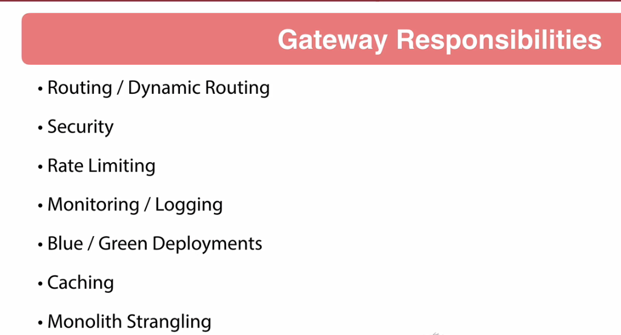

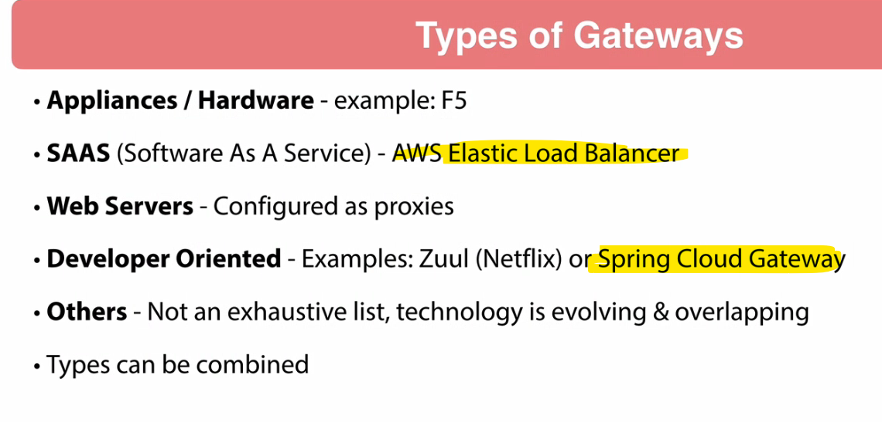





Lb load balance





Horizontal Scaling

the process of adding more instances of an application to distribute the load among multiple servers.

Auto Scaling with Load Balancers

In cloud environments, load balancers can work with auto-scaling groups to automatically add or remove instances based on traffic demands. For example, in AWS, you can configure an Elastic Load Balancer to distribute traffic across EC2 instances, and an Auto Scaling Group to dynamically adjust the number of instances based on CPU usage or other metrics.

This allows your application to scale automatically in response to traffic spikes without manual intervention. While this approach requires additional setup, it’s crucial for handling unpredictable traffic patterns effectively.

Containerization for Consistency and Scalability

One of the most effective ways to deploy multiple instances of a Spring Boot application is by using containers. Containers package your application along with all its dependencies into a standardized unit that can run on any platform. This simplifies deployment across various environments and scales easily by replicating the container across servers.

A popular choice for containerization is Docker, which allows you to create lightweight, standalone containers for each instance of your Spring Boot application.

Once your application is containerized, you can build the Docker image and create multiple containers across different servers. This approach provides consistency across all environments, reducing the risk of compatibility issues.

By running this container on multiple servers or within an orchestration platform like **Kubernetes**, you can scale out your Spring Boot application easily.

Netflix Eureka

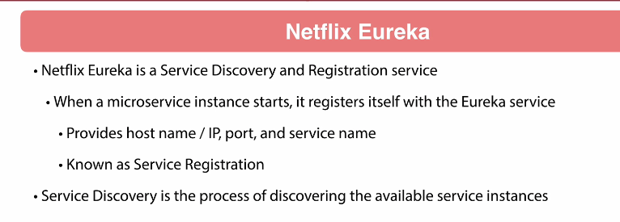

Fault Tolerance

Ability to continue operating without operation

Ex. Failure in 1 ms does not mean complete app failure

Resilience

ability to recover quickly from difficulties

Circuit Breaker. Prevent network or service failure from cascading

Fallbacks default responses preconfigured

Timeouts

Graceful Degradation. Reduced functionality

Resilience4j

Lightweight easy to use fault tolerance library, easy to integrate with spring boot





After some failure circuit breaker changes it to closed, no more requests allowed, configured to go to half open after 10 seconds, to accept another attempt

Fallback



Service down, circuit breaker Open but no error received



Retry

Attempt configured number of times to fulfill the request, If couldn’t process it will throw the fallback





Rate Limiter

Limit of request accepted in a period of time





Asynchronous Communication

Rabbit MQ



If review service is down its ok, message will be stores in message queue for a while



Message queue

Form of asynchronous service to service communication in ms arquitectures

Producer

Service that creates a message into the message queue

Consumer

Service that consumes a message from the message queue

Channel

can be thought of as "lightweight connections that share a single TCP connection".



Producer







Consumer







Packaging

Compile source code into bytecode, bundling it with any dependent libraries and creating a single executable artifact that can be distributed and run



Hibernate entity manager vs entitymanager factory

EntityManagerFactory provides instances of EntityManager for connecting to same database.

Hibernate merge vs update

Update: if you are sure that the session does not contains an already persistent instance with the same identifier, then use update to save the data in hibernate

Merge: if you want to save your modifications at any time with out knowing about the state of an session, then use merge() in hibernate.

Hibernate merge vs refresh

MERGE - for existing objects, to merge the existing data in the table with the data in my object. (sync to database) PERSIST - is create new records from object in the database. REFRESH - is to refresh the data in the object.

Database

Get only duplicated values

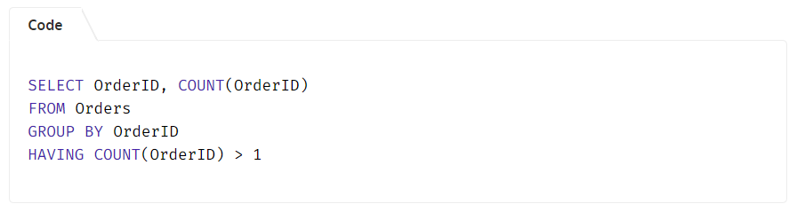

What is SQL?

SQL (Structured Query Language) is a standard programming language used to communicate with relational databases.

What are the main types of SQL commands?

SQL commands are broadly classified into:

DDL (Data Definition Language): CREATE, ALTER, DROP, TRUNCATE.

DML (Data Manipulation Language): SELECT, INSERT, UPDATE, DELETE.

DCL (Data Control Language): GRANT, REVOKE.

TCL (Transaction Control Language): COMMIT, ROLLBACK, SAVEPOINT.

SQL Transaction?

A transaction in SQL is a sequence of one or more SQL statements executed as a single unit of work. These statements could be performing operations like INSERT, UPDATE, or DELETE. The main goal of a transaction is to ensure that all operations within it should be either completed successful or rolled back entirely if an error occurs.

BEGIN TRANSACTION;

-- Deduct $150 from Account A

UPDATE Accounts

SET Balance = Balance - 150

WHERE AccountID = 'A';

-- Add $150 to Account B

UPDATE Accounts

SET Balance = Balance + 150

WHERE AccountID = 'B';

-- Commit the transaction if both operations succeed

COMMIT;

COMMIT

COMMIT command is used to save all changes made during the current transaction to the database

ROLLBACK

Rollback command is used to undo all changes made in the current transaction.

SAVEPOINT COMMAND

SAVEPOINT is used to create a checkpoint within a transaction. We can roll back to a specific SAVEPOINT instead of rolling back the entire transaction.

SAVEPOINT SP1;

//Savepoint created.

DELETE FROM Student WHERE AGE = 20;

//deleted

SAVEPOINT SP2;

//Savepoint created.

ROLLBACK TO SAVEPOINT SAVEPOINT_NAME;

RELEASE SAVEPOINT Command

This command is used to remove a SAVEPOINT that we have created. Once a SAVEPOINT has been released, we can no longer use the ROLLBACK command to undo transactions performed since the last SAVEPOINT

Monitoring and Optimizing SQL Transactions

To maintain performance and prevent issues, consider the following techniques:

1. Monitor Locks: Track locking behavior and adjust queries to minimize locking conflicts.

2. Limit Transaction Scope: Limit the number of rows or records affected by a transaction to speed up processing.

3. Use Batch Processing: If you're handling large amounts of data, break the operations into smaller transactions or batches to avoid overwhelming the system.

Default Constraint

DEFAULT constraint assigns a default value to a column when no value is provided during an INSERT operation. This helps maintain consistent data and simplifies data entry.

Normalization

Normalization is the process of organizing data in a database to reduce redundancy and improve data integrity. This involves dividing large tables into smaller, related tables and defining relationships between them to ensure consistency

Denormalization

Denormalization is the process of combining normalized tables into larger tables for performance reasons. It is used when complex queries and joins slow down data retrieval, and the performance benefits outweigh the drawbacks of redundancy.

What are the different operators available in SQL?

Arithmetic Operators: +, -, *, /, %

Comparison Operators: =, !=, <>, >, <, >=, <=

Logical Operators: AND, OR, NOT

Set Operators: UNION, INTERSECT, EXCEPT

Special Operators: BETWEEN, IN, LIKE, IS NULL

What is a view in SQL?

A view is a virtual table created by a SELECT query. It does not store data itself, but presents data from one or more tables in a structured way. Views simplify complex queries, improve readability, and enhance security by restricting access to specific rows or columns.

What is the purpose of the UNIQUE constraint?

The UNIQUE constraint ensures that all values in a column (or combination of columns) are distinct. This prevents duplicate values and helps maintain data integrity.

What are the different types of joins in SQL?

INNER JOIN: Returns rows that have matching values in both tables.

LEFT JOIN (LEFT OUTER JOIN): Returns all rows from the left table, and matching rows from the right table.

RIGHT JOIN (RIGHT OUTER JOIN): Returns all rows from the right table, and matching rows from the left table.

FULL JOIN (FULL OUTER JOIN): Returns all rows when there is a match in either table.

CROSS JOIN: Produces the Cartesian product of two tables.

What is the purpose of the GROUP BY clause?

The GROUP BY clause is used to arrange identical data into groups. It is typically used with aggregate functions (such as COUNT, SUM, AVG) to perform calculations on each group rather than on the entire dataset.

What are aggregate functions in SQL?

Aggregate functions perform calculations on a set of values and return a single value. Common aggregate functions include:

COUNT(): Returns the number of rows.

SUM(): Returns the total sum of values.

AVG(): Returns the average of values.

MIN(): Returns the smallest value.

MAX(): Returns the largest value.

What is a subquery?

A subquery is a query nested within another query. It is often used in the WHERE clause to filter data based on the results of another query, making it easier to handle complex conditions.

What is the difference between DELETE and TRUNCATE commands?

DELETE: Removes rows one at a time and records each deletion in the transaction log, allowing rollback. It can have a WHERE clause.

TRUNCATE: Removes all rows at once without logging individual row deletions. It cannot have a WHERE clause and is faster than DELETE for large data sets.

What is the purpose of the SQL ORDER BY clause?

The ORDER BY clause sorts the result set of a query in either ascending (default) or descending order, based on one or more columns. This helps present the data in a more meaningful or readable sequence.

What are indexes, and why are they used?

Indexes are database objects that improve query performance by allowing faster retrieval of rows. They function like a book’s index, making it quicker to find specific data without scanning the entire table. However, indexes require additional storage and can slightly slow down data modification operations.

What is a cursor in SQL?

A cursor is a database object used to retrieve, manipulate, and traverse through rows in a result set one row at a time. Cursors are helpful when performing operations that must be processed sequentially rather than in a set-based manner.

What is a trigger in SQL?

A trigger is a set of SQL statements that automatically execute in response to certain events on a table, such as INSERT, UPDATE, or DELETE.

What is a stored procedure?

A stored procedure is a precompiled set of SQL statements stored in the database. It can take input parameters, perform logic and queries, and return output values or result sets. Stored procedures improve performance and maintainability by centralizing business logic.

Alter command

The ALTER command is used to modify the structure of an existing database object. This command is essential for adapting our database schema as requirements evolve.

Add or drop a column in a table.

Change a column’s data type.

What is a composite primary key?

A composite primary key is a primary key made up of two or more columns.

What are the advantages of using stored procedures?

Improved Performance: Stored procedures are precompiled and cached in the database, making their execution faster than sending multiple individual queries.

Reusability and Maintenance: Once a procedure is written, it can be reused across multiple applications. If business logic changes, you only need to update the stored procedure, not every application that uses it.

What is the difference between UNION and UNION ALL?

UNION: Combines result sets from two queries and removes duplicate rows, ensuring only unique records are returned.

UNION ALL: Combines the result sets without removing duplicates, meaning all records from both queries are included.

SELECT Name FROM Customers

UNION ALL

SELECT Name FROM Employees;

WHEN

SELECT ID,

CASE

WHEN Salary > 100000 THEN 'High'

WHEN Salary BETWEEN 50000 AND 100000 THEN 'Medium'

ELSE 'Low'

END AS SalaryLevel

FROM Employees;

How does indexing improve query performance?

Indexing allows the database to locate and access the rows corresponding to a query condition much faster than scanning the entire table. Instead of reading each row sequentially, the database uses the index to jump directly to the relevant data pages.

CREATE INDEX idx_lastname ON Employees(LastName);

SELECT * FROM Employees WHERE LastName = 'Smith';

What are the trade-offs of using indexes in SQL databases?

Advantages

Faster query performance, especially for SELECT queries with WHERE clauses, JOIN conditions, or ORDER BY clauses.

Improved sorting and filtering efficiency.

Disadvantages:

Increased storage space for the index structures.

Additional overhead for write operations (INSERT, UPDATE, DELETE), as indexes must be updated whenever the underlying data changes.

Potentially slower bulk data loads or batch inserts due to the need to maintain index integrity.

In short, indexes make read operations faster but can slow down write operations and increase storage requirements.

What are temporary tables, and how are they used?

Temporary tables are tables that exist only for the duration of a session or a transaction. They are useful for storing intermediate results, simplifying complex queries, or performing operations on subsets of data without modifying the main tables.

CREATE TABLE #TempResults (ID INT, Value VARCHAR(50));

INSERT INTO #TempResults VALUES (1, 'Test');

SELECT * FROM #TempResults;

What is a sequence in SQL?

A sequence is a database object that generates a series of unique numeric values. It’s often used to produce unique identifiers for primary keys or other columns requiring sequential values.

What is the difference between a local and a global temporary table?

Local Temporary Table:

Prefixed with # (e.g., #TempTable).

Exists only within the session that created it.

Automatically dropped when the session ends.

Global Temporary Table:

Prefixed with ## (e.g., ##GlobalTempTable).

Visible to all sessions.

Dropped only when all sessions referencing it are closed.

CREATE TABLE #LocalTemp (ID INT);

CREATE TABLE ##GlobalTemp (ID INT);

What is the purpose of the SQL MERGE statement?

The MERGE statement combines multiple operations INSERT, UPDATE, and DELETE into one. It is used to synchronize two tables by:

Inserting rows that don’t exist in the target table.

Updating rows that already exist.

Deleting rows from the target table based on conditions

Microservices

What are Microservices?

Microservices is an architecture in which the application performs as a loosely coupled service that can be developed, deployed, and maintained independently.

Microservices are useful when the application or our project needs to be more scalable and manageable or requires more resources.

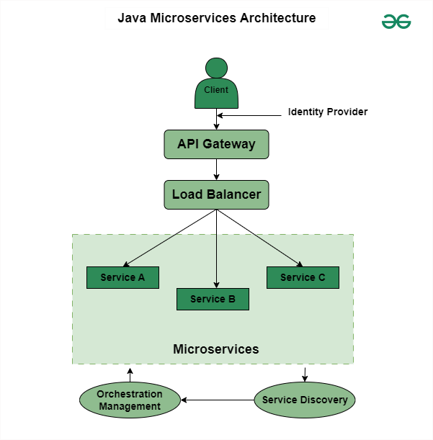

Design patterns of Java Spring Boot Microservices.

Service Registry and Discovery: Services automatically register in a central registry, allowing others to identify and interact with them dynamically.

API Gateway: It acts as a customer entry point and forwards requests to appropriate microservices to provide additional functionality such as authentication and rate limits.

Circuit Breaker: It monitors the availability of services and protects from failures by sending requests or by providing responses if service is unavailable.

CQRS (Command Query Responsibility Segregation): It separates the read and write operations. Also, it optimizes each and every operation separately for efficiency.

Saga Pattern: It manages distributed tasks by organizing a sequence of local transactions.

Database per service: Each of the services has separate databases. This ensures data isolation and also enables scaling and individual development.

Asynchronous messaging: Each services communicate with each other through message queues like Kafka or RabbitMQ.

What are the Main Components of Java Spring Boot Microservices?

The main components of Java Spring Boot Microservices include:

Services

Service Registry

API Gateway

Cloud Infrastructure

Containerization and Orchestration

Message Broker

Security

Monitoring

How do Microservices Communicate with each other?

In Microservices, multiple services run independently. Services communicate with each other through,

HTTP/REST: These are light-weight protocols used for perform communication between two services.

Message queues: Message queues such as Kafka or RabbitMQ used to make connection.

What is WebClient and How Java Microservices Communicate using WebClient?

An interface called WebClient represents the primary access point for web requests. It is also known as Reactive Web Client that is introduced in Spring 5. The new client is a non-blocking, reactive solution that works over HTTP/1.1 protocol. Also, it is the replacement of classic RestTemplate. We can use the WebClient for Java Microservices Communication by the following approach.

What is RestTemplate and How Java Microservices Communicate using RestTemplate?

The RestTemplate is a synchronous REST client that performs HTTP requests by using a simple API of template style.

What is FeignClient and How Java Microservices Communicate using FeignClient?

FeignClient is known as Spring Cloud OpenFeign.

It is a declarative REST Client in Spring Boot Web Application. Declarative REST Client means to specify the client specification as an Interface and spring boot will take care of the implementation.

With the help of FeignClient, writing web services is very simple.

It is mostly used to consume REST API endpoints exposed by third parties or microservices.

FeignClient(name = "giveHereServiceName", url = "provideUrlHere", path = "provideContextPathHere")

public interface AddressClient {

@GetMapping("/address/{id}")

public ResponseEntity<AddressResponse> getAddressByEmployeeId(@PathVariable("id") int id);

Load balancing ex nginx

Load balancing is the process of distributing traffic among different instances of the same application.

Load Balancing are two types:

Client-Side Load Balancing

the decision about which instance of the service to route the request to is made by the client itself

Server-Side Load Balancing

Server-side load balancing is performed by the infrastructure layer between client requests and service instances. This layer receives requests from clients and routes them to available service instances based on factors such as load, availability, and other metrics.

Horizontal Scaling:

Adding more servers or instances to handle the load. Ideal for larger applications with significant growth potential, distributing workload across multiple servers.

Circuit Breaker pattern in Microservices

The Circuit Breaker pattern is a fault-tolerance mechanism used in microservices to prevent cascading failures. It monitors for failures in remote service calls and, if a failure threshold is reached, opens the circuit, diverting subsequent calls to a fallback mechanism.

API gateways in a Spring Boot microservices architecture.

API gateways in Spring Boot act as an entry point for clients to access microservices. They provide features like authentication, authorization, rate limiting, and request routing while also simplifying the client-side interface by aggregating multiple microservices into a single endpoint.

How do you ensure security in a Spring Boot microservices architecture?

Security in Spring Boot microservices can be ensured by implementing features like authentication and authorization using Spring Security. This includes techniques such as OAuth2 for token-based authentication and role-based access control.

What is Eureka, and what is its role in microservices architecture?

Eureka is a service registry and discovery server provided by Netflix. Its role in microservices architecture is to help services register themselves and discover other services dynamically, enabling communication between them.

Api Gateway

Oauth2

Redis

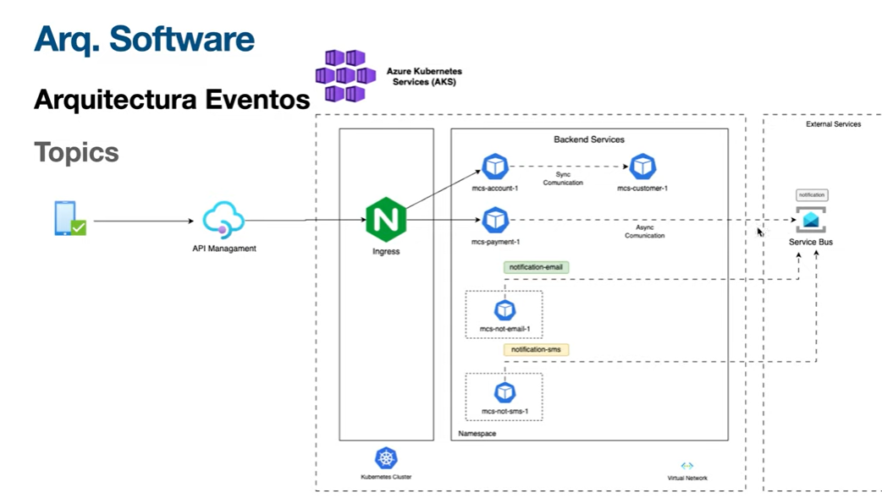

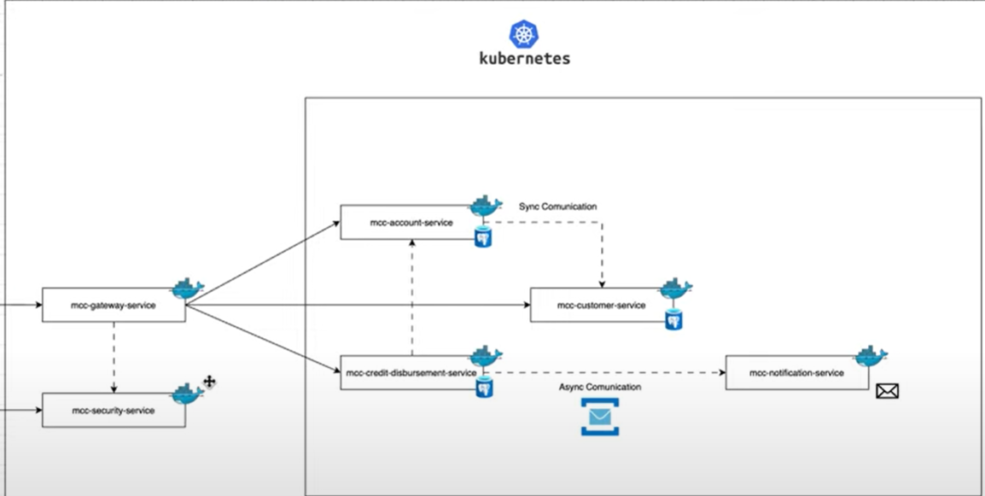

@Entity

JPA Entity

@RequestBody

public CustomerDTO addCustomer(@RequestBody CustomerDTO customerDTO){

return this.customerService.add(customerDTO);

}

@PathVariable

@GetMapping("cu/{cu}")

public CustomerDTO getCustomerByCu(@PathVariable String cu){

return this.customerService.getByCU(cu);

}

JPA Repository

@Repository

public interface IAccountRepository extends JpaRepository<AccountEntity, String> {

Optional<AccountEntity> findByAccountNumberAndCustomerCu(String username);

}

OpenFeign

a declarative REST client for Spring Boot apps.

Feign makes writing web service clients easier with pluggable annotation support, which includes Feign annotations and JAX-RS annotations.

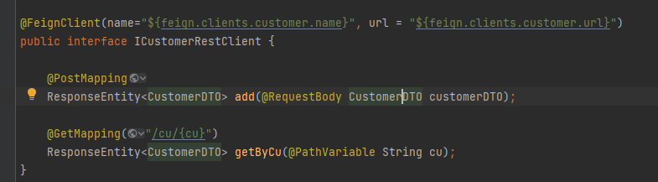

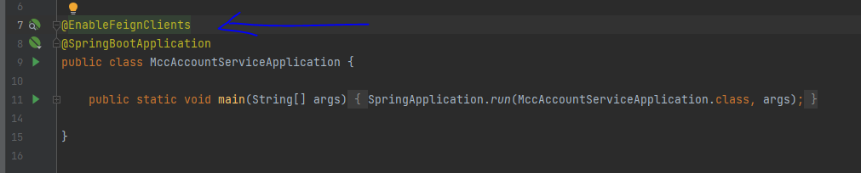

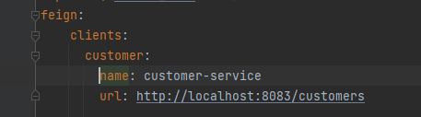

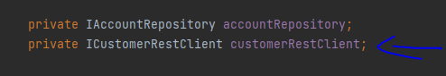

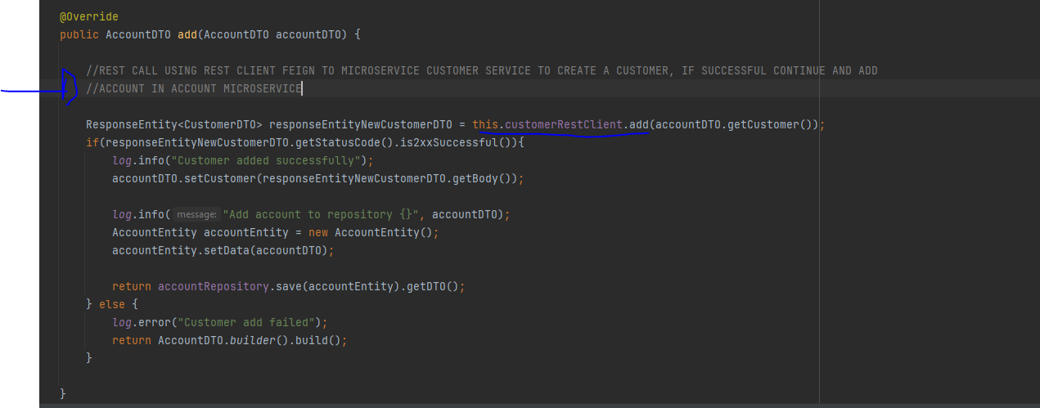

@RequestBody

To get an object into a parameter (send from postman the object in the body and catch it in here)

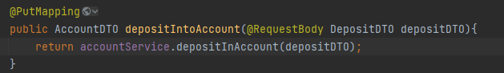

Azure Service Bus

Azure Service Bus is a fully managed cloud messaging service that facilitates communication between applications and services, especially in distributed or hybrid environments. It allows for reliable and asynchronous data transfer, decoupling systems and enabling scalable messaging patterns like queues and topics, according to Microsoft.

In yaml

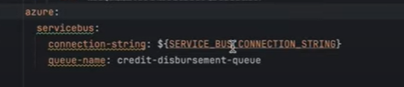

Service bus connection obtained from azure after created it and added the queue in azure as well, queue -> credit-disbursement-queue

Add dependency of azure

Create service bus builder

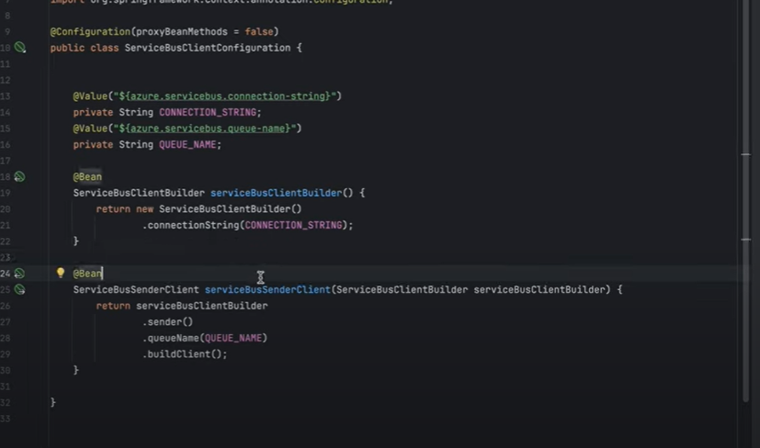

Se utiliza el service bus client para mandar a la queue un mensaje

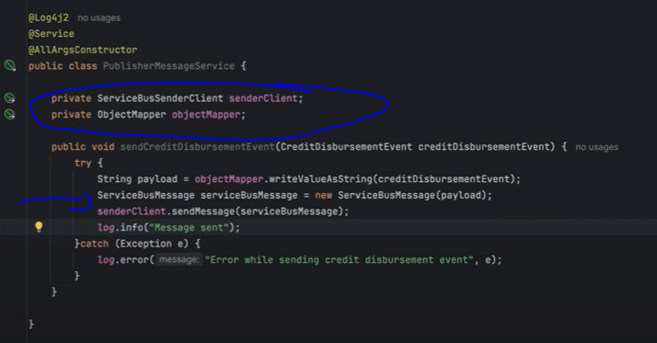

Créate the message evento, use the sender service to send the event to the desired queue

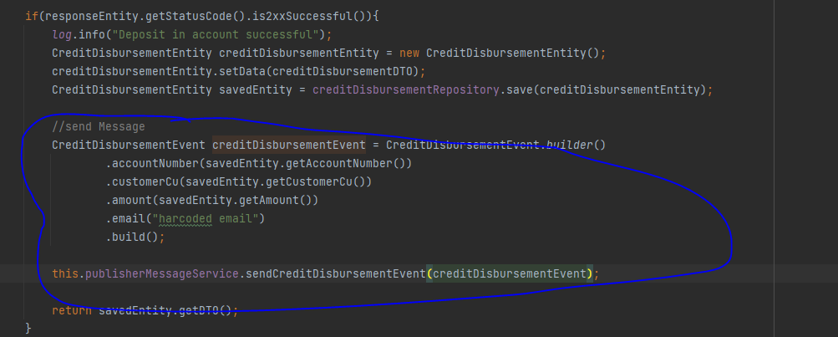

@Value

Get a property and use it as value

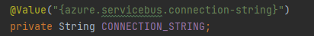

Listener Bus events subscriptor

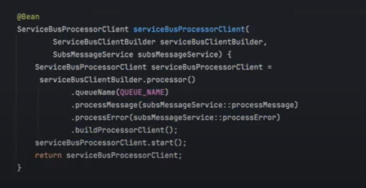

Get message from the queue

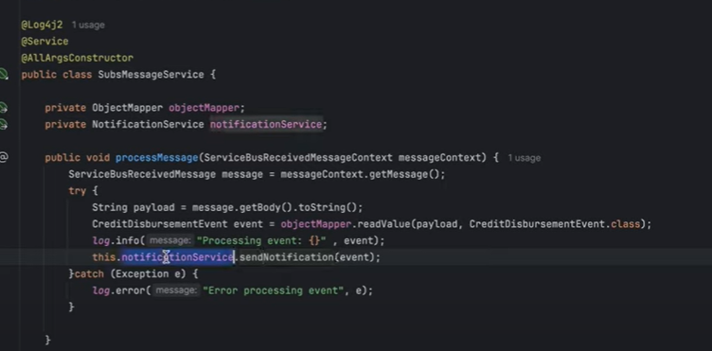

To send message

Create client which has the queue information, create event, send the message

Goes into the queue

To receive the message

Create a client with queue information, what to do to process, what to do in error case, start listener, when an event gets into the queue it its processed by the listener client

Java Mail sender, spring boot api to send mails, ex

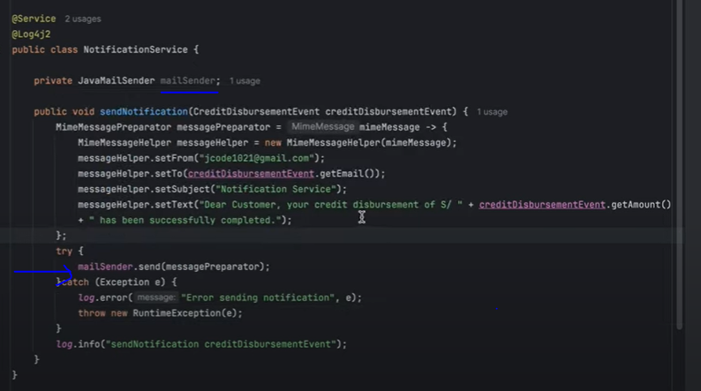

Api Gateway

We have 4 different micro services in 4 different ports, it is not suitable to be calling each port on each request, gateway instead will receive all the request and redirect to the right micro service.

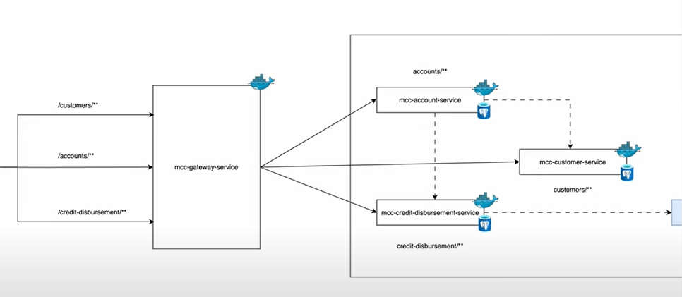

Configure routes gateway will handle

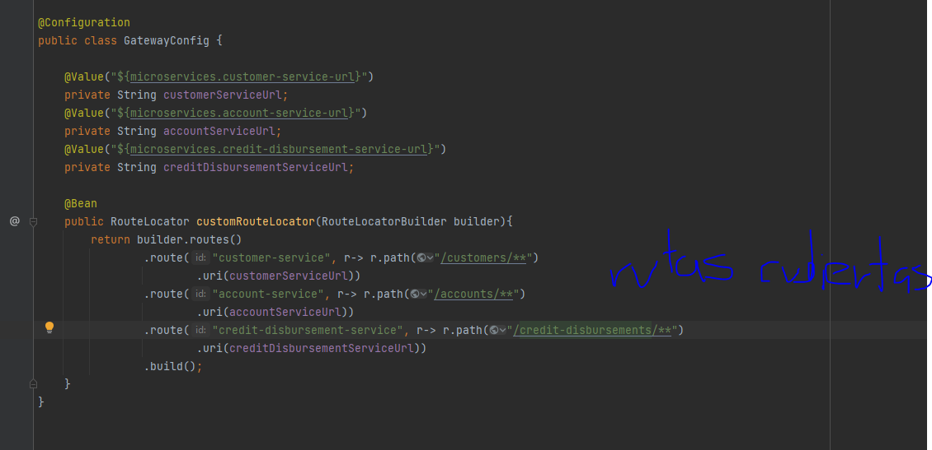

Configure gateway microservice port

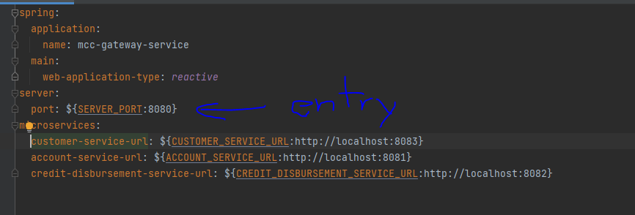

OAuth

By adding the dependency only, if you send a request to the micro service, it will ask for a token or return 401 unauthorized If not sent

OAuth allow users to grant access to his data to a third party application without sharing login credentials. It's a way to delegate access, providing a secure method for applications to interact on behalf of a user. Essentially, OAuth lets users control which applications can access their information and what specific data they can access.

Access token

OAuth uses access tokens, which are temporary credentials, to grant permission to third-party applications.

How it works:

The user initiates the authorization process by clicking a link or button to grant access to a third-party application.

The application is redirected to a website (often the service provider's) for user authentication.

If the user successfully authenticates, the service provider issues an access token and redirects the user back to the application.

The application can then use the access token to interact with the service provider and access the user's data on their behalf.

Configure port and applications

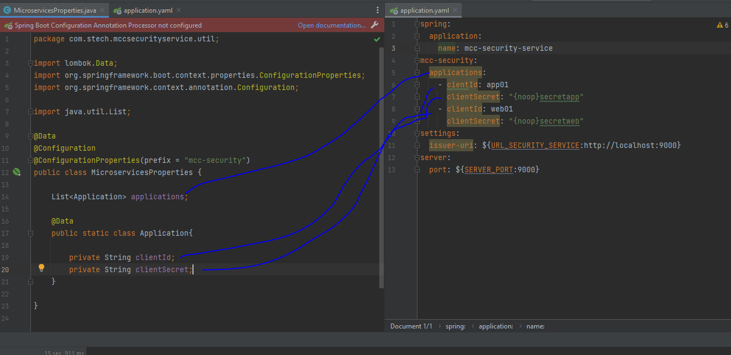

Configure OAuth2 settings

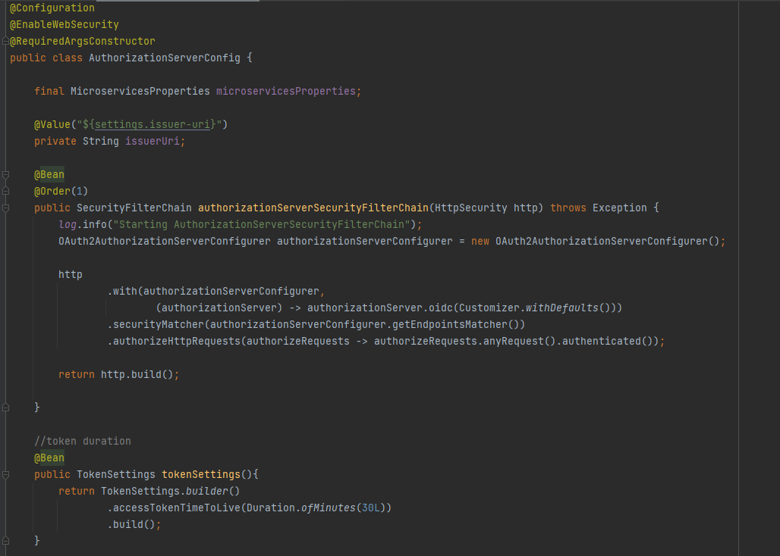

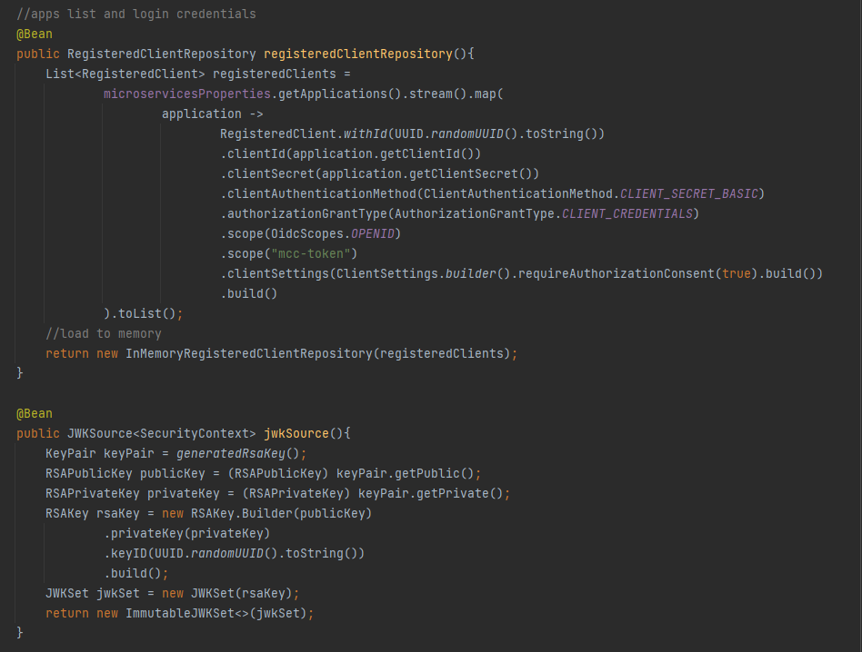

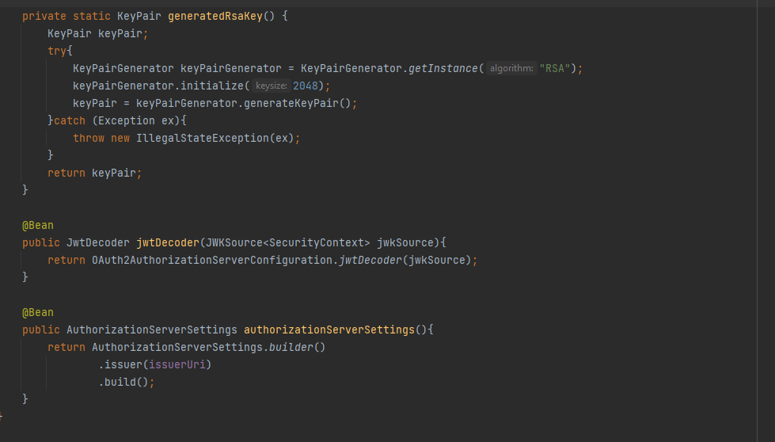

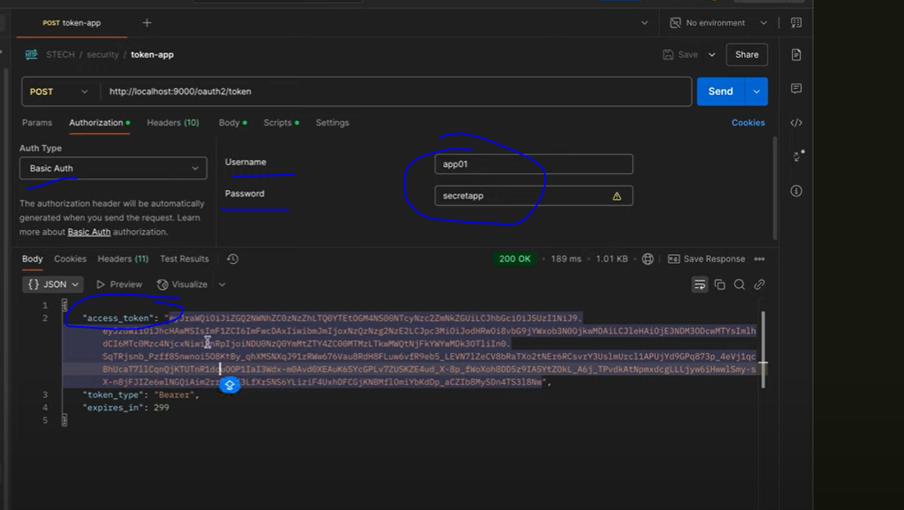

At gateway configure to look for oauth2

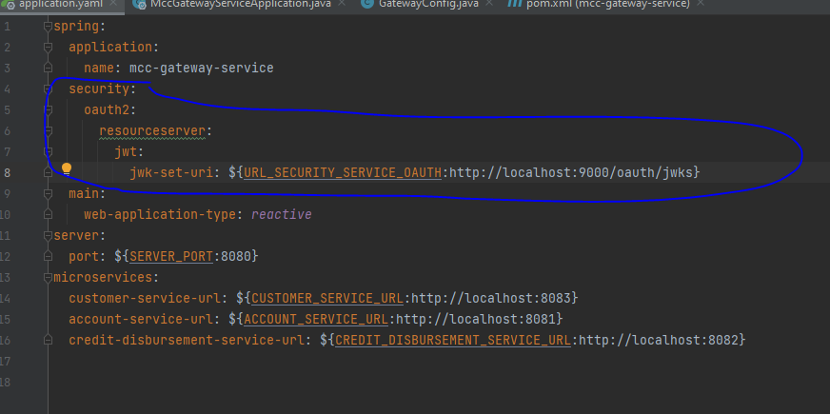

Circuit Breaker

The circuit breaker pattern is a design approach used in software development to enhance system resilience and prevent cascading failures in distributed systems.

States:

A circuit breaker typically has three states:

Closed: The initial state where calls are allowed to pass through.

Open: When the failure threshold is reached, the circuit breaker blocks calls to the service.

Half-Open: After a timeout period, a limited number of calls are allowed to pass through to check if the service has recovered. If successful, the circuit breaker returns to the closed state. If they fail, the circuit breaker returns to the open state

Thresholds:

The circuit breaker's behavior is controlled by thresholds, such as the number of failures before opening the circuit and the timeout period before attempting a half-open state.

Fallback:

When the circuit breaker is open, a fallback mechanism is typically used to provide an alternative response, such as a cached result or a default value.

Config threshold 50 request reach then open circuit

Wait 10 seconds then half open circuit

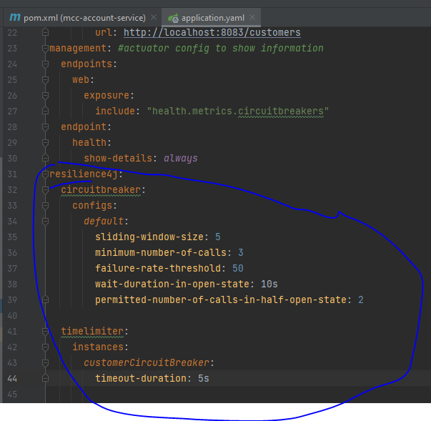

Ex Circuit Breaker

Fill configurations in yaml or properties file

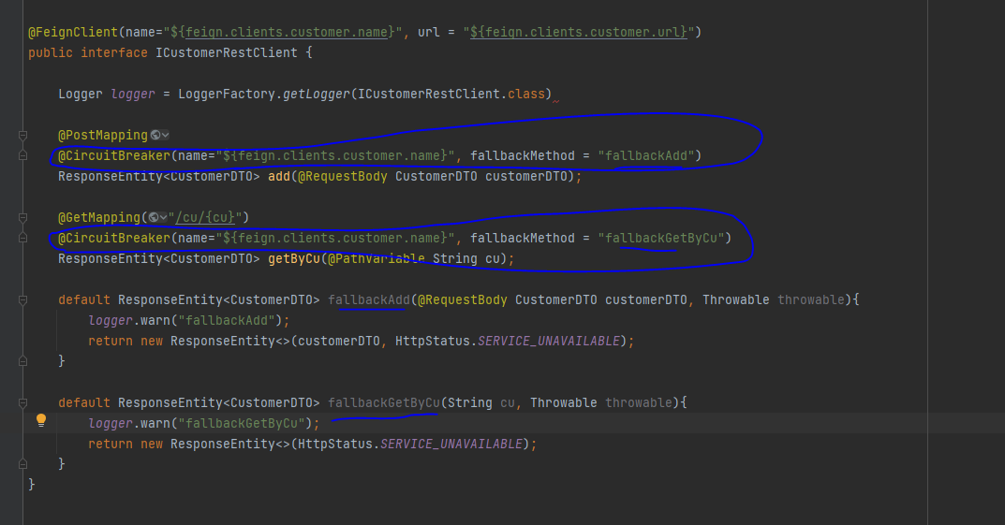

From gateway config circuit breaker

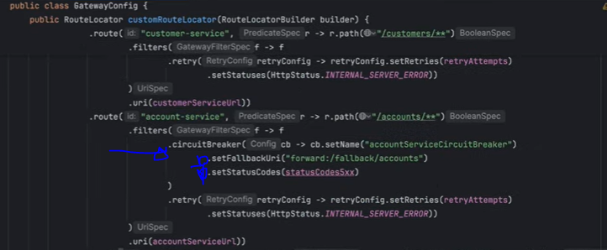

KAFKA

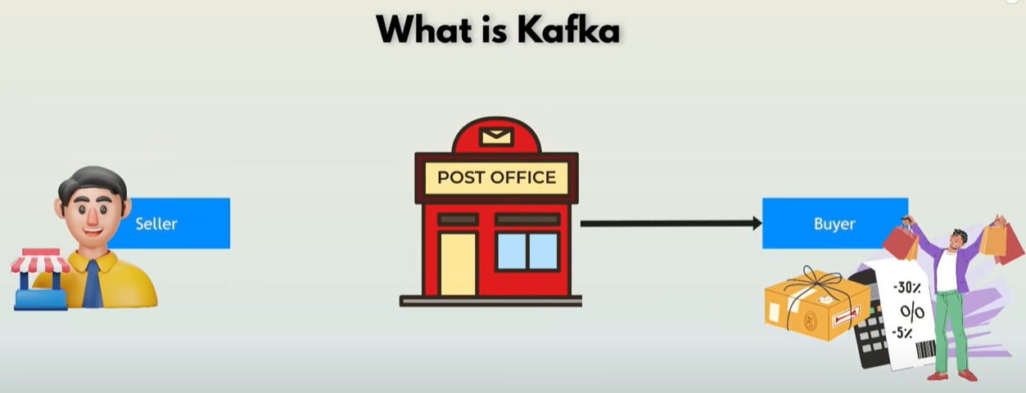

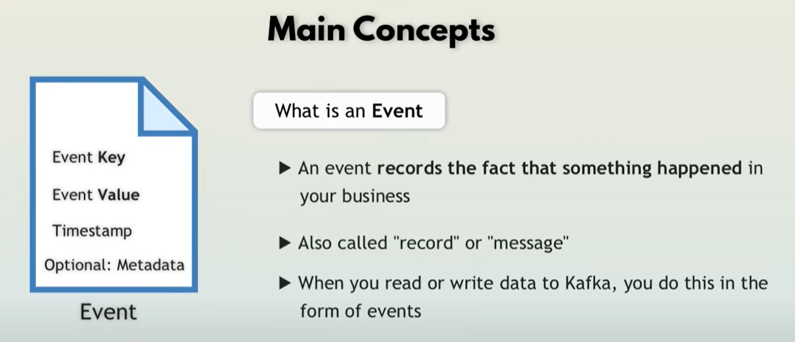

Producers

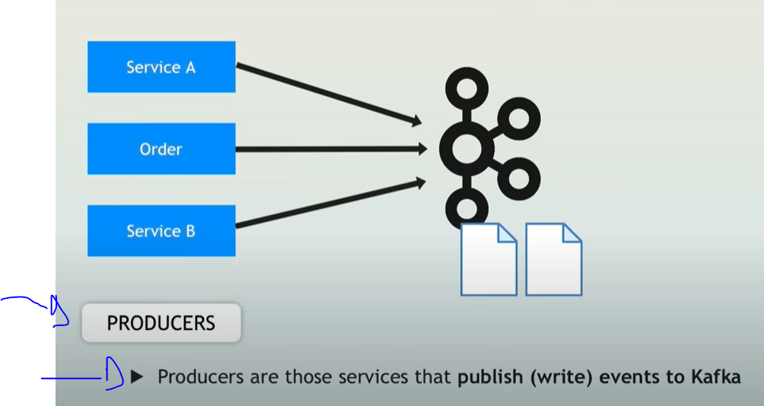

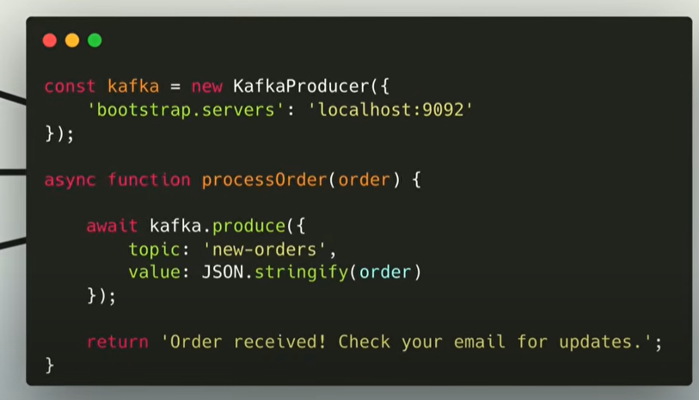

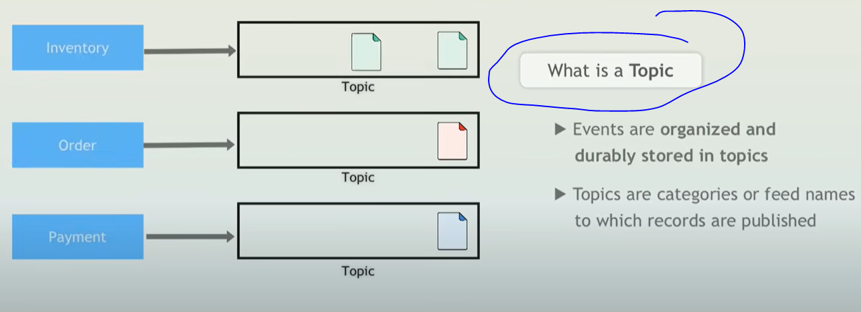

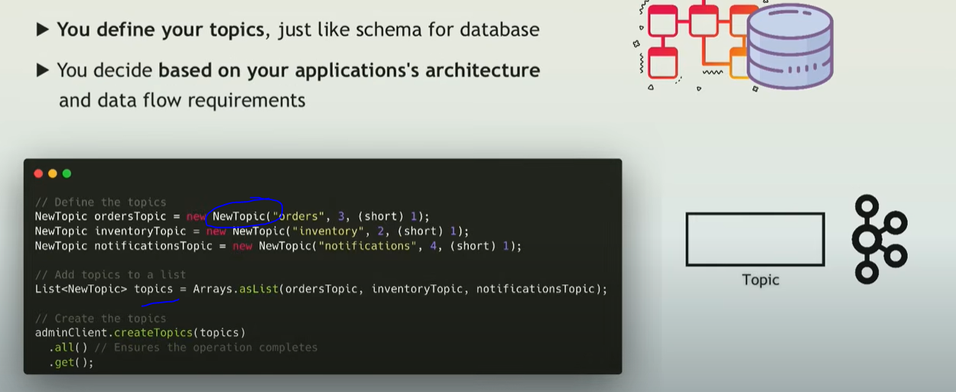

ORDER EVENT

Order event sends to the order topic and other actions are triggered

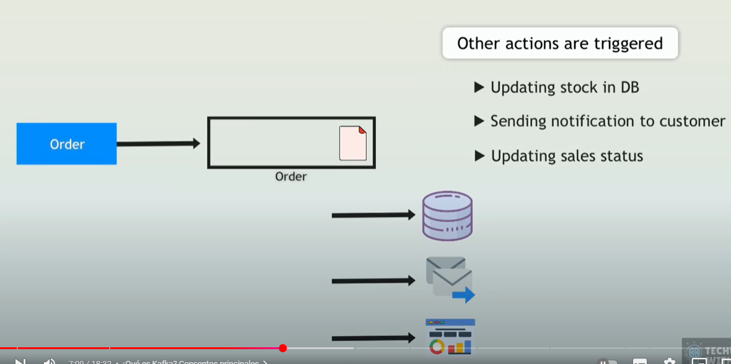

Consumers

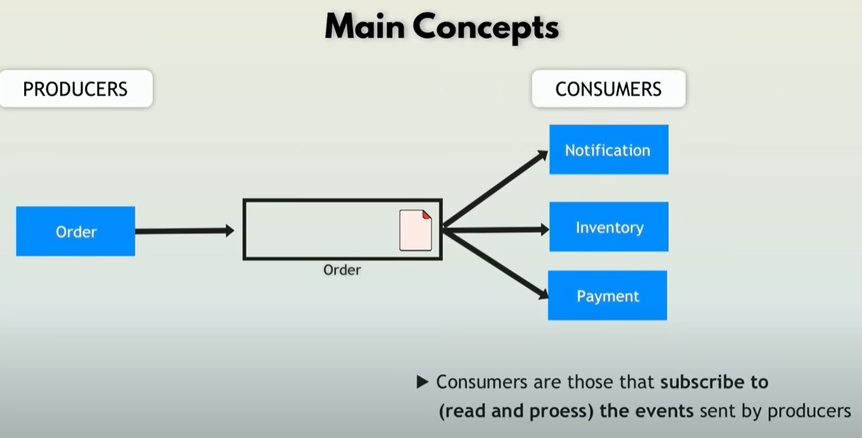

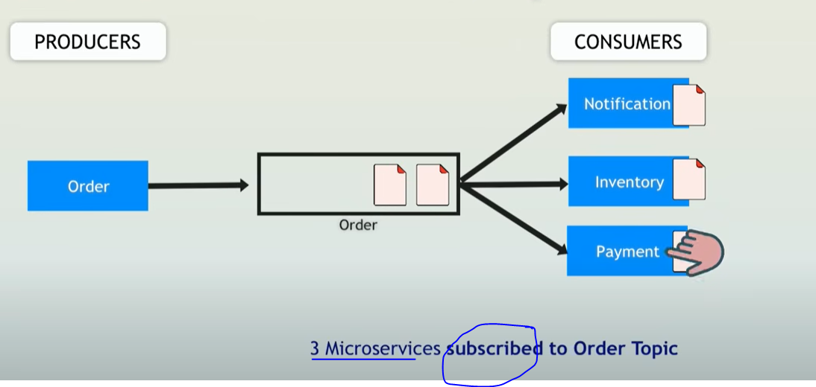

Order event is triggered, it is send to the order topic, notification, inventory and payment services are consumers of the order topic, when there is a event added to the topic, the generate an action, one of those actions could send the event to another topic, for example inventory consumes from the order topic and then triggers an event adding the event to the inventory topic.

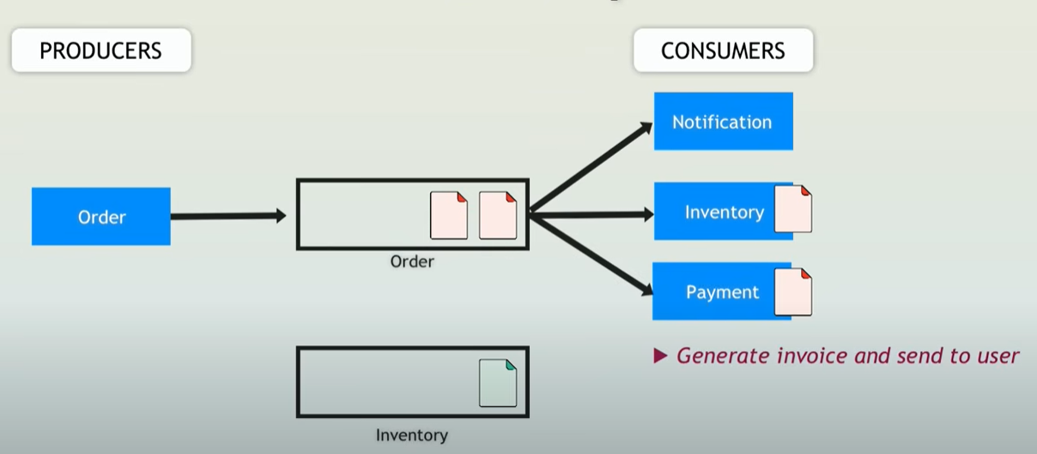

Chain of events, inventory send to the topic inventory, alerts is consuming this topic, and if below threshold, then send an event to the re-stock topic, which when consumes an event will trigger an action to fill again inventory

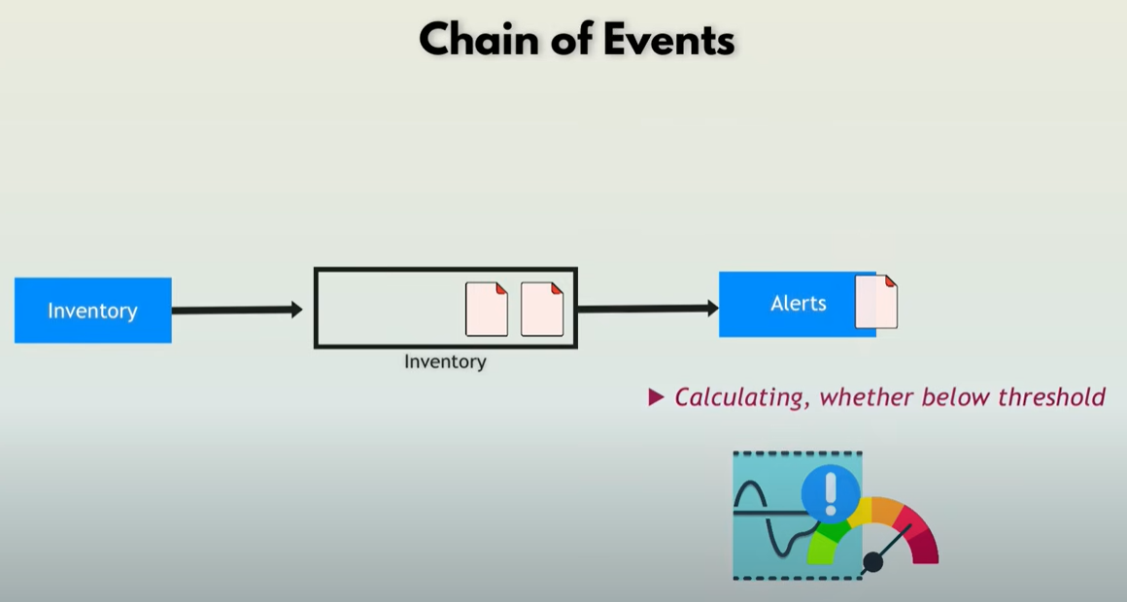

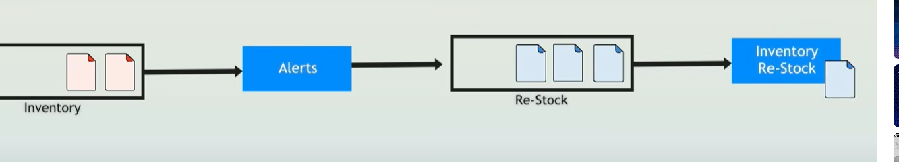

Real time processing (Streams)

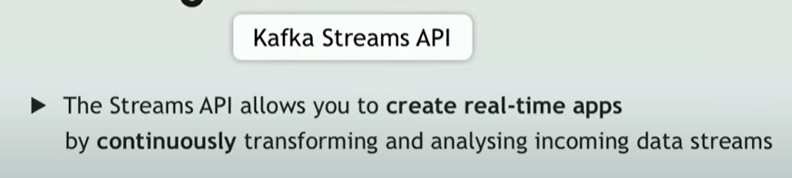

Difference Individual Process and Streams

Producer Consumer processes messages individually

Streams is a continuous real time flow of records, you don’t need to explicitly request new records, you just receive them

Streams:

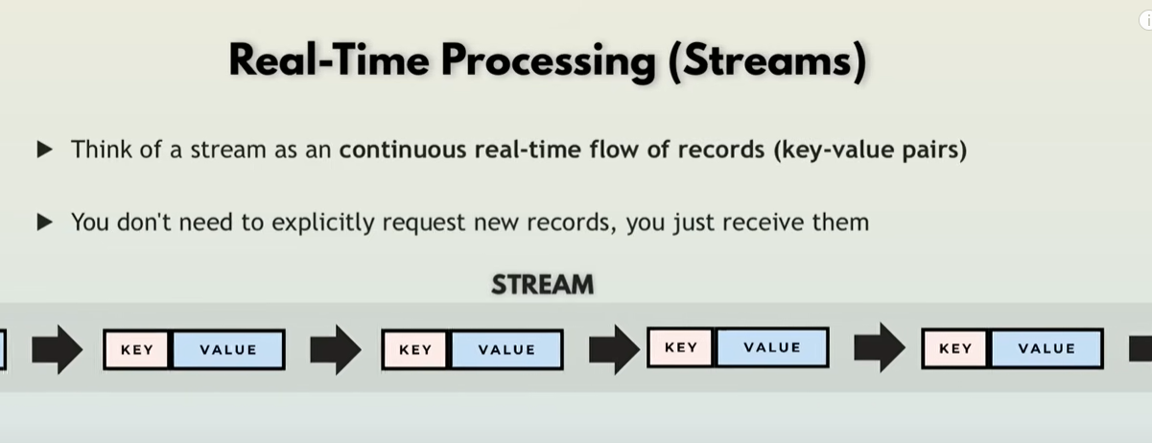

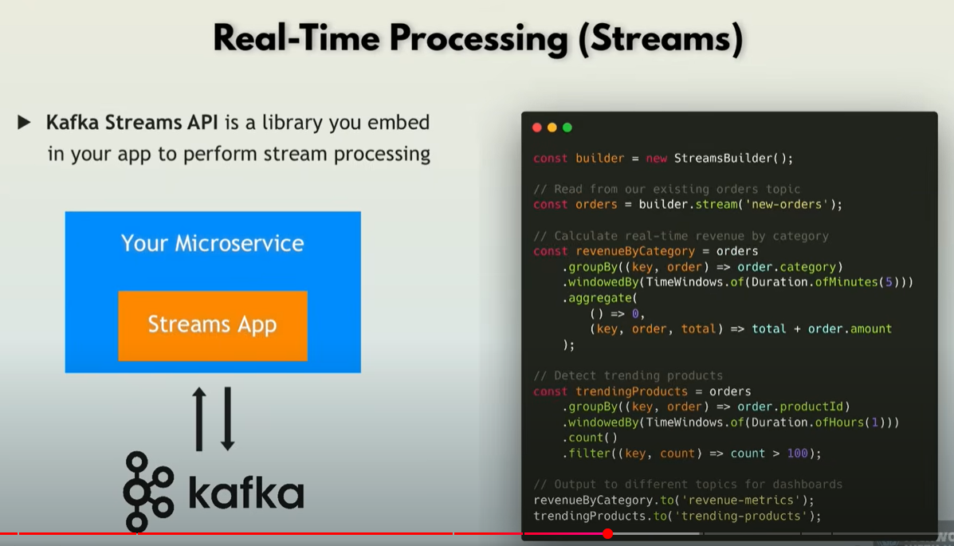

Scability with partitions

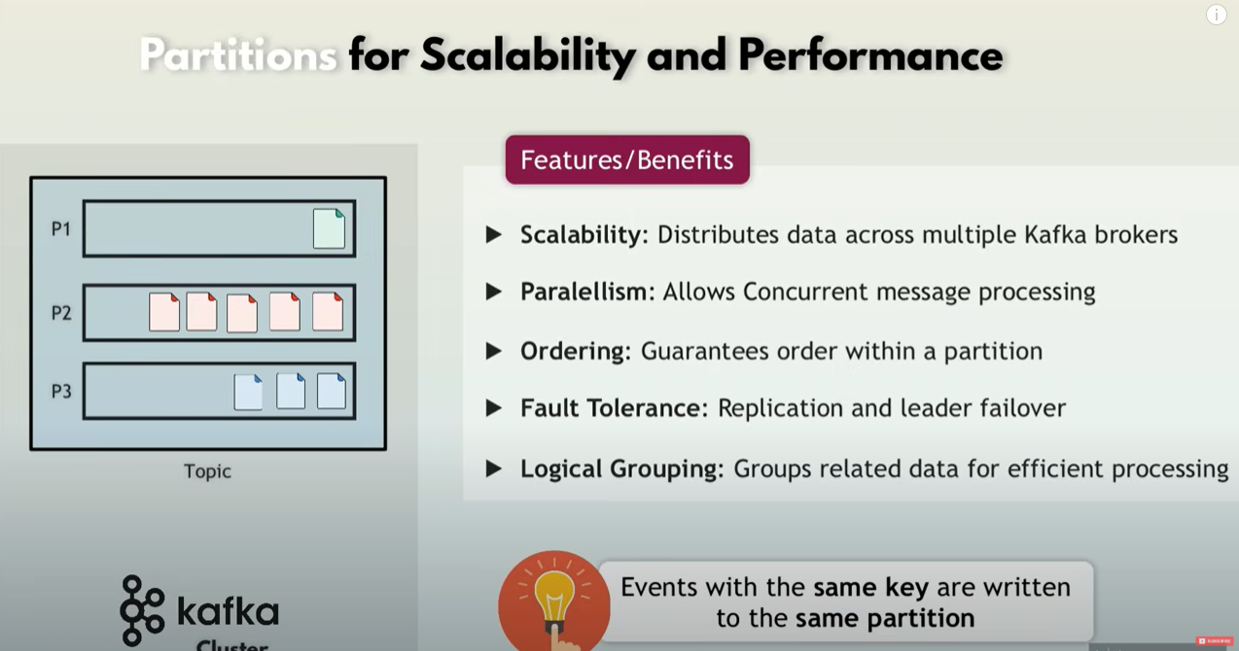

Offset

offset is a sequential integer identifier assigned to each message within a partition of a topic.

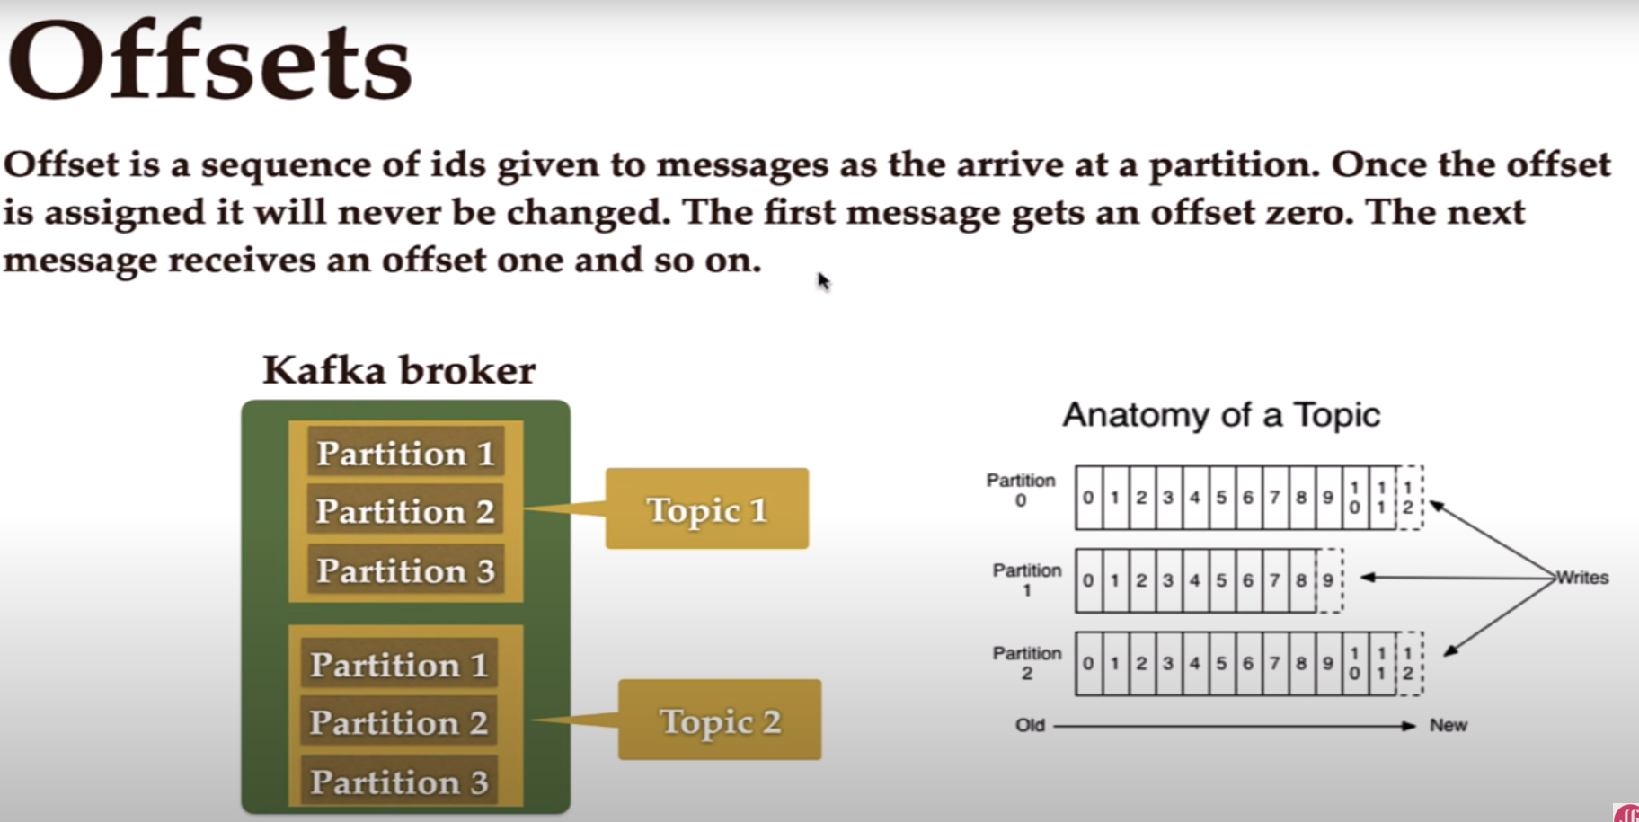

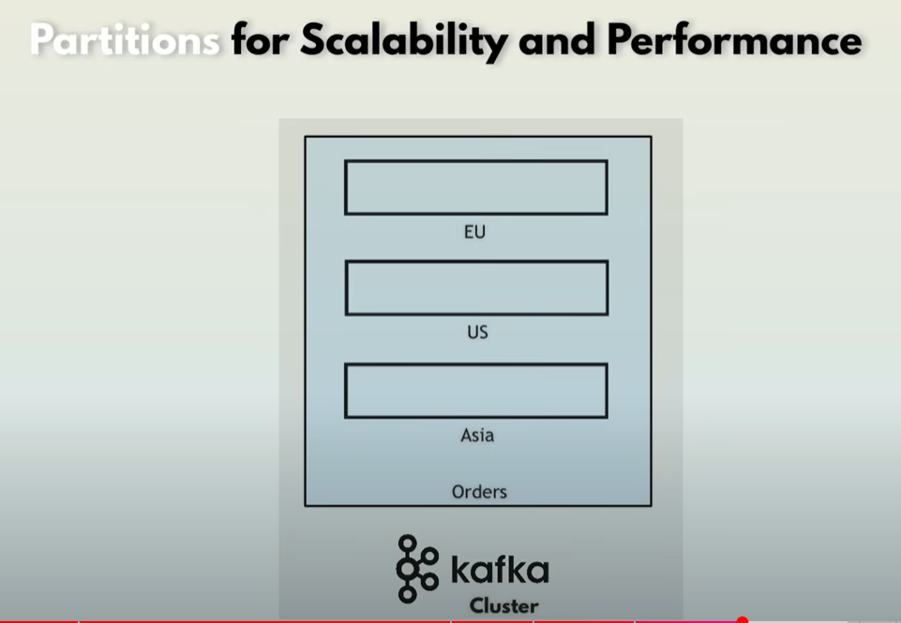

Consumer groups for scalable message consumption

If we use partitions in order to process huge amount of events ( adding partitions for example divided into regions, us, Europe, asia), then its going to be a huge amount also for the consumer who is listening to the partitions, for this we have consumer groups, using the groupId to identify which groups go together

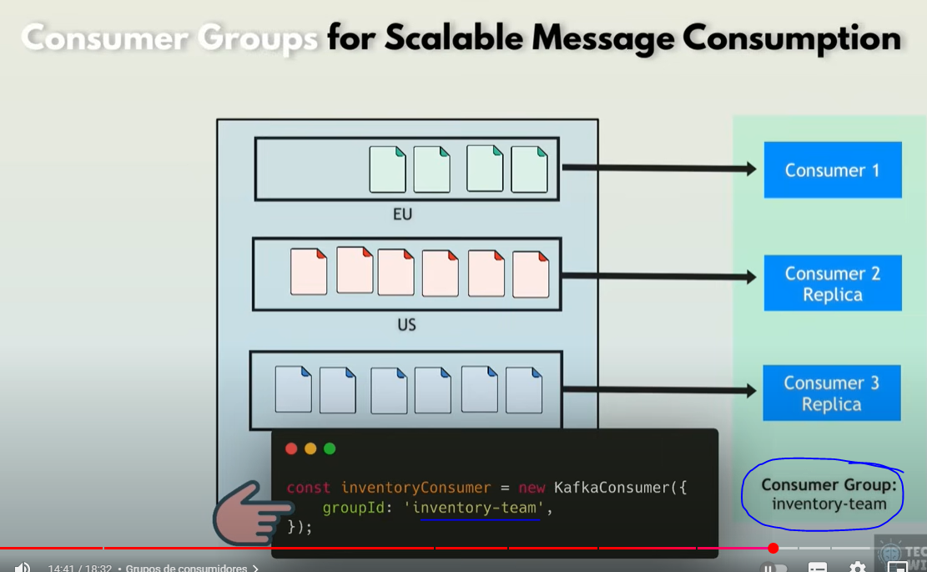

Whenever a replica consumer is up or down, kafka distributes load automatically for the new available consumers

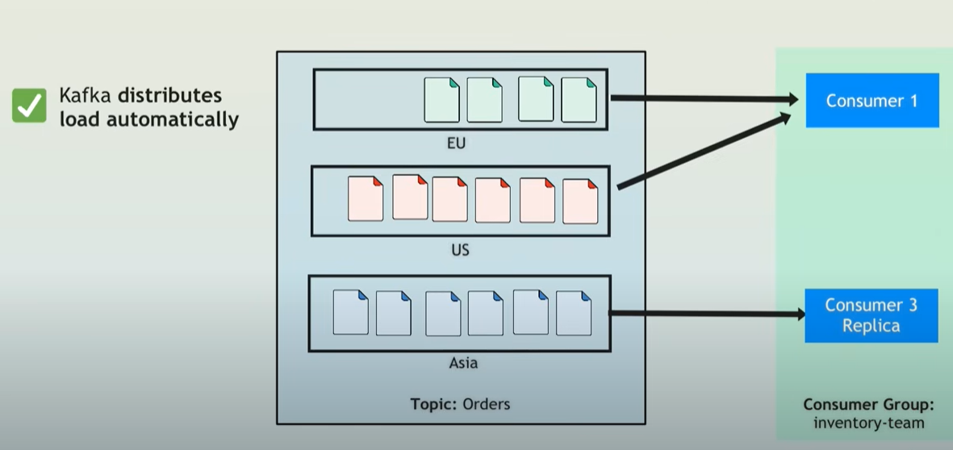

Kafka Broker

Server that stores data (messages) in topics, manages message distribution to consumers

Topics partitions are distributed across multiple brokers, for fault tolerance

Each partition has a leader brojer and multiple replicas, in case a kafka broker goes down, there will be another with a replica of the partition, for fault tolerance

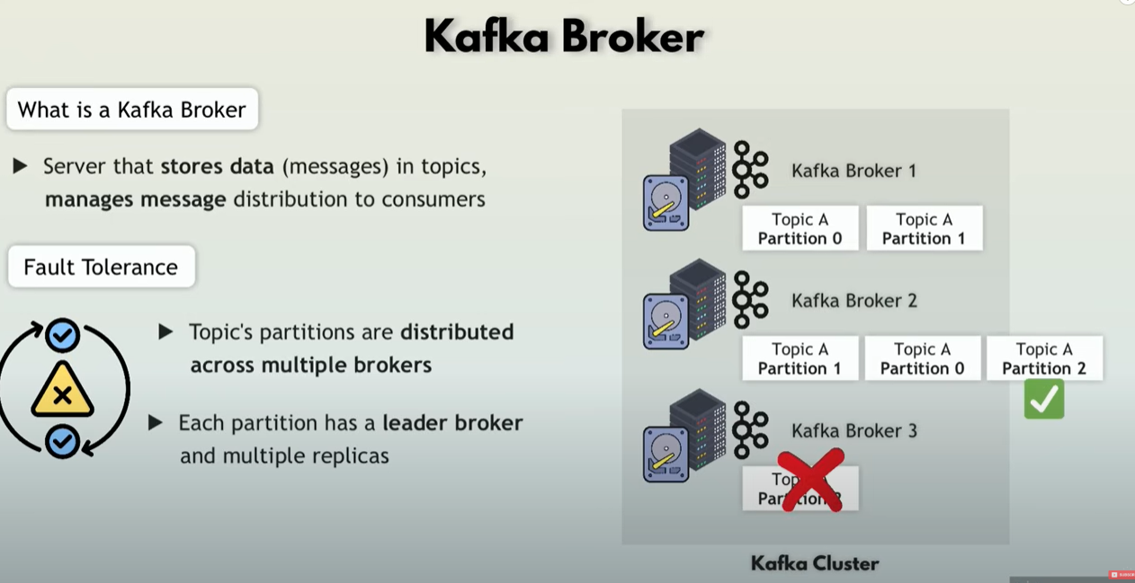

**Kafka vs rabbit or active mq**

In rabbit or active mq, messages are deleted after consumption where in kafka you can configure a retention period where it will be stored for that time on a disk.

Keeping data allows you to use for analytics

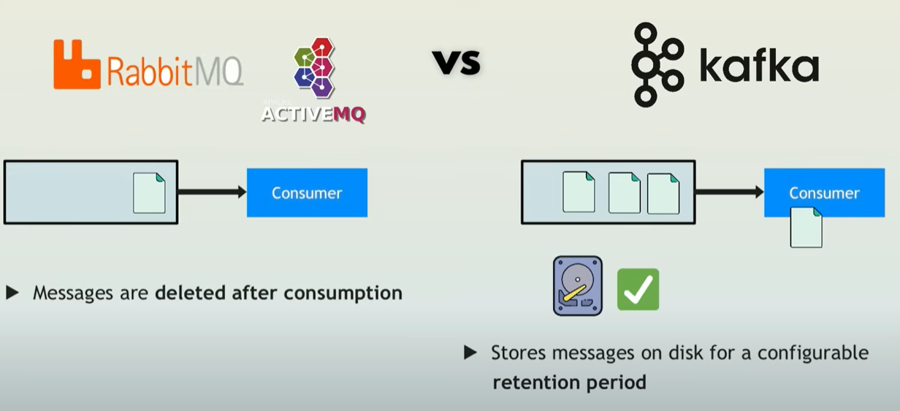

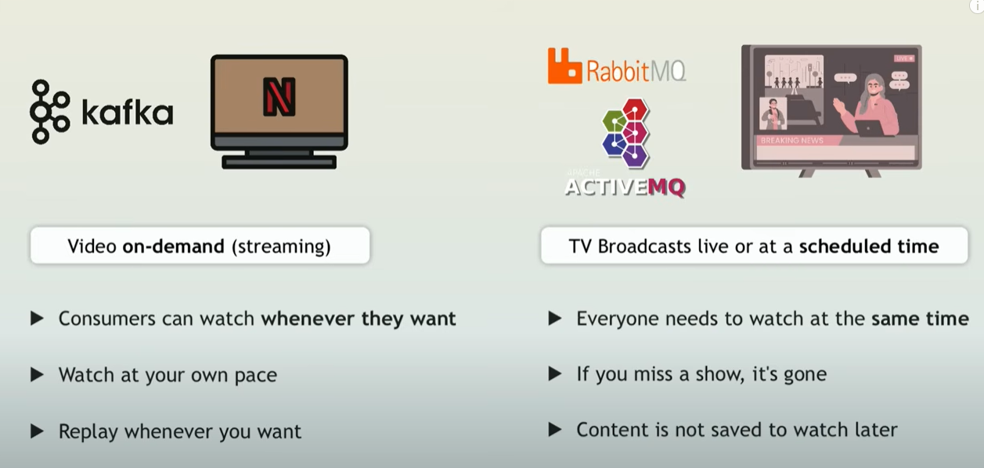

Zookeeper

External dependency used by kafka before version 3, to manage and coordinate tasks for distributed systems

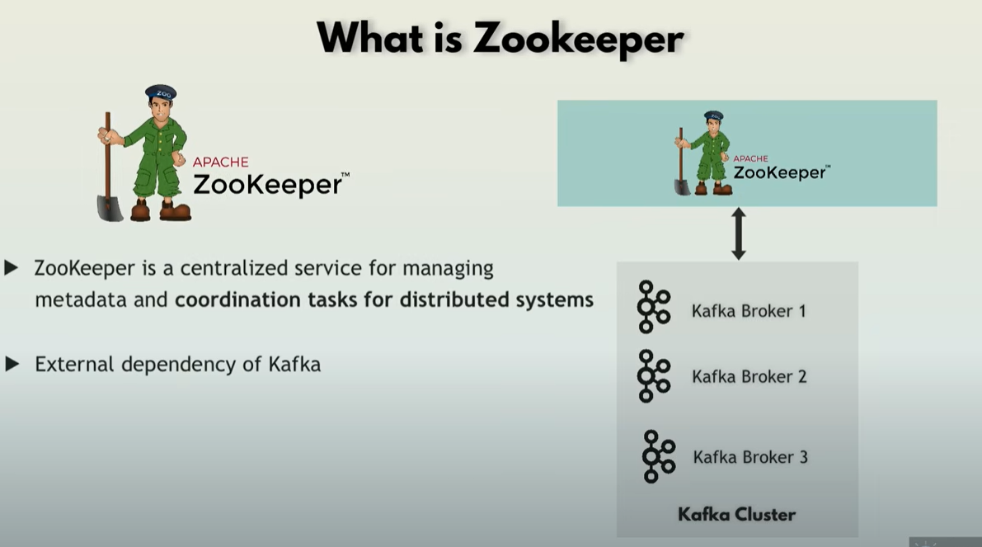

Kafka 3.0 introduced kraft which removes zookeeper

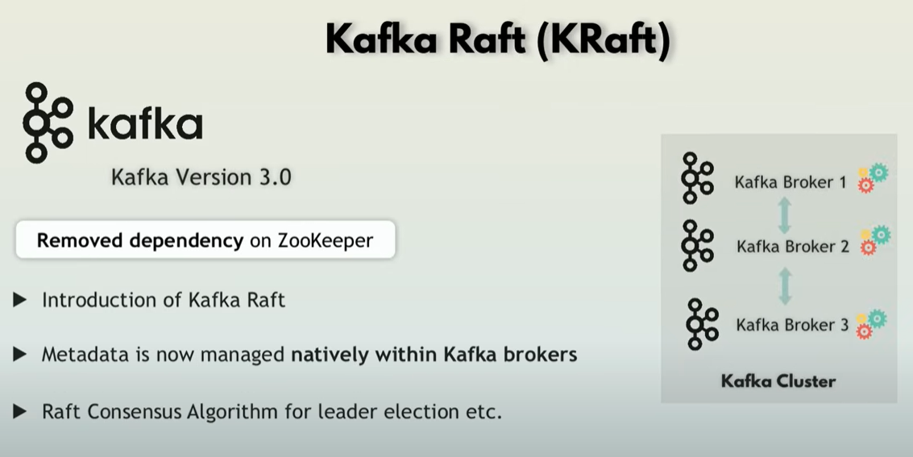

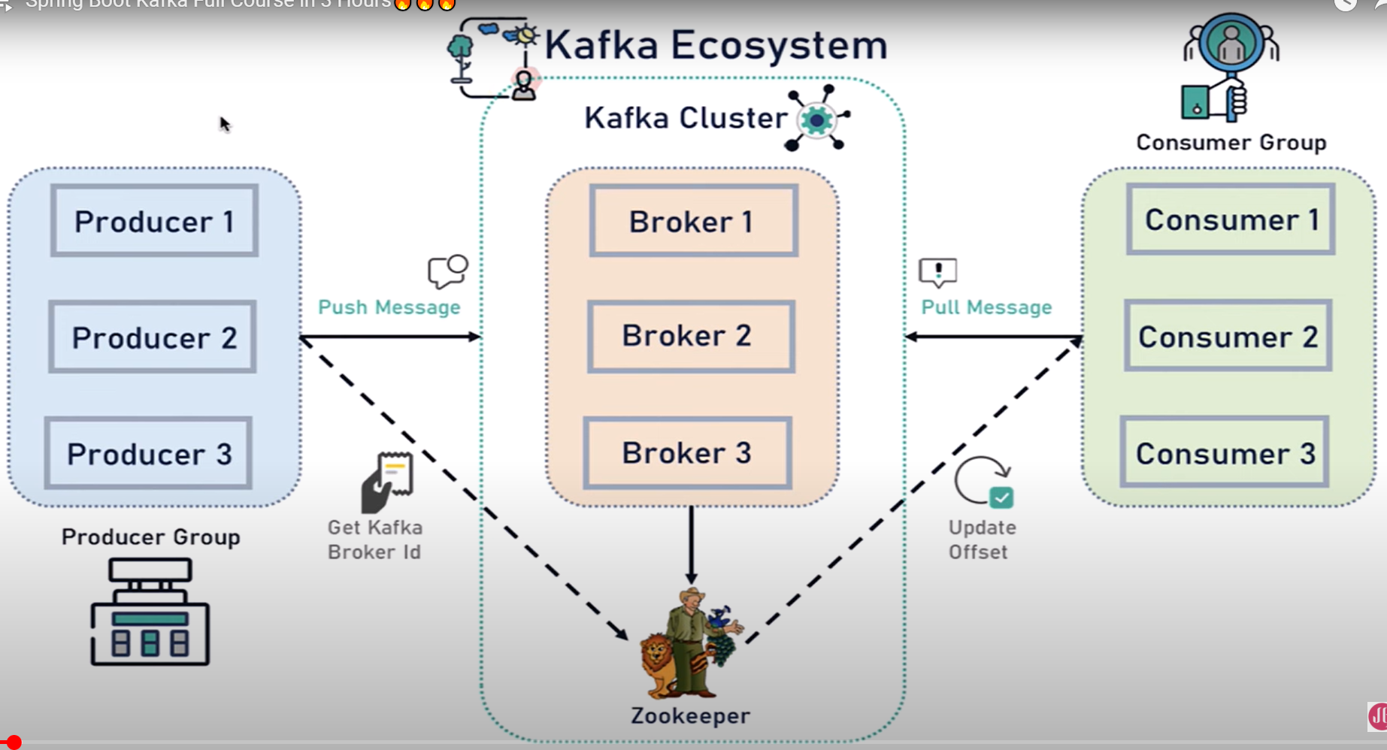

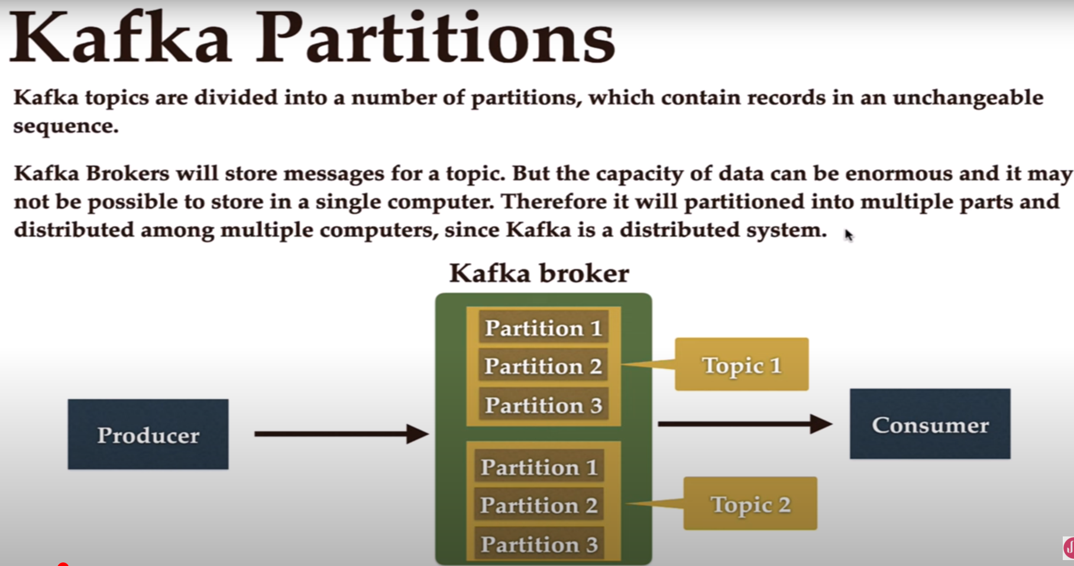

What is a consumer group in Kafka?

* [Apache Kafka](https://codingharbour.com/apache-kafka/)

When sending messages in a distributed setup using a messaging system, you typically have two scenarios you want to achieve. Either you want to:

* send a message to a targeted group of consumers (which might be just one consumer) or
* broadcast the message to all the consumers

Kafka allows you to achieve both of these scenarios by using consumer groups.

Consumer group

A consumer group is a group of consumers that share the same group id. When a topic is consumed by consumers in the same group, every record will be delivered to only one consumer. As the official documentation states: “If all the consumer instances have the same consumer group, then the records will effectively be load-balanced over the consumer instances.”

This way you can ensure parallel processing of records from a topic and be sure that your consumers won’t be stepping on each other toes.

How does Kafka achieve this?

Each topic consists of one or more partitions. When a new consumer is started it will join a consumer group (this happens under the hood) and Kafka will then ensure that each partition is consumed by only one consumer from that group.

So, if you have a topic with two partitions and only one consumer in a group, that consumer would consume records from both partitions.

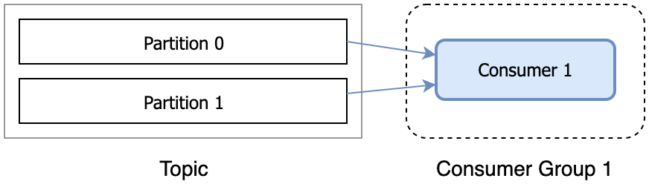A single consumer in a consumer group

After another consumer joins the same group, each consumer would continue consuming only one partition.

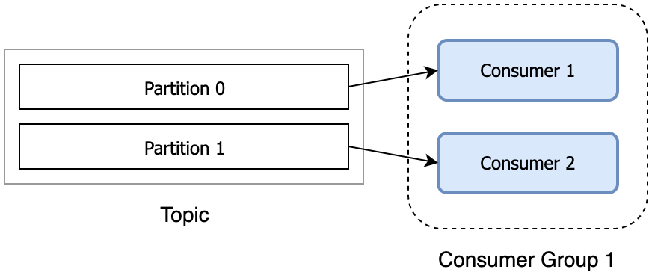Multiple consumers in one consumer group

Does it mean if I want to have more than one consumer (from the same group) reading from one topic I need to have more than one partition?

That is correct. If you have more consumers in a group than you have partitions, extra consumers will sit idle, since all the partitions are taken. If you know that you will need many consumers to parallelize the processing, then plan accordingly with the number of partitions.

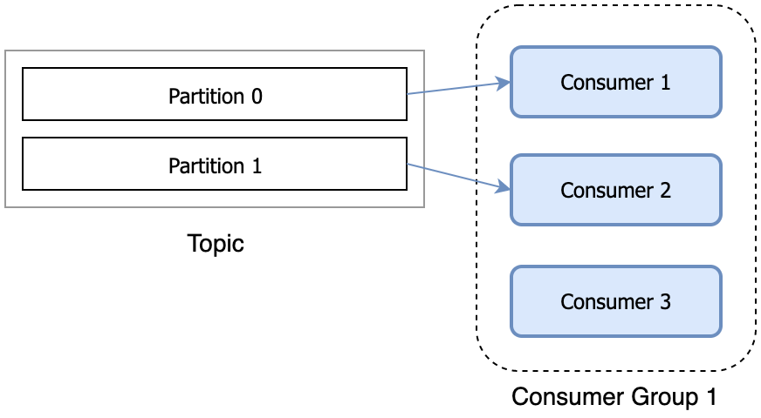Additional consumers in a group sit idly

When we talked about [topics and partitions](https://codingharbour.com/apache-kafka/the-introduction-to-kafka-topics-and-partitions/), I mentioned that a partition is a unit of parallelism from the consumer’s perspective. Now you know the reason – there is a direct link between the number of partitions and number of consumers from a group reading in parallel.

What if I want to consume the same record from multiple consumers?

That is also possible. You can have many consumers reading the same records from the topic, as long as they all have different group ids.

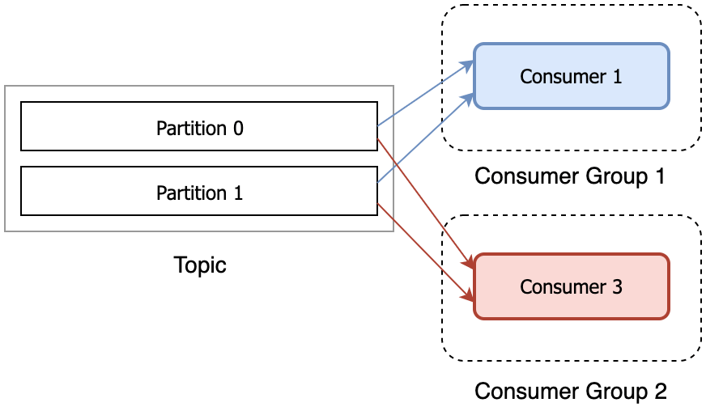Multiple consumers reading the same records from the topic

An example to recap

Let’s illustrate what we’ve been talking about with an example.

Let’s say we’re building an online store and it consists of few microservices that are sending events to each other: payment service, shipping service, and notification service. Once the payment service processes the payment it will send an event PaymentProcessed as a record on Kafka topic. Then we want both the shipping service and notification service to consume this record. The shipping service needs the record in order to start the shipping process, while the notification service wants to receive this record so it could send an email to the customer saying ‘Your payment has been received‘. In this case, we want the PaymentProcessed record to be broadcasted to all the consumers.

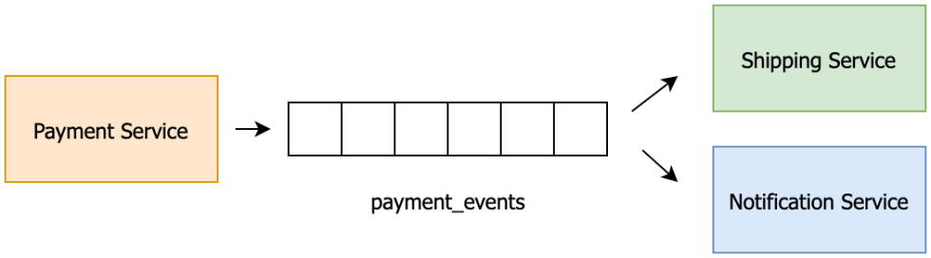Microservices communicating using Kafka

Yet, if we have multiple instances of the consuming services, we always want exactly one of the instances to process each record. For example, we wouldn’t want multiple instances of the notification service to process the PaymentProcessed record and send multiple ‘Your payment has been received’ emails to the customer. Nor would we want multiple instances of shipping service to receive the same PaymentProcessed record and start the shipment process multiple times, potentially losing us money.

To ensure the record reaches both the shipping and the notification service but only once, we would put all the payment service instances in one consumer group and put all the notification service instances in another consumer group.

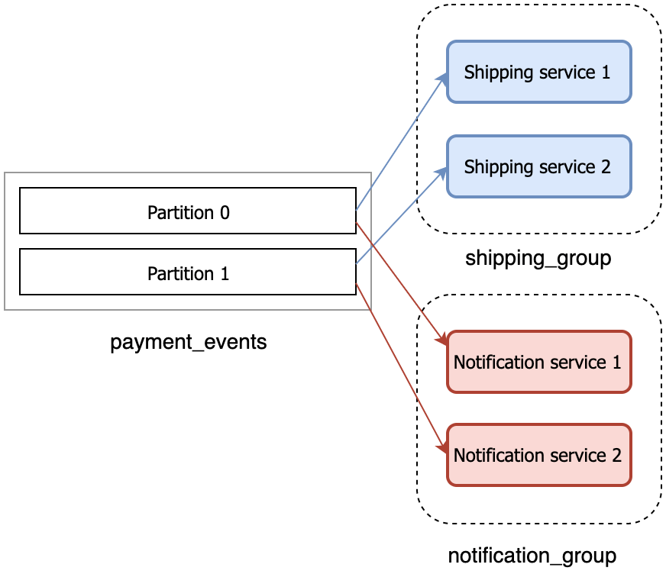Each Kafka record will reach one shipping and one notification service

This ensures that all the records are always read by both shipping_group and notification_group, but within those groups, one record will always go to only one instance. That’s what consumer groups enable us to do.

Code a Producer, Topic and Consumer

Properties:

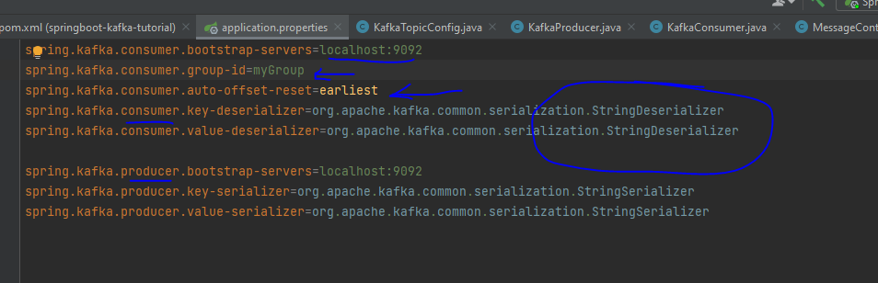

Create Kafka topic:

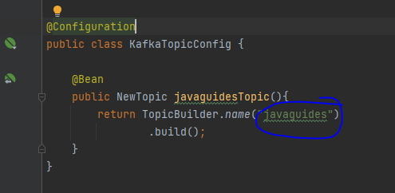

Create Producer to send events by using KafkaTemplate

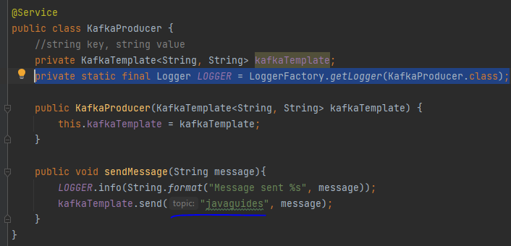

Configure a consumer which listen into the topic for new events

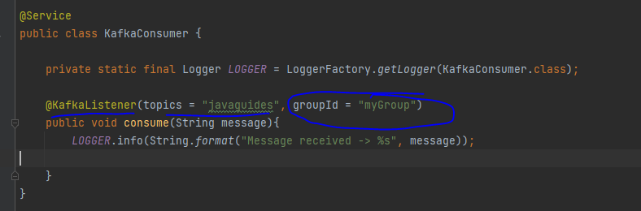

Json Serializer and Deserializer

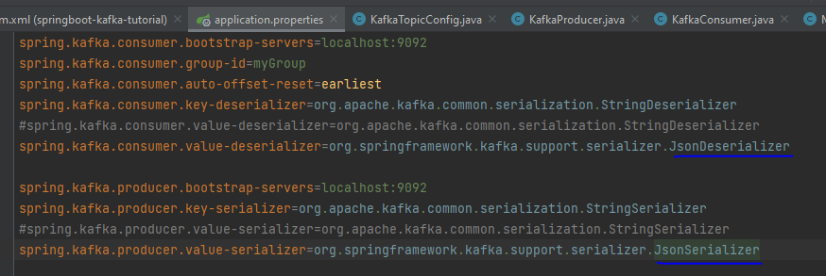

Trust conversion of any type



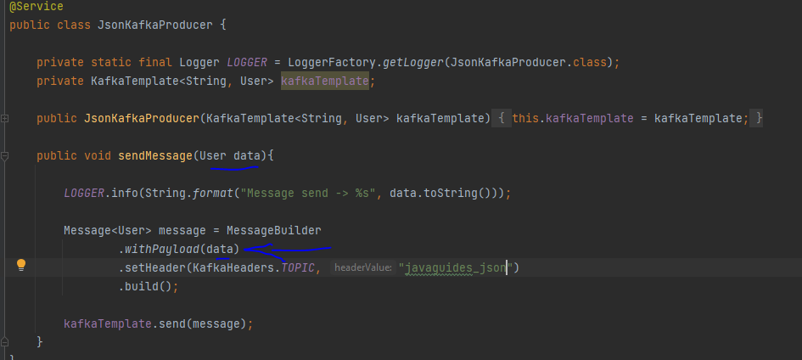

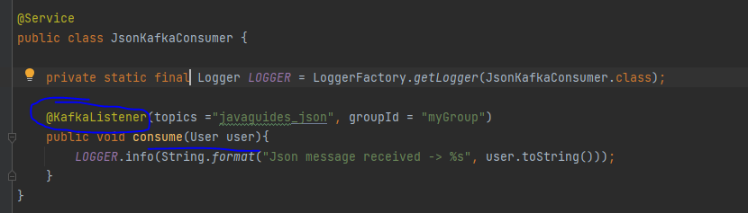

Another consumer ex

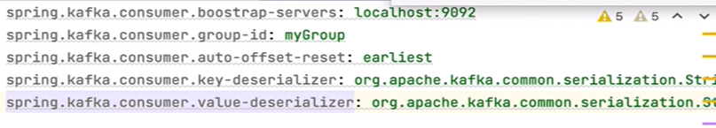

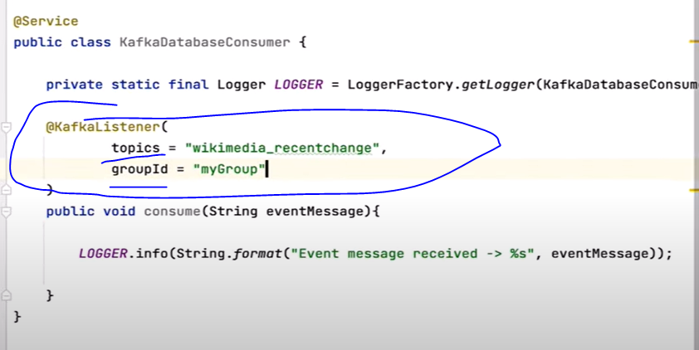

Cache

Most enterprise and web applications use some method of caching. If an application receives a large number of requests, it is often beneficial to store some of the responses in a cache. Then, under certain conditions, the same response can be sent to answer similar requests. Rather than redoing all the processing and computations, returning the previously cached response can save lots of CPU resources.

here are the main classes defined by JSR 107:

CacheProvider,

CacheProvider in Java is an interface or abstract class that provides a mechanism for creating and managing caches. It acts as a factory for Cache instances

Ex: EhCache, Redis, JCS (java caching system)

CacheManager

Manages the lifecycle of caches, including creation, configuration, and destruction.

Provides a way to access and control multiple caches within an application.

Often acquired through a CachingProvider

Cache

A temporary storage area holding frequently accessed data to reduce the need to retrieve it from slower primary storage.

Improves application performance by providing faster data access.

Typically stores data as key-value pairs, similar to a java.util.Map but with added features like eviction policies.

Entry

A Java cache entry represents a single element stored within a cache.

Caching in spring boot

Needs to enable cache by using @EnableCaching annotation in a @Configuration or @SpringBootApplication class

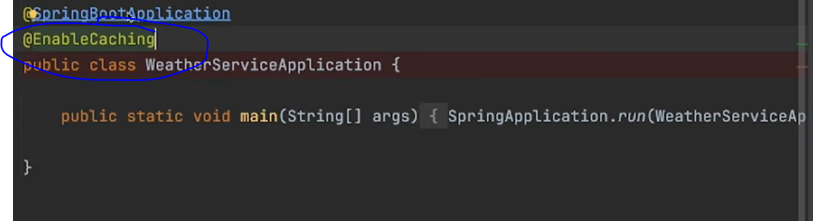

Using @Cacheable, allows to cache the output of our method for same input

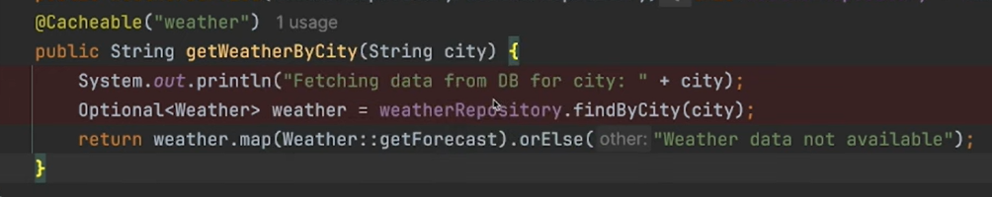

First time it will access the method getWeatherByCity, second time if it has the same city as input, it wont access getWeatherByCity at all, cache will automatically send back the cache result

CacheManager spring class

Allows you to take a look to contents on the cache

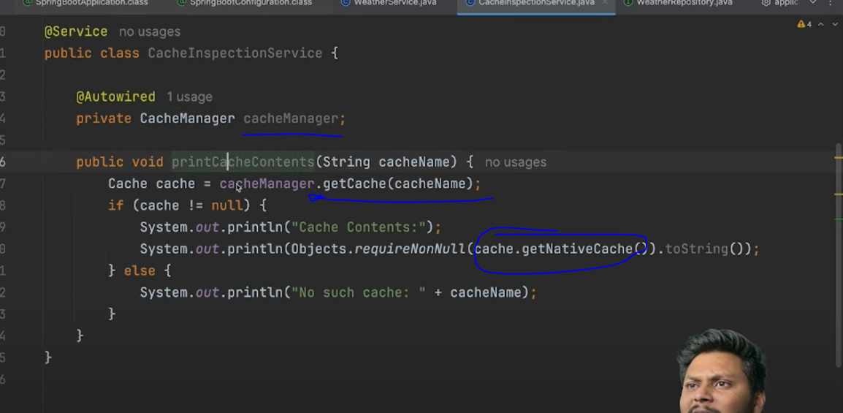

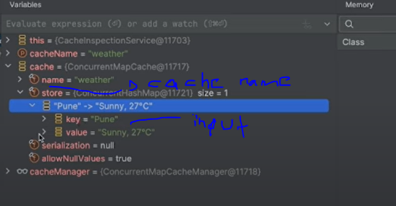

Cache internals concurrent hashmap

Types of caching

In Memory, store in heap memory

In scalation each node will have its own cache, not shared by other nodes which each need to make the same call to cache it losing performance and creating inconsistencies

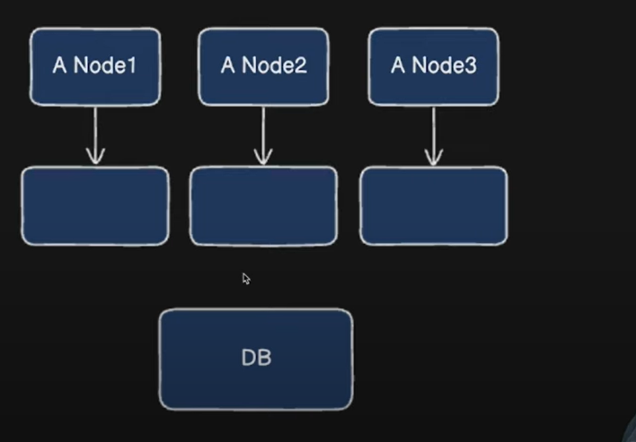

Distributed, example Redis, a single cache outside the application, shared by all nodes

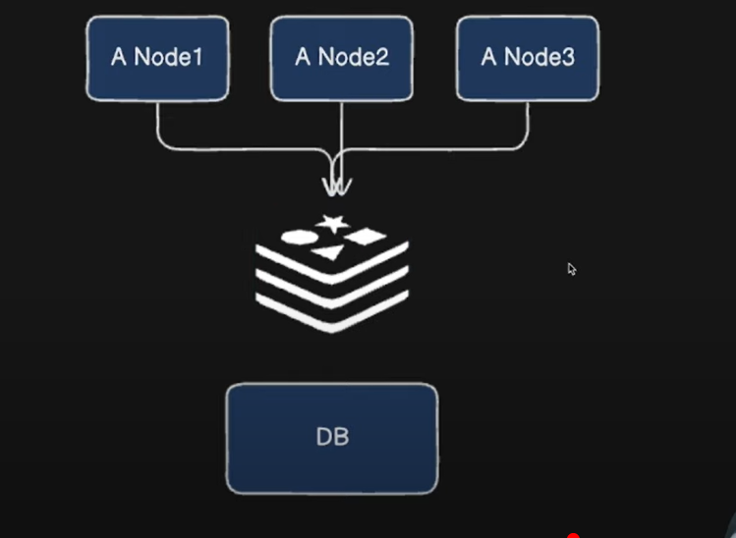

@CachePut

Allows to update cache on updates, ex: you get a weather returned as 22°, then you update weather to 15°, but when you call the get again you still get 22° which is the value existing in the cache, when there is an update to the db, cache should be updated as well @CachePut helps with this. Key makes sure the map stores the correct keys to update instead of adding a new entry in the cache when the CachePut method executes

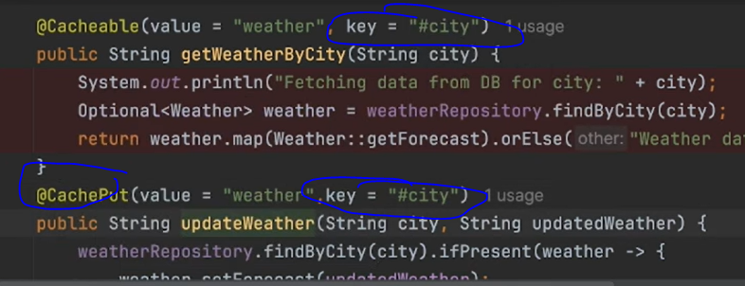

@CacheEvict

Like @CachePut but for deletes to remove from the cache

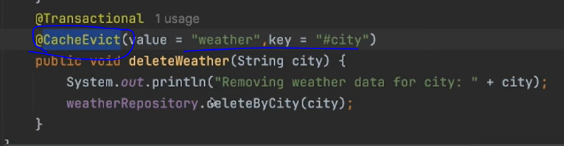

Redis Cache



Redis can store data on ram, making it very fast, can be run in a separate server

Run redis through docker



Configure redis into the spring boot app

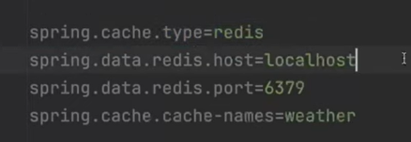

Add dependency

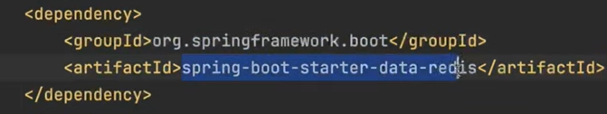

Take a look to redis cache

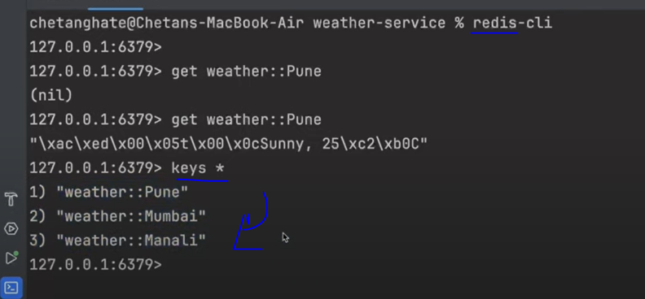

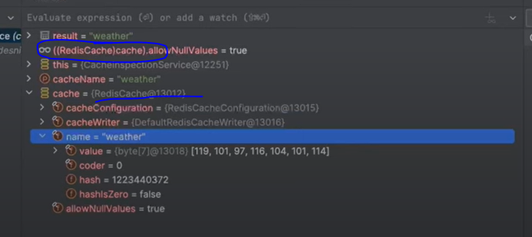

Microservices Scaling

Vertical Scaling:

Increase the resources (CPU, RAM, storage) of the existing server. Suitable for smaller applications but has limitations.

Horizontal Scaling:

Add more instances of the application across multiple servers. Ideal for handling high traffic and is more scalable.

Kubernetes:

A powerful platform for orchestrating containerized applications, offering features like automatic scaling, load balancing, and service discovery.

Kubernetes' Horizontal Pod Autoscaler (HPA) can automatically adjust the number of pods (containers) based on defined metrics like CPU utilization.

Docker Swarm:

A simpler alternative to Kubernetes for container orchestration, especially for smaller deployments.

3. Key Strategies for Horizontal Scaling

Load Balancing:

Distribute traffic across multiple instances of a service. This prevents any single instance from being overwhelmed.

Implementation Approaches

Client-Side Load Balancing:

Uses tools like Spring Cloud LoadBalancer or Ribbon where the client is aware of all available service instances and makes the selection. Spring Cloud LoadBalancer is the modern approach and includes implementations like Round-Robin and Random.

Server-Side Load Balancing:

Involves a dedicated load balancer (e.g., Nginx, HAProxy) that sits between clients and microservices, routing requests.

Service Discovery:

Often paired with service discovery tools like Eureka. These tools allow microservices to register themselves and discover other services dynamically, without hardcoding locations.

Service Discovery:

Use tools like Eureka to enable microservices to find and communicate with each other dynamically, without hardcoded URLs.

Service Registry

A central database or registry that keeps track of information about available services in the system.

Each microservice, when it starts or shuts down, registers or deregisters itself with the service registry.

Service Provider

The microservice that offers a specific functionality or resource is considered a service provider.

Service providers register themselves with the service registry so that other services can discover and connect to them.

Service Consumer

The microservice that needs to use the functionality provided by another service is considered a service consumer.

Service consumers query the service registry to discover the location and details of the service providers they want to interact with.

API Gateway:

Use an API Gateway to manage requests to different microservices, providing a single entry point and enabling load balancing.

Database per Service:

Each microservice should have its own database to prevent resource conflicts.

Asynchronous Communication:

Use message queues (e.g., RabbitMQ, Kafka) for communication between services to decouple them and improve fault tolerance.

Caching:

Implement caching mechanisms (e.g., Redis, Hazelcast) to reduce database load. Use a shared cache for all instances to ensure data consistency.

4. Auto-scaling

Dynamic Scaling:

Automatically adjust the number of service instances based on current demand.

Reactive and Predictive Scaling:

Combine reactive scaling (responding to real-time metrics) with predictive scaling (adjusting based on known traffic patterns).

Spring Cloud

Spring Cloud provides tools for developers to quickly build some of the common patterns in distributed systems (e.g. configuration management, service discovery, circuit breakers, intelligent routing, micro-proxy, control bus, short lived microservices and contract testing).

Features

Spring Cloud focuses on providing good out of box experience for typical use cases and extensibility mechanism to cover others.

Distributed/versioned configuration

Service registration and discovery

Service Registry

Routing

Gateway

Service-to-service calls

Load balancing

Circuit Breakers

Distributed messaging

Spring Cloud bus

It provides a distributed systems communication method that can broadcast events across all connected services as needed.

In a microservice architecture, updating each service individually can be tedious and error-prone. Spring Cloud Bus provides a mechanism to refresh configurations across all services at once.

Spring Cloud Bus offers a way to manage and propagate state changes across all services, reducing the complexity of handling service-to-service communications

Short lived microservices (tasks)

Spring Cloud Task is a framework that facilitates the creation of short-lived microservices

The goal of Spring Cloud Task is to provide the functionality of creating short-lived microservices for Spring Boot application.

In Spring Cloud Task, we’ve got the flexibility of running any task dynamically, allocating resources on demand and retrieving the results after the Task completion.

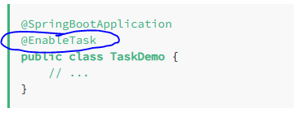

By default, an in-memory map is used to store the status of the TaskRepository.

Ideal for batch processing, ETL (Extract, Transform, Load), data migration, or other tasks that run once and then terminate.

ANGULAR

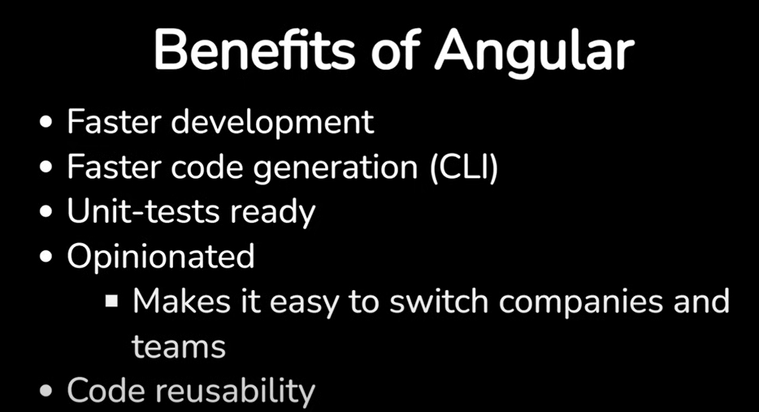

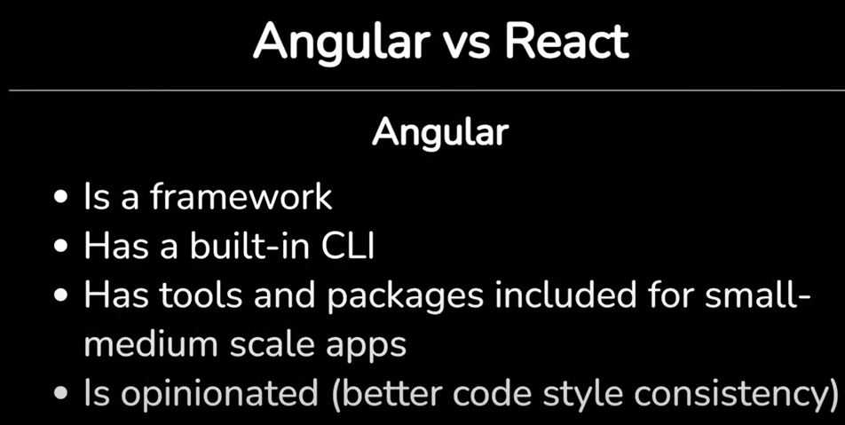

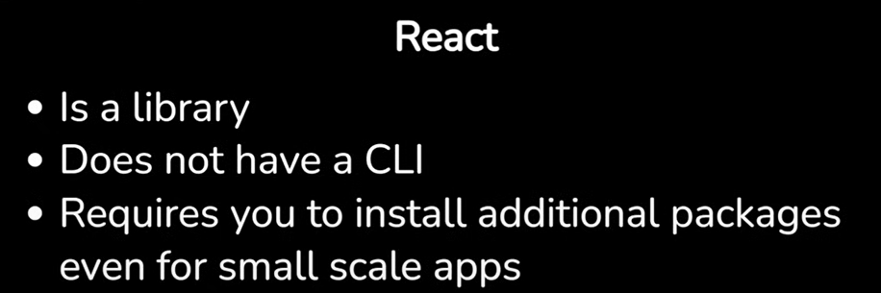

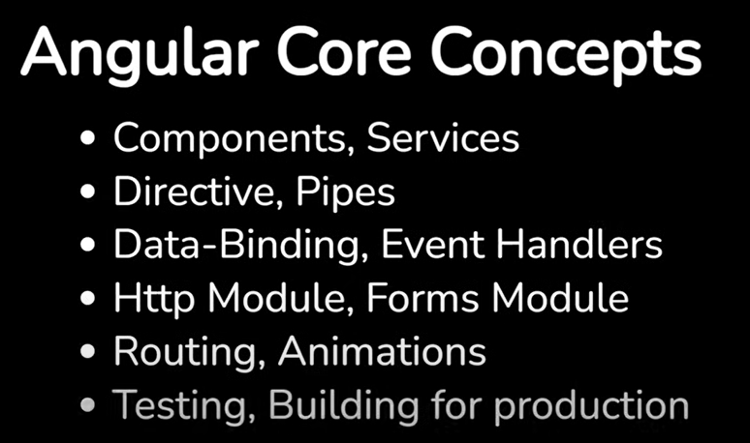

Main file

Package.json

Npm start

Run server on port 4200

To build the project

Npm build

To execute the unit test

Npm test

Index.hmlt

<app-root>

Top level component

Main.ts

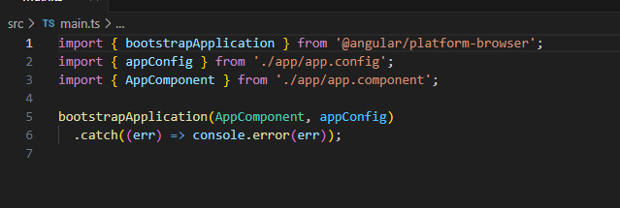

Declare Array of objects

Array: any[] = [{id: 0, name: 'Sarah'}]

@for

@for(user of users; track user.id){

<p>{{user.name}}</p>

}

Bind property:

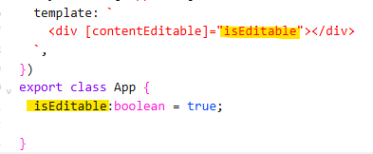

Event handler

In Angular you bind to events with the parentheses syntax

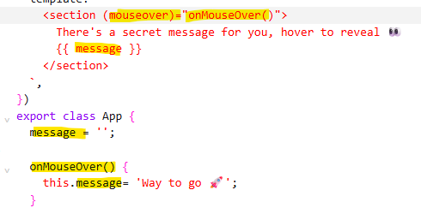

Output

When working with components it may be required to notify other components that something has happened. Perhaps a button has been clicked, an item has been added/removed from a list or some other important update has occurred. In this scenario components need to communicate with parent components.

Angular uses the output() function to enable this type of behavior.

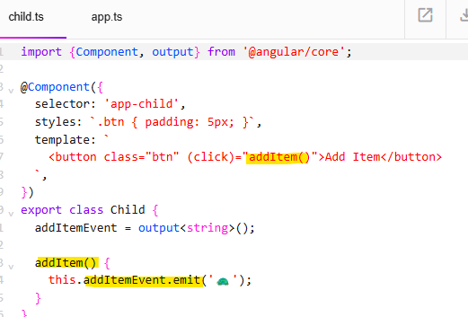

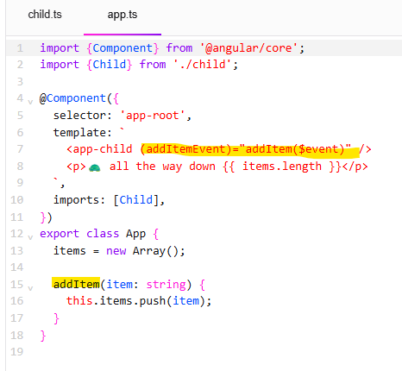

Deferrable Views

Sometimes in app development, you end up with a lot of components that you need to reference in your app, but some of those don't need to be loaded right away for various reasons.

Maybe they are below the visible fold or are heavy components that aren't interacted with until later. In that case, we can load some of those resources later with deferrable views.

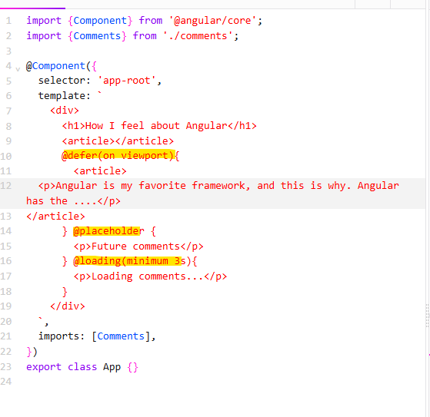

Binding

In Angular, a binding creates a dynamic connection between a component's template and its data.

You can bind dynamic text in templates with double curly braces, which tells Angular that it is responsible for the expression inside and ensuring it is updated correctly. This is called text interpolation.

All expression values are converted to a string. Objects and arrays are converted using the value’s toString method.

Angular supports binding dynamic values into object properties and HTML attributes with square brackets.

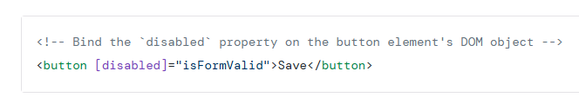

In this example, every time isFormValid changes, Angular automatically sets the disabled property of the HTMLButtonElement instance.

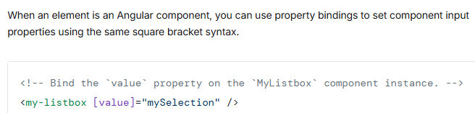

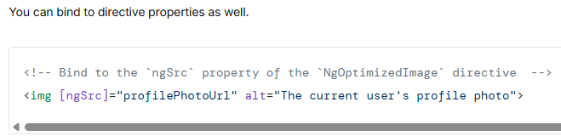

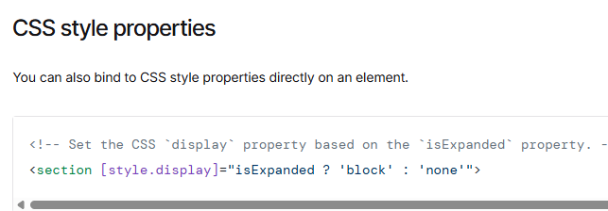

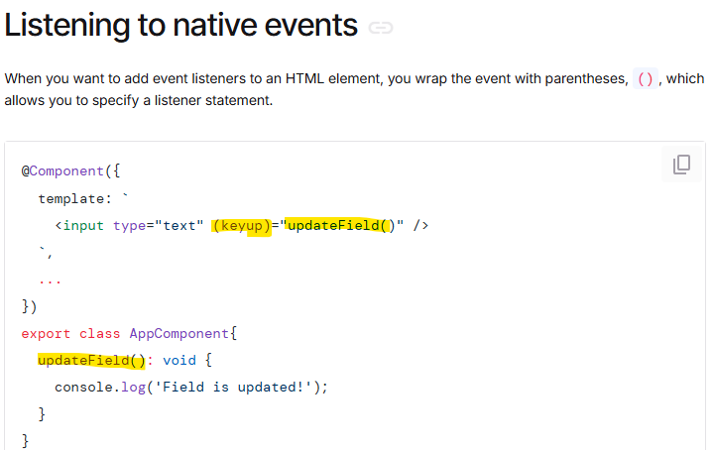

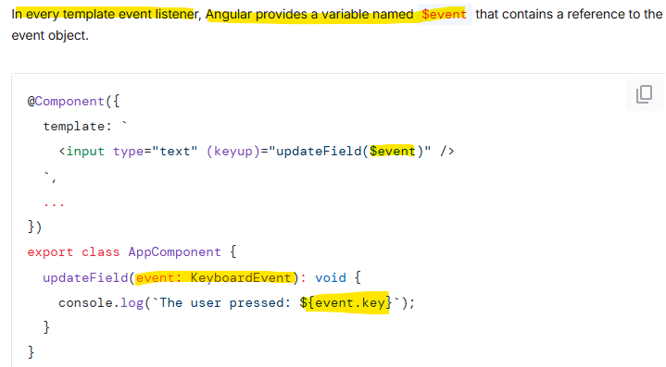

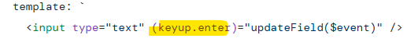

Two Way Binding

wo way binding is a shorthand to simultaneously bind a value into an element, while also giving that element the ability to propagate changes back through this binding

The syntax for two-way binding is a combination of square brackets and parentheses, [()]. It combines the syntax from property binding, [], and the syntax from event binding,

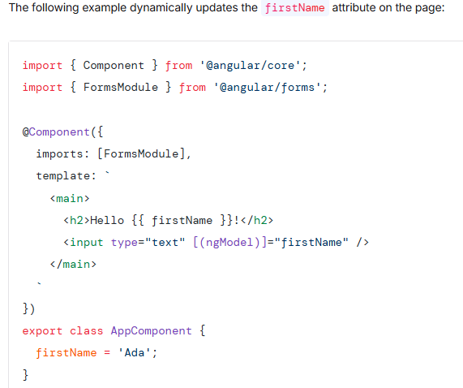

Two-way binding between components

Leveraging two-way binding between a parent and child component requires more configuration compared to form elements.

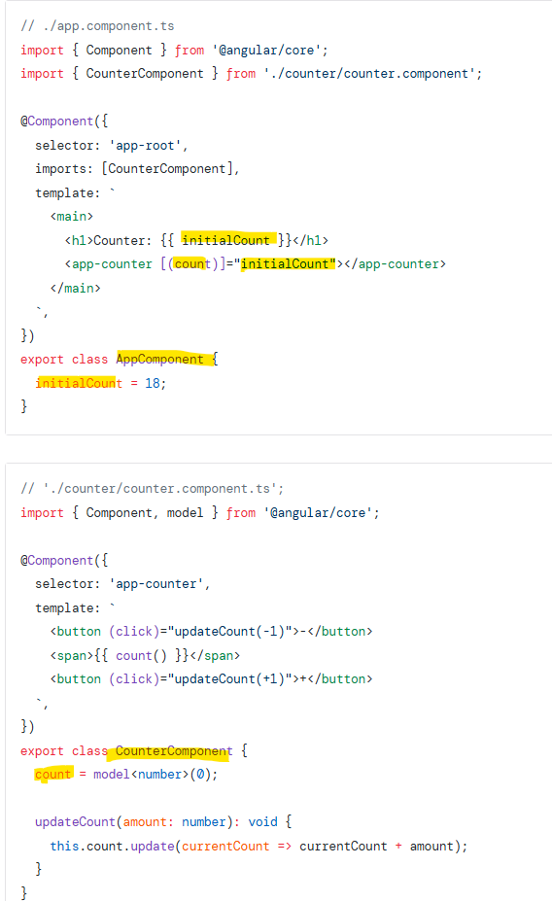

Control flow

Angular templates support control flow blocks that let you conditionally show, hide, and repeat elements. Conditionally display content with @if, @else-if and @else

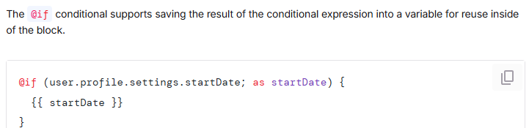

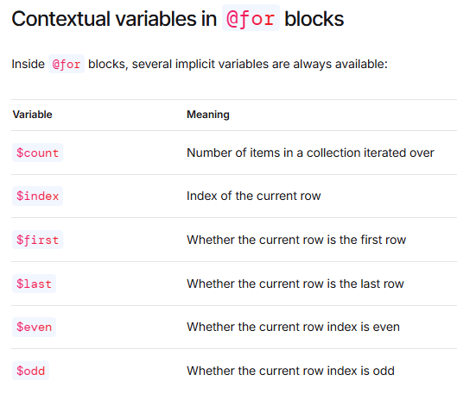

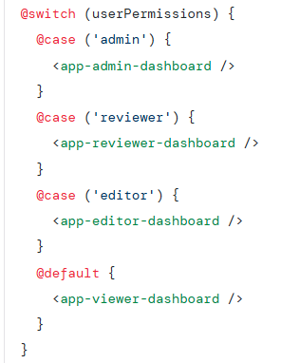

Pipes

Pipes are a special operator in Angular template expressions that allows you to transform data declaratively in your template. Pipes let you declare a transformation function once and then use that transformation across multiple templates. Angular pipes use the vertical bar character (|)

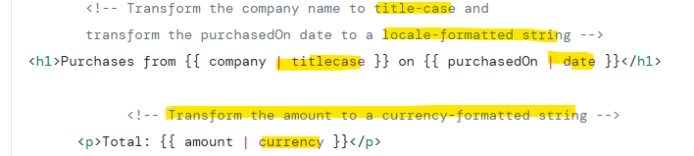

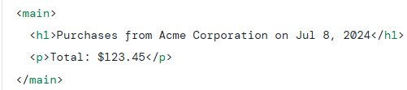

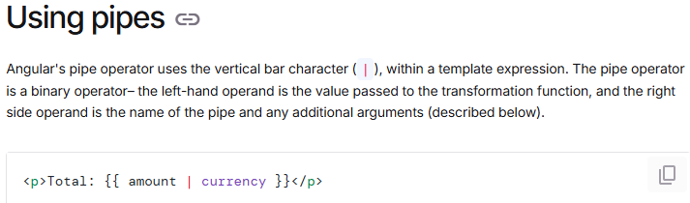

In this example, the value of amount is passed into the CurrencyPipe where the pipe name is currency. It then renders the default currency for the user’s locale.

Combining multiple pipes



Passing parameters to pipes

Some pipes accept parameters to configure the transformation. To specify a parameter, append the pipe name with a colon (:) followed by the parameter value.



Conceptually, pipes are functions that accept an input value and return a transformed value

Custom pipes

You can define a custom pipe with the @Pipe decorator, it must have a name and a method transform that performs the value transformation

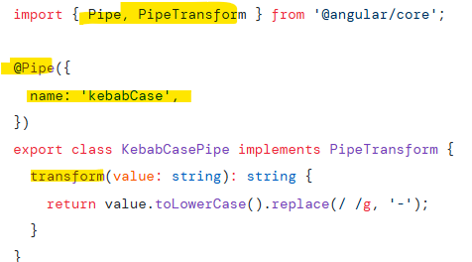

Custom pipe with parameters:

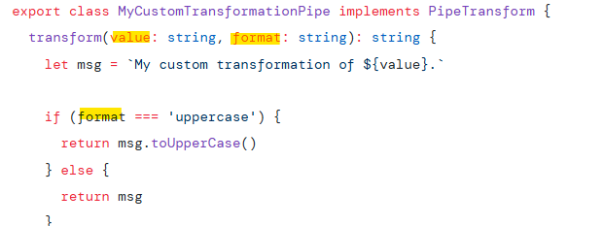

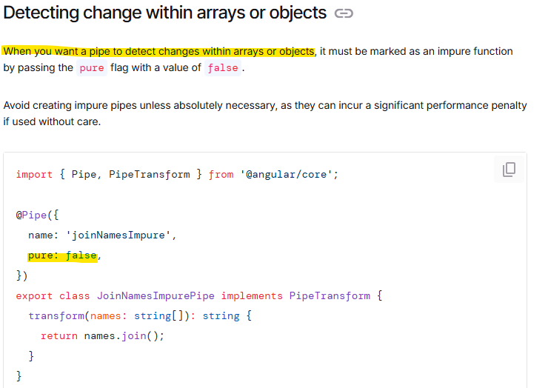

@let

declare a variable whose value is based on the result of a template expression.

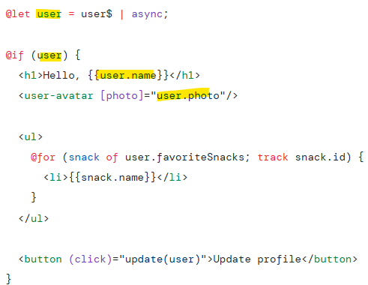

@let declarations are scoped to the current view and its descendants.

Since @let declarations are not hoisted, they cannot be accessed by parent views or sibling

@defer

Deferrable views, also known as @defer blocks, reduce the initial bundle size of your application by deferring the loading of code that is not strictly necessary for the initial rendering of a page.

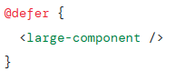

Bi directional ngModel

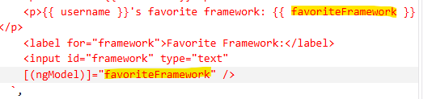

Validators

validate the inputs to ensure the correct data is submitted.

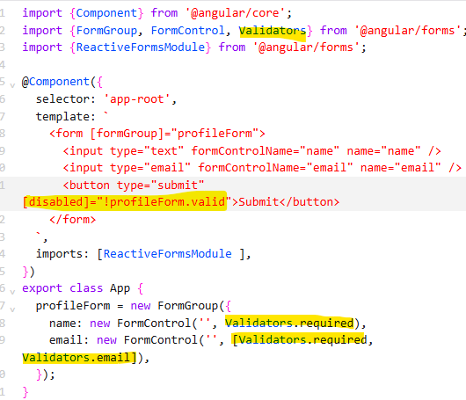

Service inject



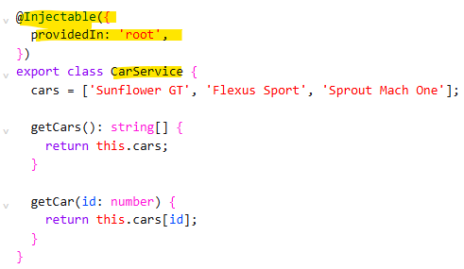

Example of grid with array of a component into another component

Housing location component, array of it in home component:

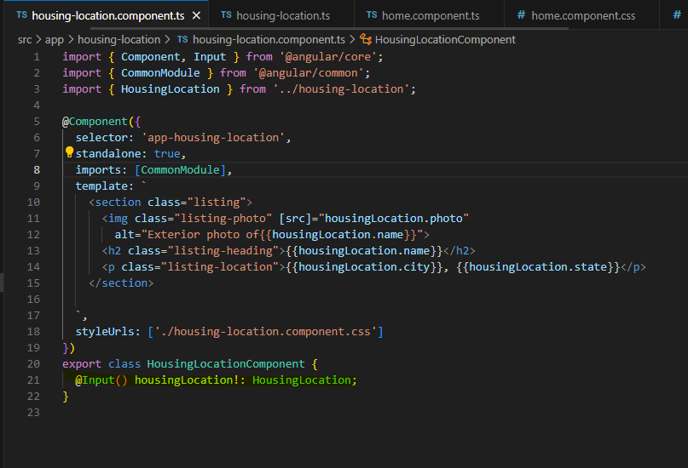

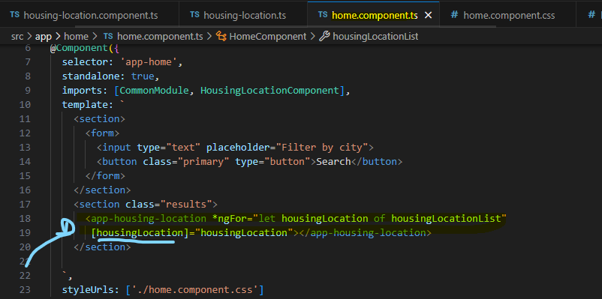

Question mark on properties

Ex: {{housingLocation?.id}}

In case housingLocation is undefined, we don’t have to worry about errors, only will print it If available

Double question mark

Ex: this.applyForm.value.firstName ?? ‘’

If the value firstName is undefined, then empty string will be used

Form, FormControl, FormGroup example:

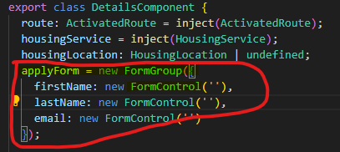

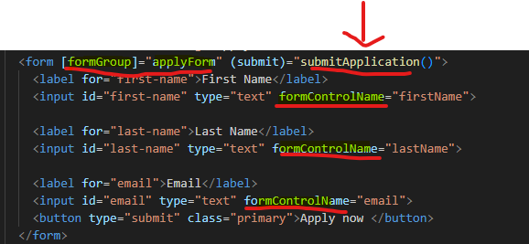

Fetch call example:

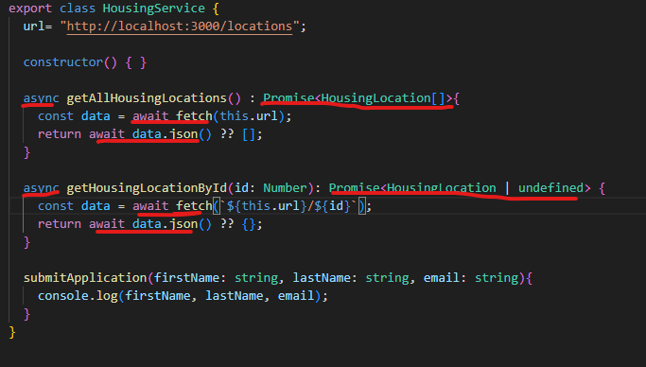





Filter Example:

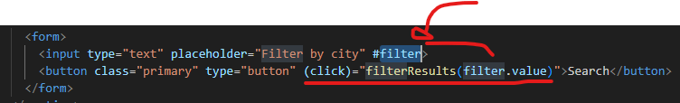

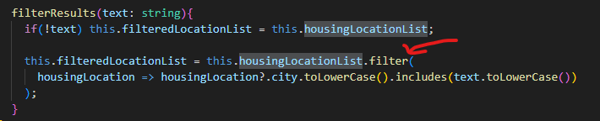

Dependency injection

When a dependency is requested, the injector checks its registry to see if there is an instance already available there. If not, a new instance is created and stored in the registry.

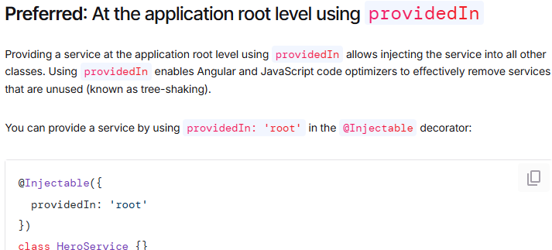

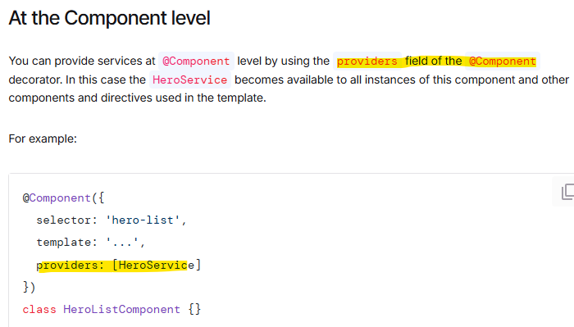

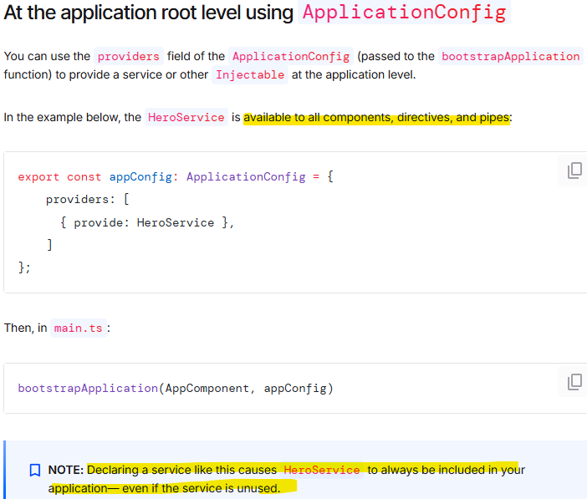

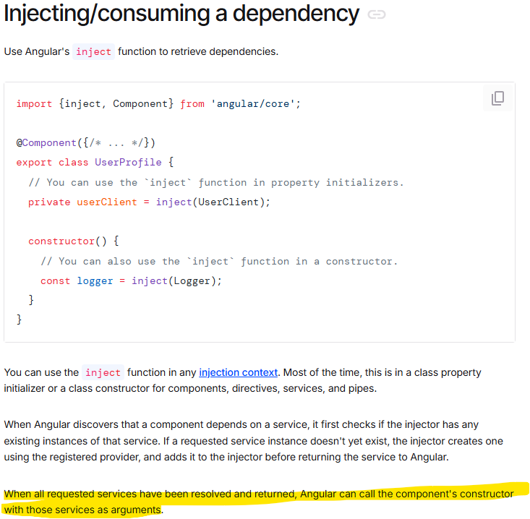

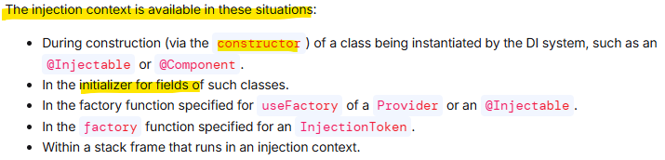

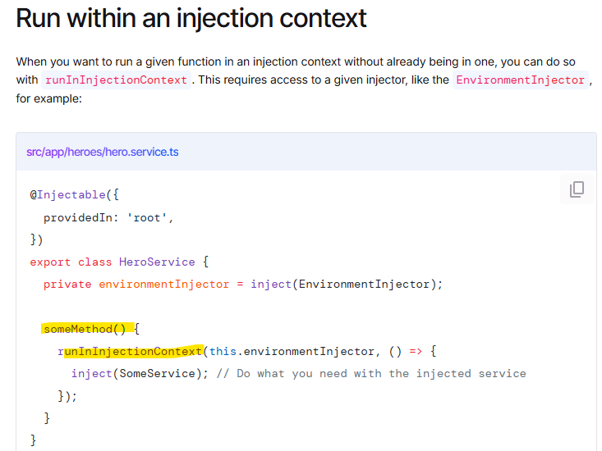

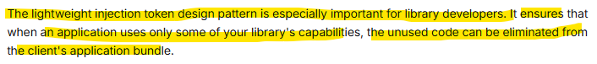

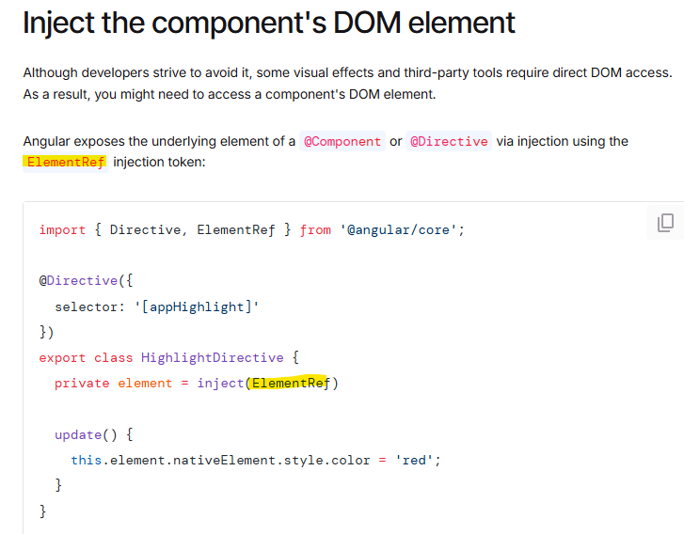

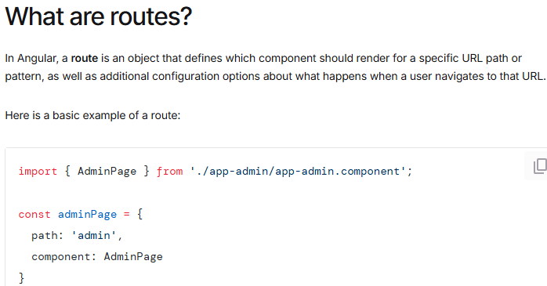

For this route, when a user visits the /admin path, the app will display the AdminPage component.

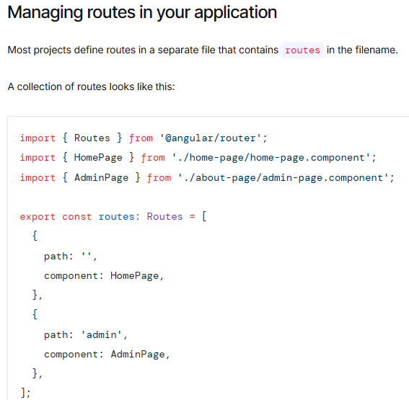

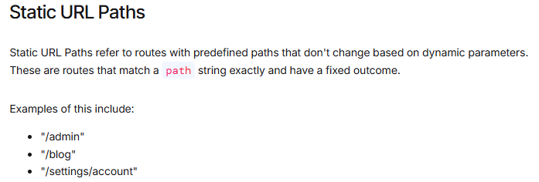

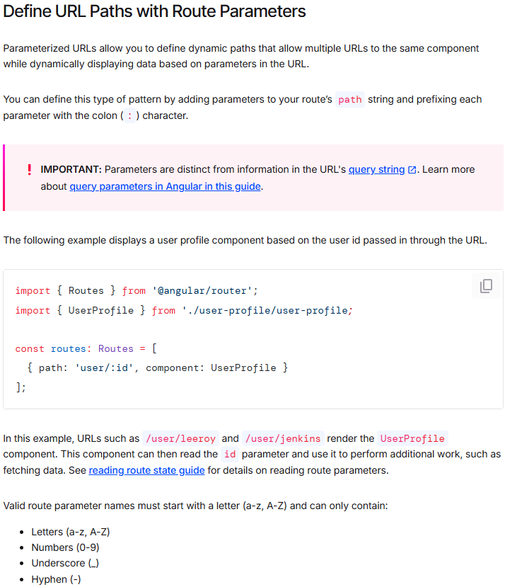

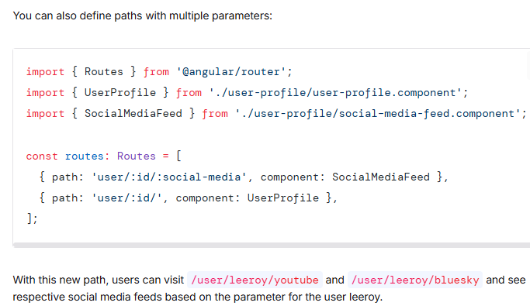

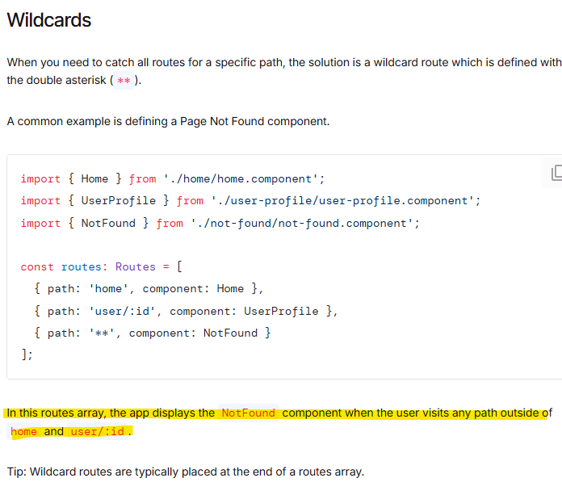

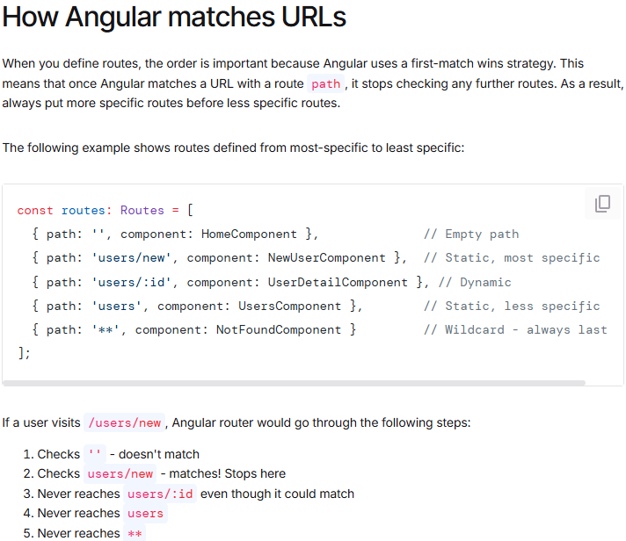

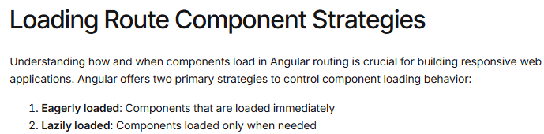

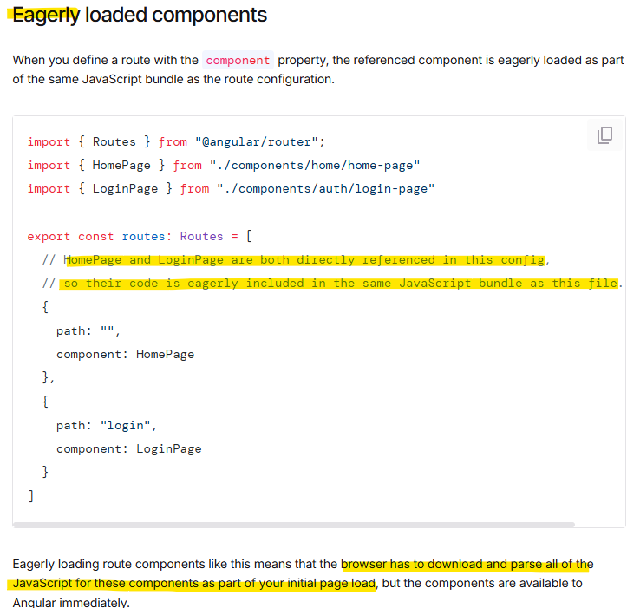

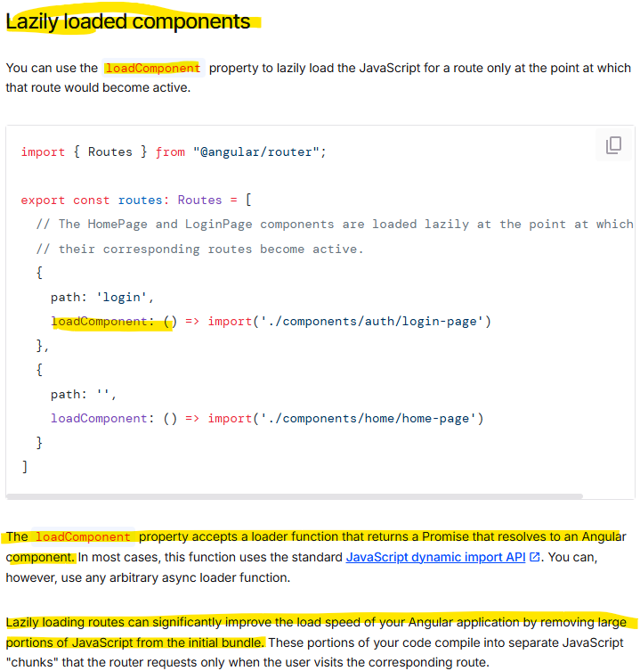

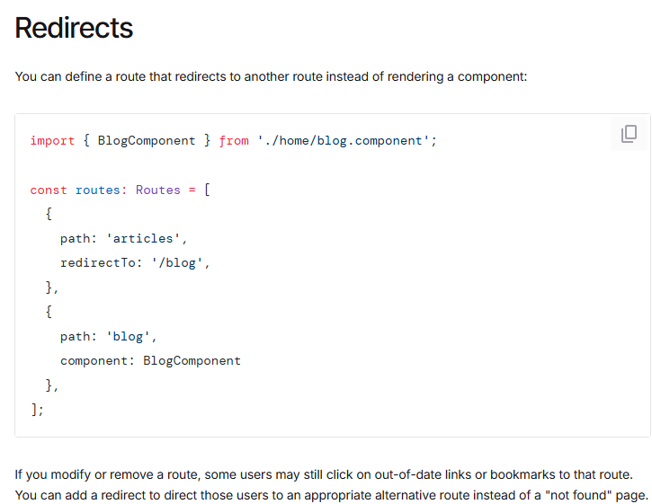

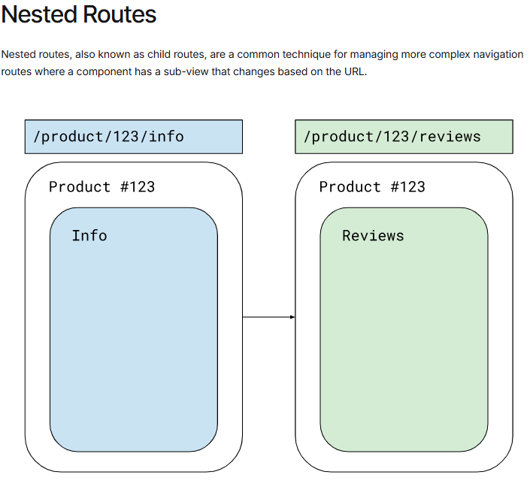

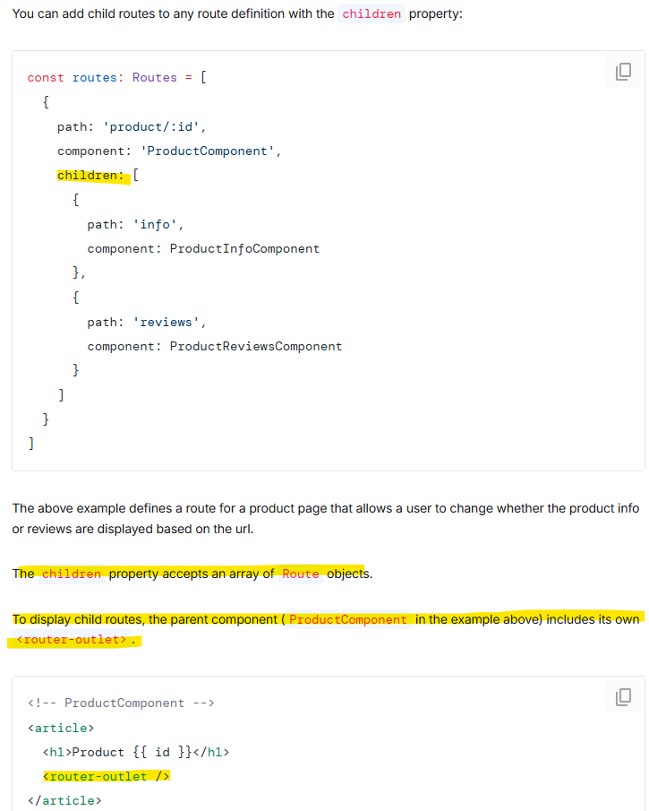

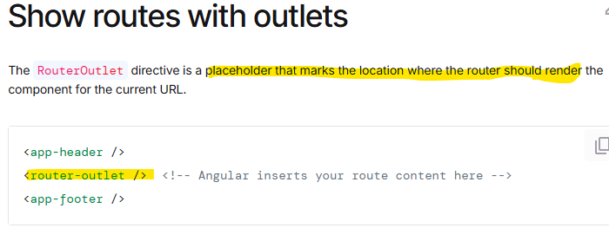

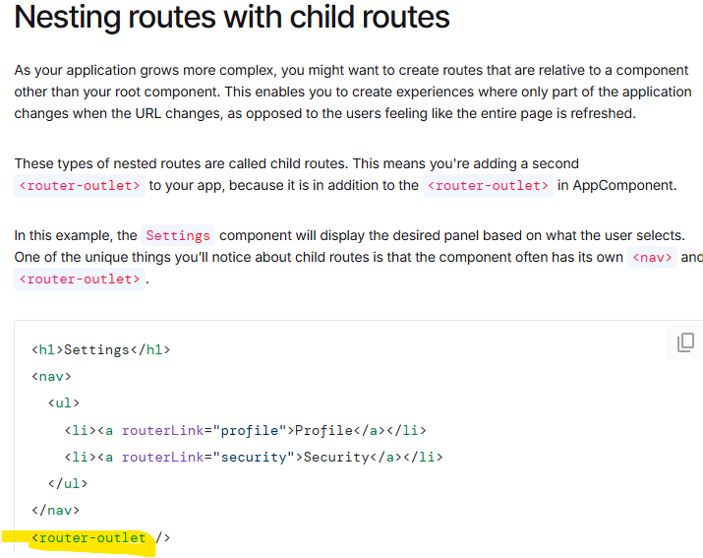

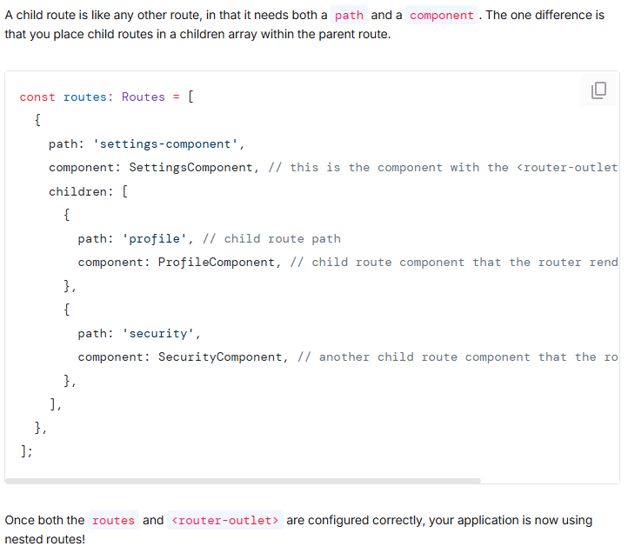

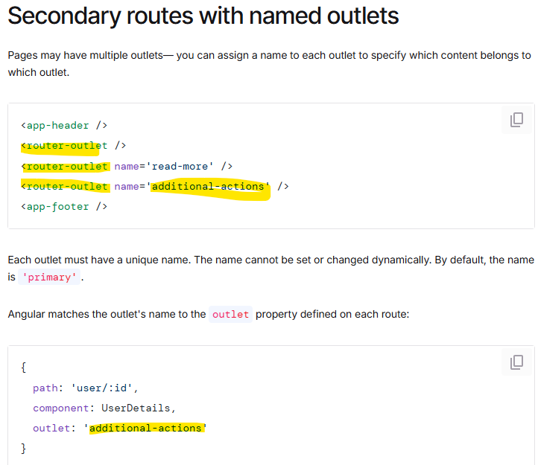

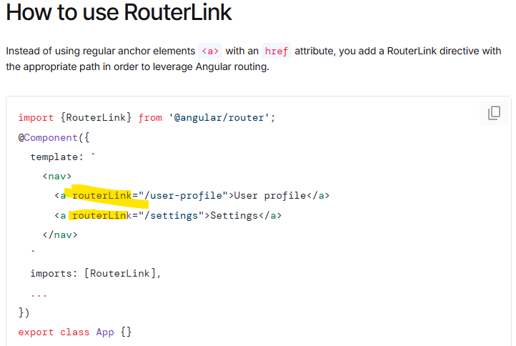

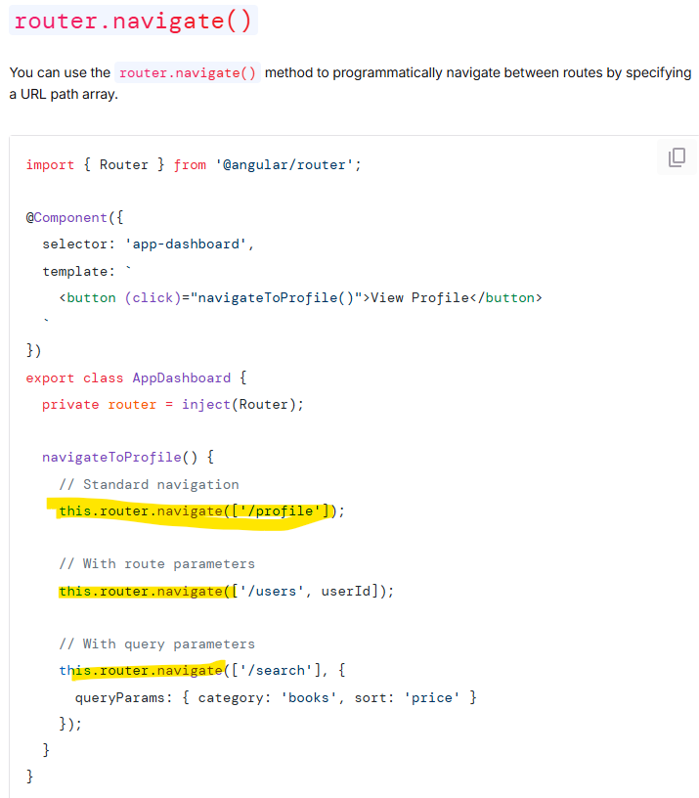

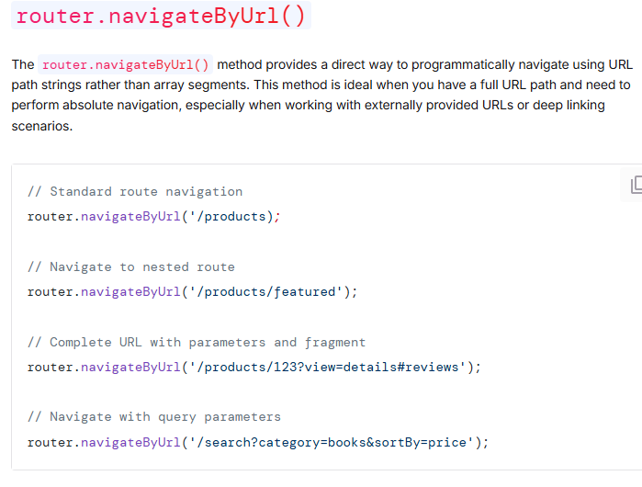

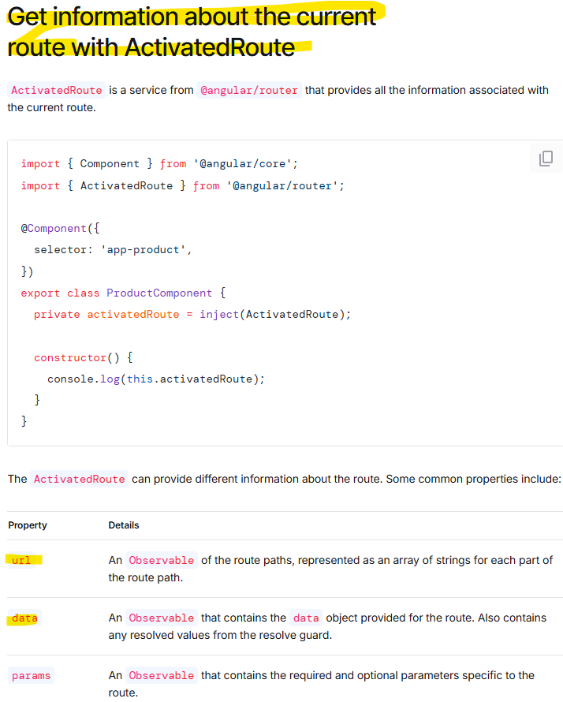

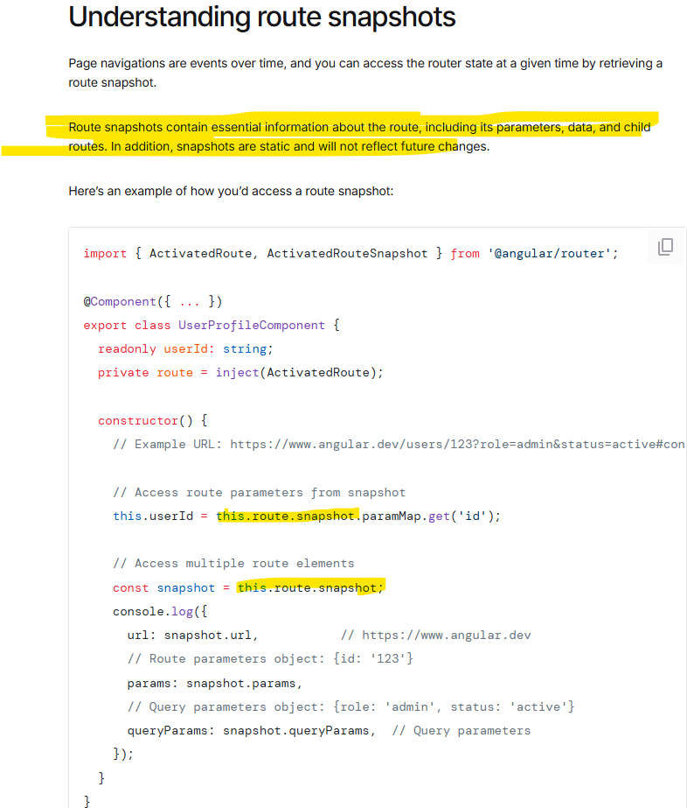

Data flow in reactive forms

In reactive forms each form element in the view is directly linked to the form model (a FormControl instance). Updates from the view to the model and from the model to the view are synchronous and do not depend on how the UI is rendered.

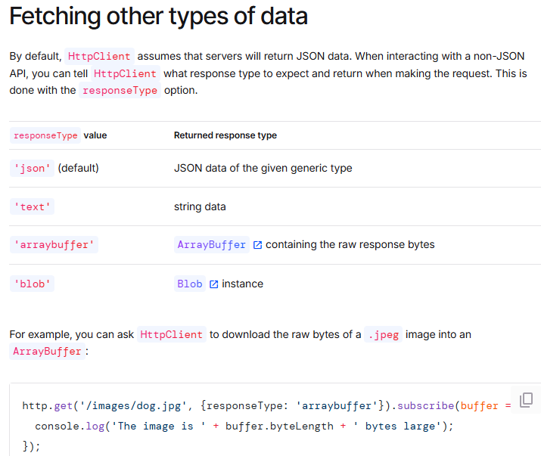

Angular Components

App component, created when starting singular

They encapsulate a portion of the user interface, combining a template, styles, and behavior. Each component represents a reusable piece of UI functionality and can be composed with other components to create complex applications.

Each component has a ts file and that has a class, whith tells it is a component

Ts file, has the selector, which will be used in index.html to tell where in the page that component goes

And the template which is what will be rendered, can be configured here

Styles allows to add css styles

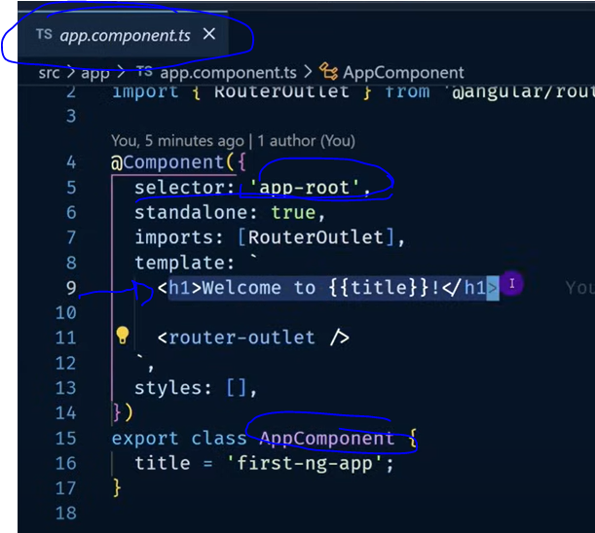

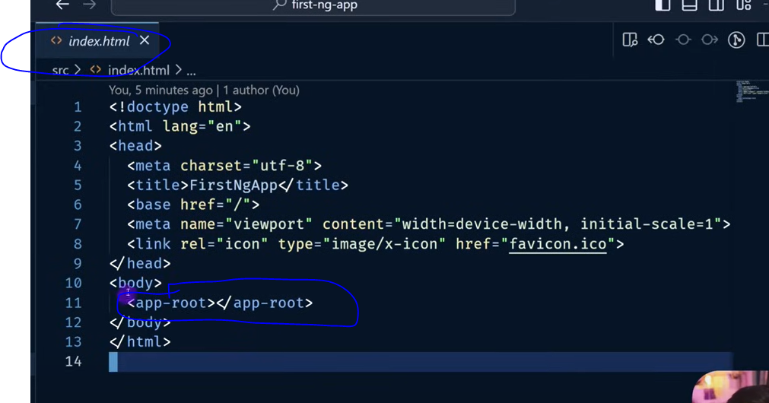

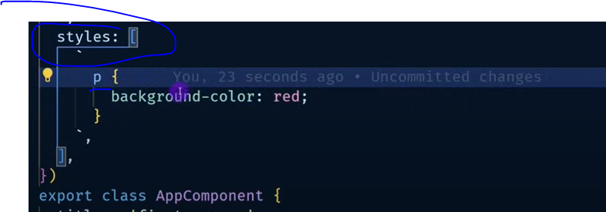

Styles in component file are appended an identifier to make sure styles only apply to that component

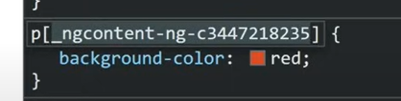

Generate a component

Ng generate component component_Name OR

Ng g c component_Name

To generate it on a folder

Ng g c folderName/componentName -> src/app/folderName/componentName

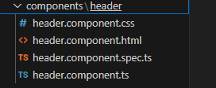

Import components into the root appComponent:

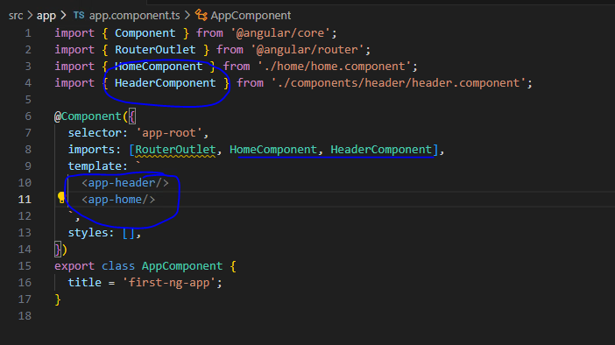

Angular Data-Binding

Comunication between component’s ts and html files

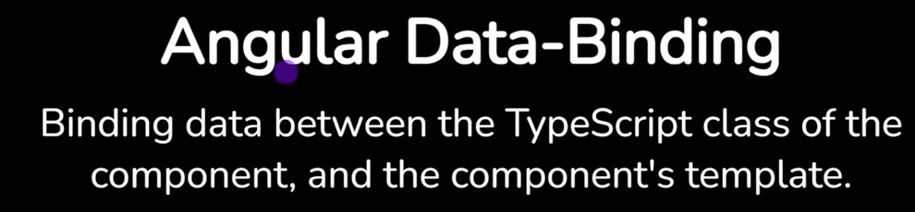

Data Binding With signals

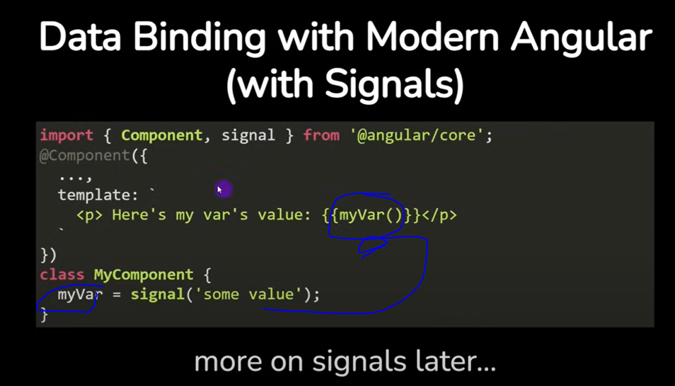

Data Binding traditional way (signals will be used generally forward)

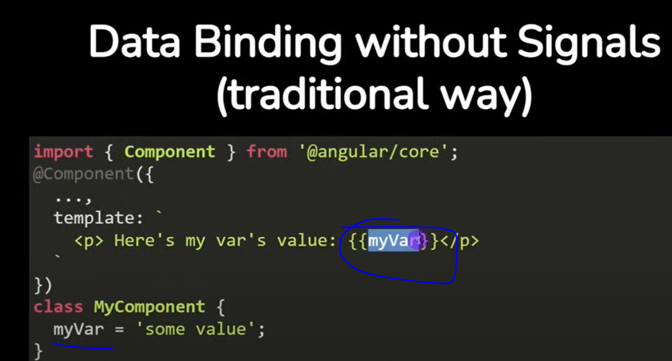

Component with child components (passing the data)

Import the child component into the parent one and use the selector of the child inside the html of the parent

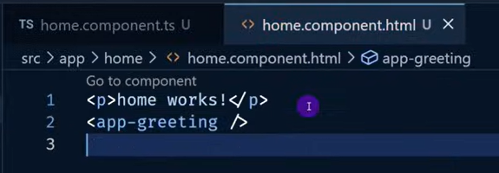

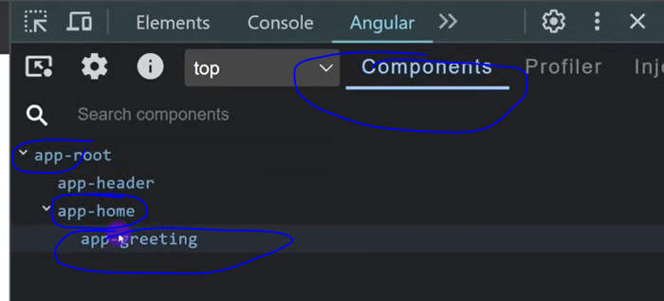

From parent component pass value to child component

Child component can receive something from the outside:

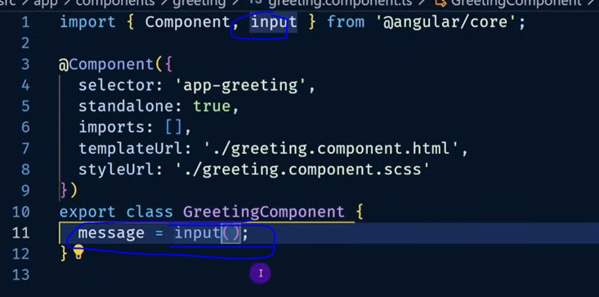

Send the value to the child:

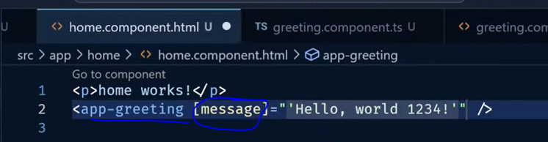

Event Listeners

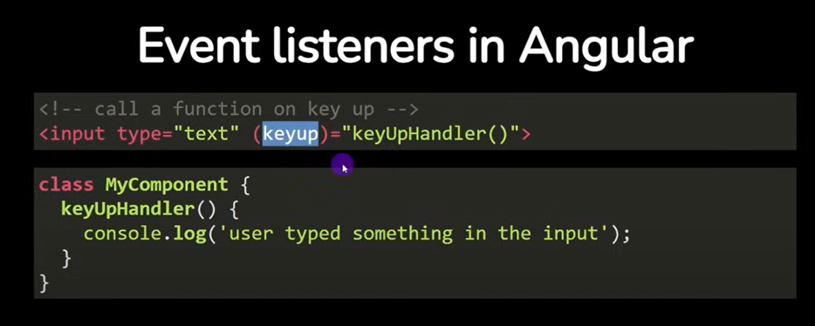

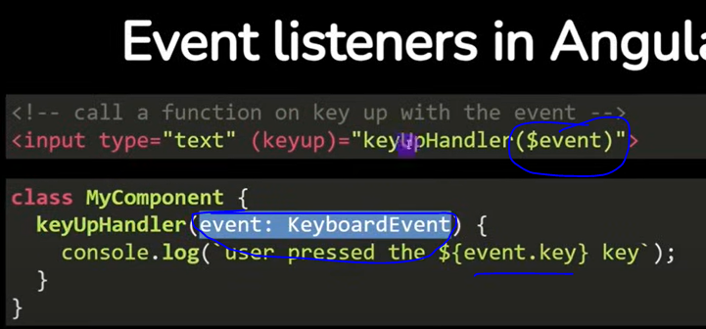

Update counter example:

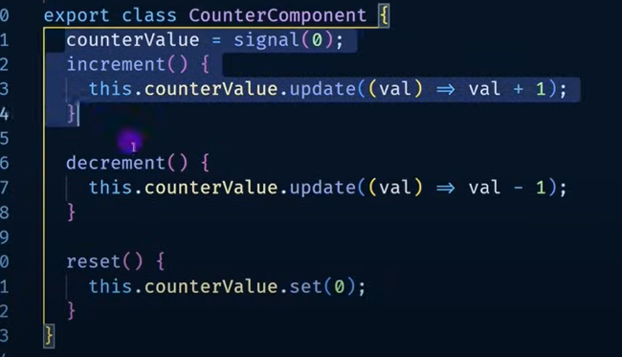



Angular Routing

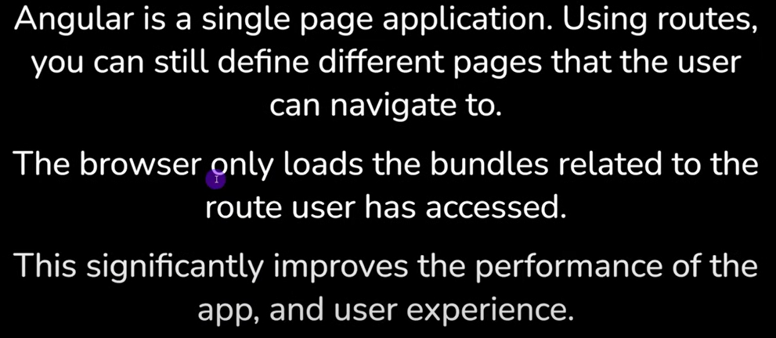

If path empty (localhost:4200) then load home component

If path todos (localhost:4200/todos) then load todos component

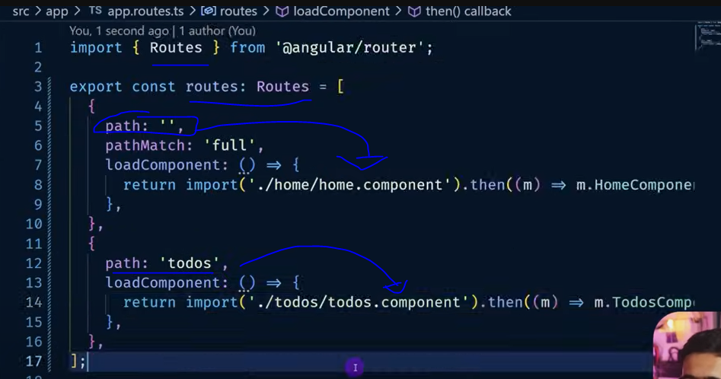

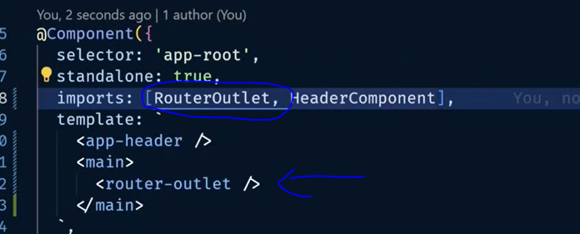

RouterLink

Link to use a route

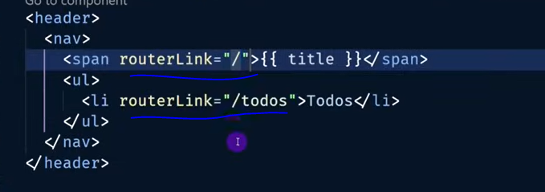

Angular Services

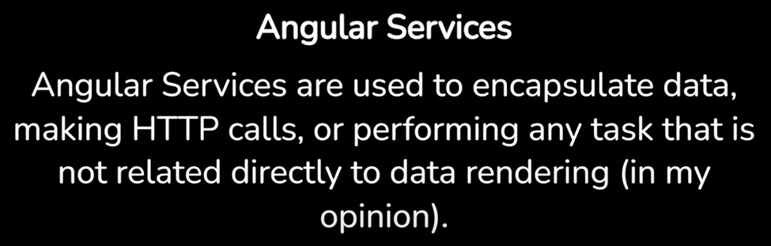

Angular Services

Sharing logic:

Services centralize code that can be used by multiple components, avoiding duplication.

Data management:

They can handle data fetching, manipulation, and storage, keeping components focused on presentation.

Encapsulation:

Services hide implementation details, allowing components to interact with them through well-defined interfaces.

Business logic:

They can contain complex business rules and calculations.

Communication:

Services can facilitate communication between components that aren't directly related.

Key Features:

Dependency Injection:

Angular uses dependency injection to provide services to components and other services.

Injectable Decorator:

Services are marked with the @Injectable() decorator, making them available for injection.



Angular Service Injected in only 1 component:

Add providers property in @Component where it is needed

Remove providedIn: ‘root’ from the @Injectable of the service

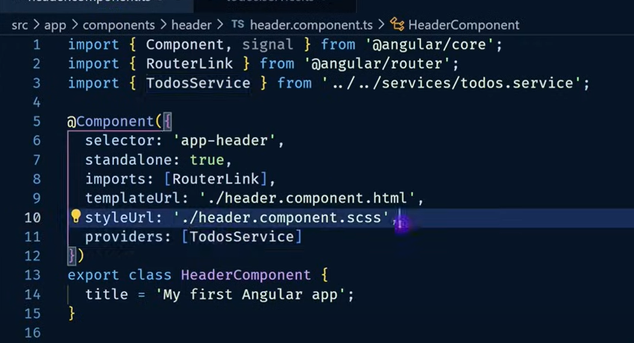

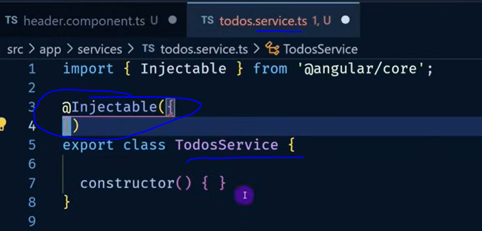

Injectable available for any component:

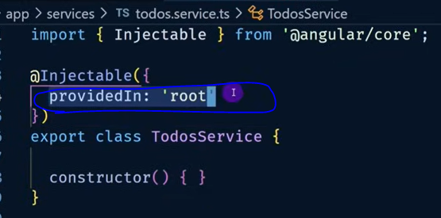

Angular Type (similar to a POJO)

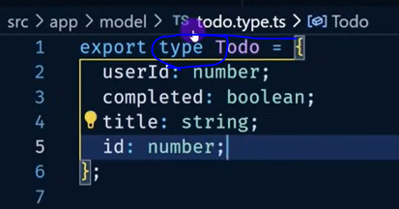

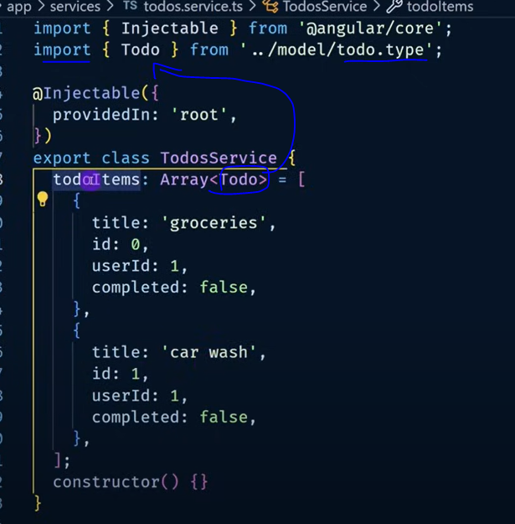

Inject Service in a component:

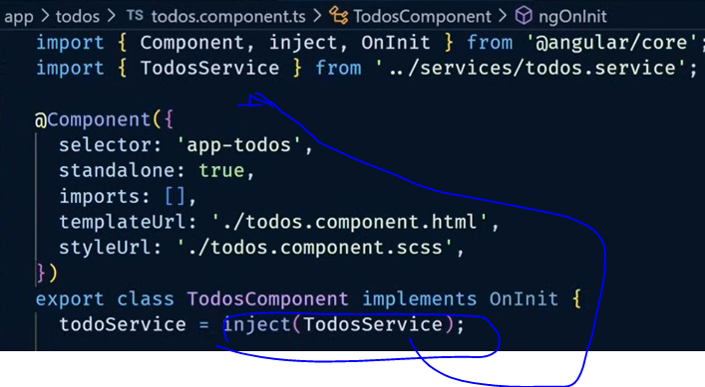

ngOnInit, runs when the component goes into view

ngOnInit(): void{

console.log(“component loaded”);

}

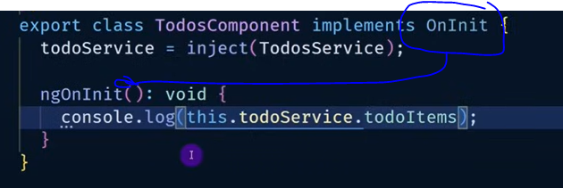

Render list of type in html

Initializing a signal of array of TODO type with empty

In ngonInit fil the TODO array with what is in the service

Print the signal in the html

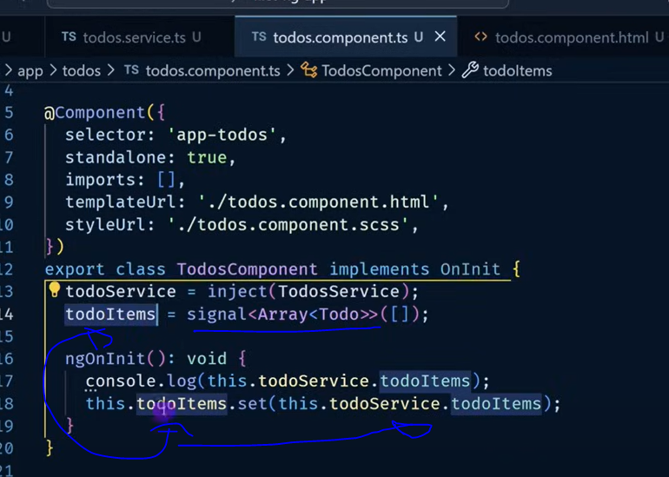

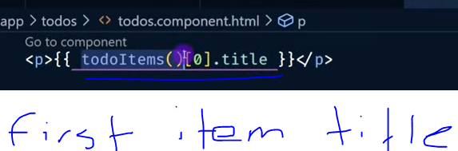

Angular for

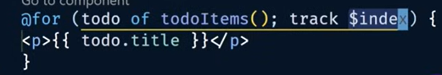

Http calls with angular

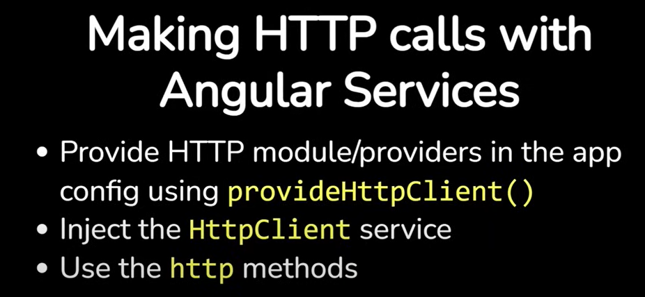

Config app to make http calls

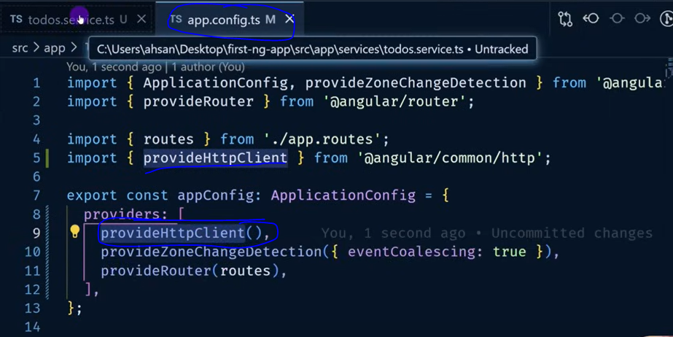

Inject httpclient into the component

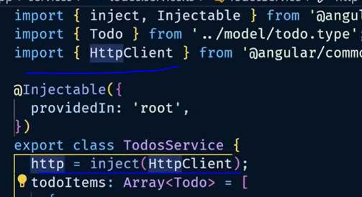

Create call from client

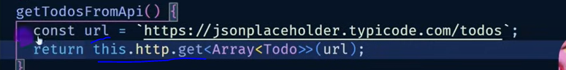

Run call from http client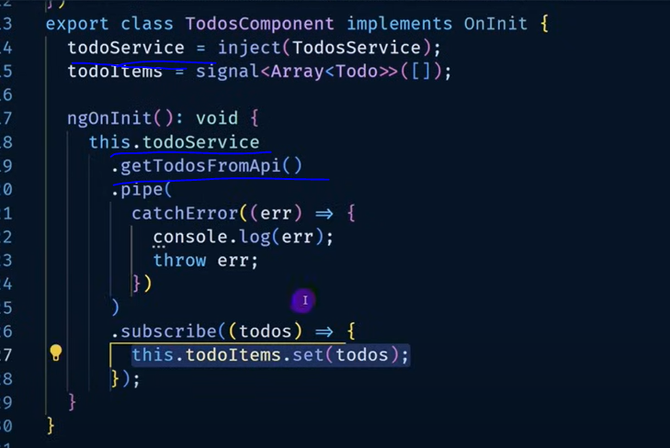

Angular Directives

Allows to add additional behavior to elements (components, services, html)

Directives in Angular are classes that modify the behavior or appearance of elements in the DOM (Document Object Model). They extend HTML's capabilities by adding custom behavior to elements. Angular provides built-in directives and the ability to create custom ones.

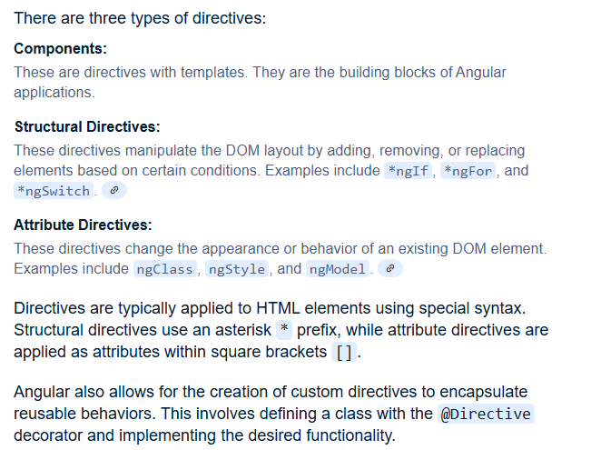

Create custom directive



Ngif example (before):

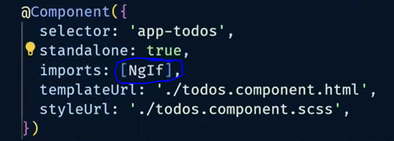



Way to do now (@if control flow block)

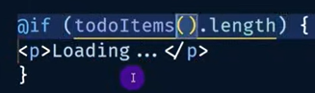

Example directive changing style in elements with status completed

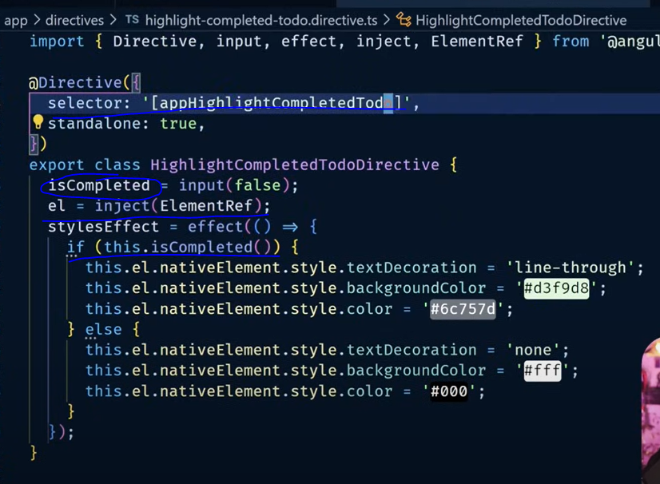

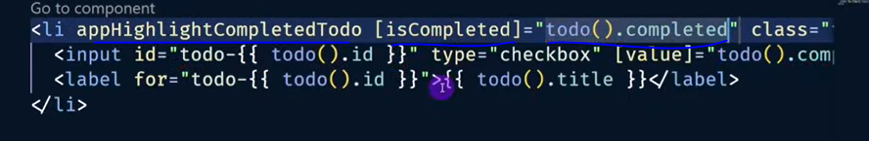

Send value from a component into a child component

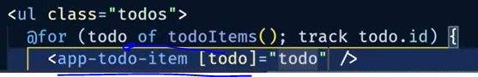

Angular Pipes

Angular pipes are a feature that allows you to transform data directly within your templates. They are used to format data for display, without altering the underlying data itself. Pipes are denoted by the pipe symbol | in template expressions.

Key Concepts:

Transformation: Pipes take an input value and return a transformed output.

Template Usage: They are used within Angular templates to modify how data is displayed.

Built-in Pipes: Angular provides a set of built-in pipes for common transformations, such as:

DatePipe: Formats dates.

UpperCasePipe: Converts text to uppercase.

LowerCasePipe: Converts text to lowercase.

CurrencyPipe: Formats numbers as currency.

DecimalPipe: Formats numbers with a specific number of decimal places.

PercentPipe: Formats numbers as percentages.

SlicePipe: Extracts a section of an array or string.

AsyncPipe: Handles asynchronous data streams from observables or promises.

JsonPipe: Converts data to JSON format.

KeyValuePipe: Transforms an object or Map into an array of key-value pairs.



Custom pipe

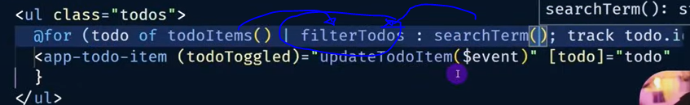

Ng Update

Runs automated code transformations, routine breaking changes keeping up with the lates version

Typescript

TypeScript offers all of JavaScript’s features, and an additional layer on top of these: TypeScript’s type system. This means that your existing working JavaScript code is also TypeScript code.

You can use interfaces to annotate parameters and return values to functions:

function deleteUser(user: User) {

// ...

}

There is already a small set of primitive types available in JavaScript: boolean, bigint, null, number, string, symbol, and undefined, which you can use in an interface. TypeScript extends this list with a few more, such as any (allow anything), unknown (ensure someone using this type declares what the type is), never (it’s not possible that this type could happen), and void (a function which returns undefined or has no return value).

Unions

With a union, you can declare that a type could be one of many types

type WindowStates = "open" | "closed" | "minimized";

type LockStates = "locked" | "unlocked";

type PositiveOddNumbersUnderTen = 1 | 3 | 5 | 7 | 9;

Unions provide a way to handle different types too

function getLength(obj: string | string[]) {

return obj.length;

}

Typeof

To learn the type of a variable, use typeof:

function wrapInArray(obj: string | string[]) {

if (typeof obj === "string") {

return [obj];

(parameter) obj: string

}

return obj;

}

Generics

Generics provide variables to types. A common example is an array. An array without generics could contain anything. An array with generics can describe the values that the array contains.

type StringArray = Array<string>;

type NumberArray = Array<number>;

type ObjectWithNameArray = Array<{ name: string }>;

interface Backpack<Type> {

add: (obj: Type) => void;

get: () => Type;

}

// This line is a shortcut to tell TypeScript there is a

// constant called `backpack`, and to not worry about where it came from.

declare const backpack: Backpack<string>;

// object is a string, because we declared it above as the variable part of Backpack.

const object = backpack.get();

// Since the backpack variable is a string, you can't pass a number to the add function.

backpack.add(23);

Argument of type 'number' is not assignable to parameter of type 'string'.

type checking focuses on the shape that values have. This is sometimes called “duck typing”

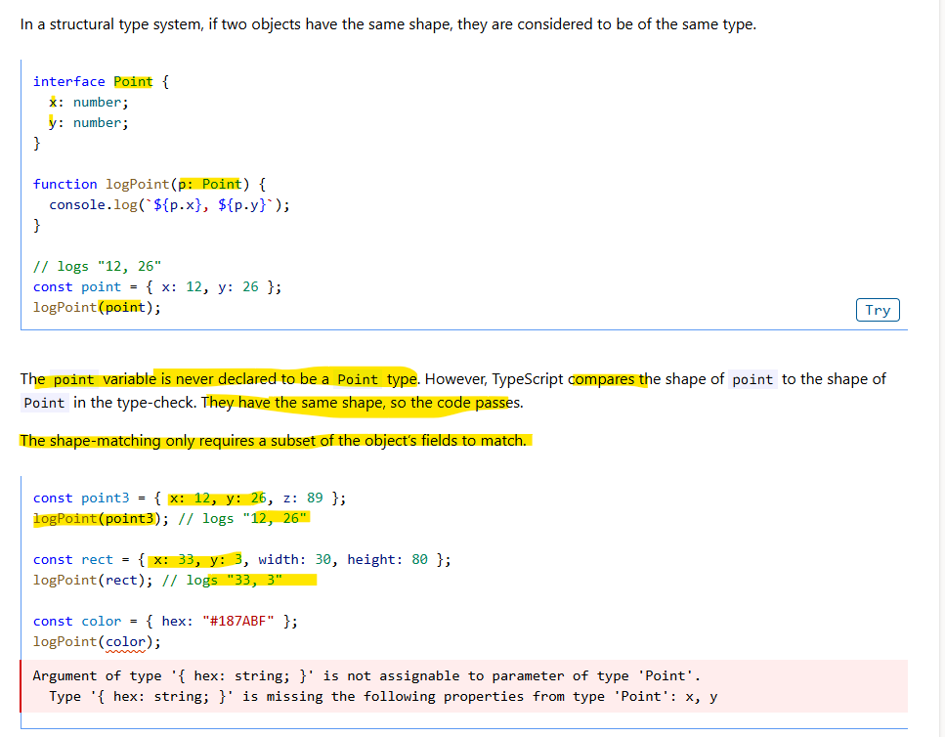

Decorator

A Decorator is a special kind of declaration that can be attached to a class declaration, method, accessor, property, or parameter. Decorators use the form @expression, where expression must evaluate to a function that will be called at runtime with information about the decorated declaration.

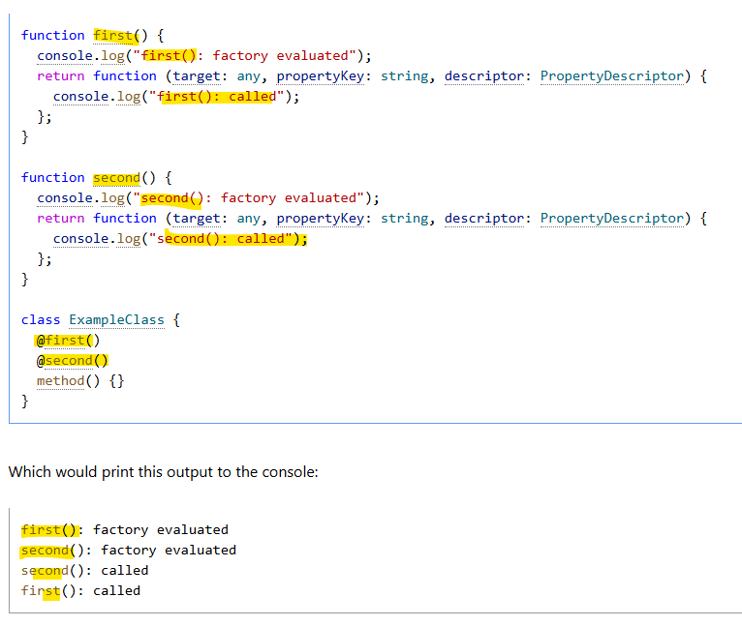

Components

Each component represents a part of a larger web page. Organizing an application into components helps provide structure to your project, clearly separating code into specific parts that are easy to maintain and grow over time.

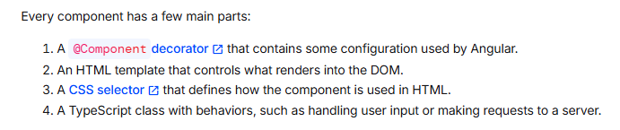

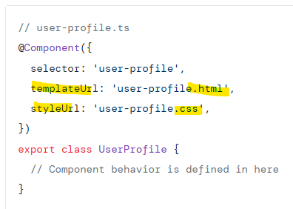

You build an application by composing multiple components together.

Import a component:

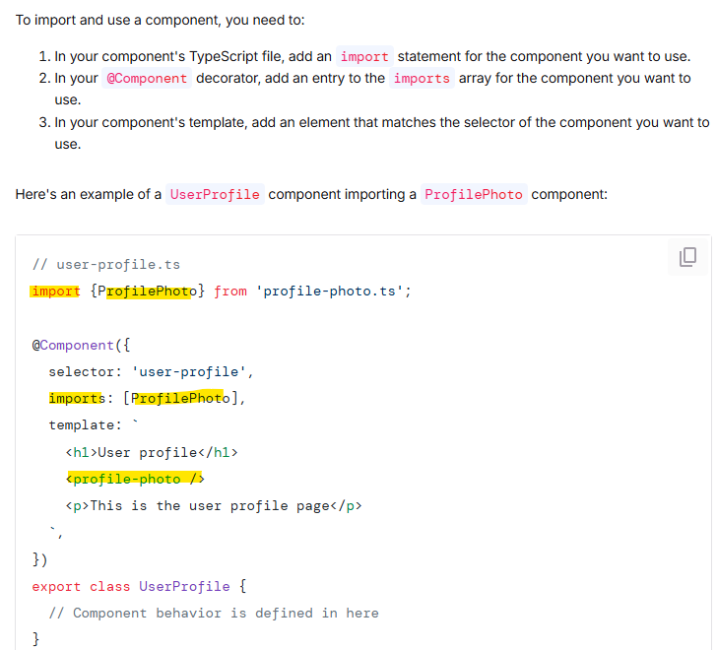

Signals

In Angular, you use signals to create and manage state. A signal is a lightweight wrapper around a value

Signals are useful because they notify interested consumers when they change

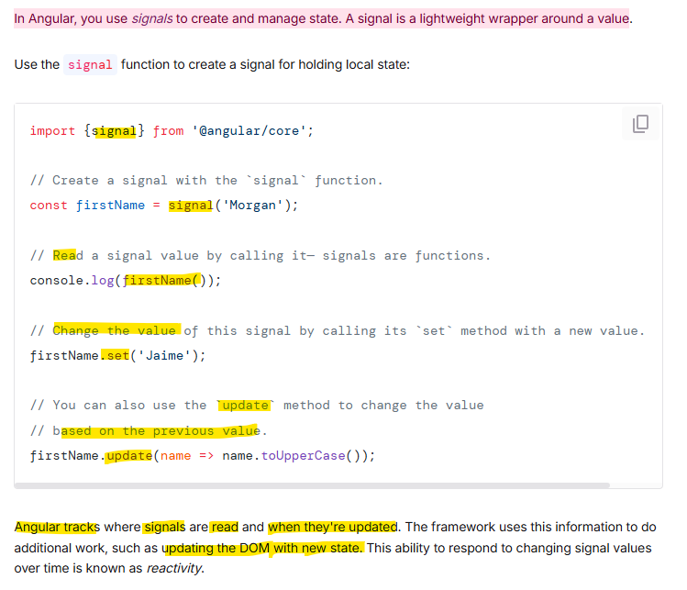

Computed Expressions

A computed is a signal that produces its value based on other signals.

A computed signal is read-only; it does not have a set or an update method. Instead, the value of the computed signal automatically changes when any of the signals it reads change:

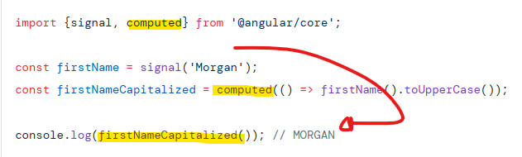

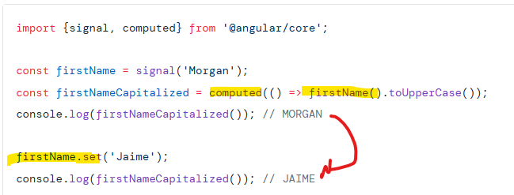

Signal in template example:

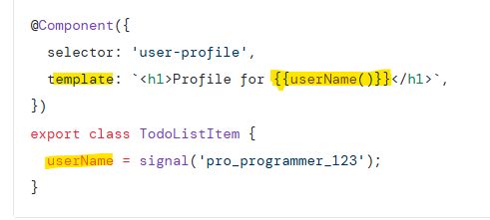

Effects

Signals are useful because they notify interested consumers when they change

Effects always run at least once. When an effect runs, it tracks any signal value reads. Whenever any of these signal values change, the effect runs again

Effects always execute asynchronously, during the change detection process.

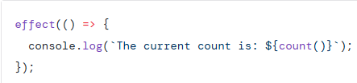

Effects are rarely needed in most application code, but may be useful in specific circumstances. Here are some examples of situations where an effect might be a good solution:

Logging data being displayed and when it changes, either for analytics or as a debugging tool.

Keeping data in sync with window.localStorage.

When not to use effects

Avoid using effects for propagation of state changes. This can result in ExpressionChangedAfterItHasBeenChecked errors, infinite circular updates, or unnecessary change detection cycles.

Instead, use computed signals to model state that depends on other state.

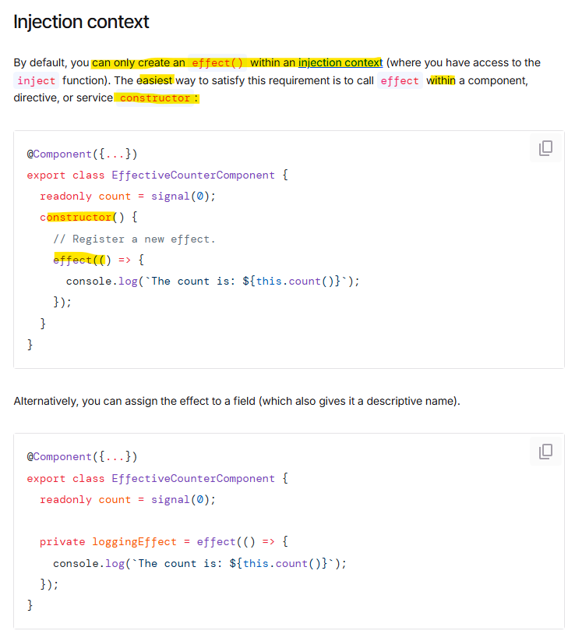

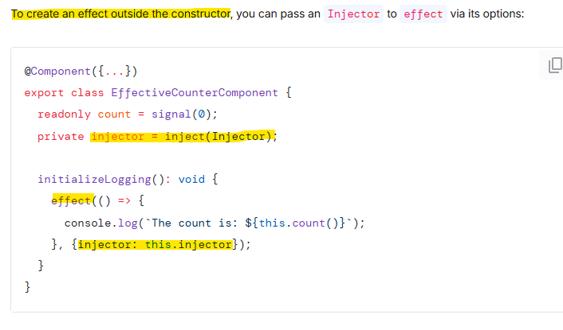

Destroy effects

effects created within components are destroyed when the component is destroyed. The same goes for effects within directives, services, etc.

Effects return an EffectRef that you can use to destroy them manually, by calling the .destroy() method

Effect without creating a dependency:

However, if the effect should only run when currentUser changes, then the read of counter is only incidental and changes to counter shouldn't log a new message.

You can prevent a signal read from being tracked by calling its getter with untracked

effect(() => {

console.log(`User set to ${currentUser()} and the counter is ${untracked(counter)}`);

});

untracked is also useful when an effect needs to invoke some external code which shouldn't be treated as a dependency:

effect(() => {

const user = currentUser();

untracked(() => {

// If the `loggingService` reads signals, they won't be counted as

// dependencies of this effect.

this.loggingService.log(`User set to ${user}`);

});

});

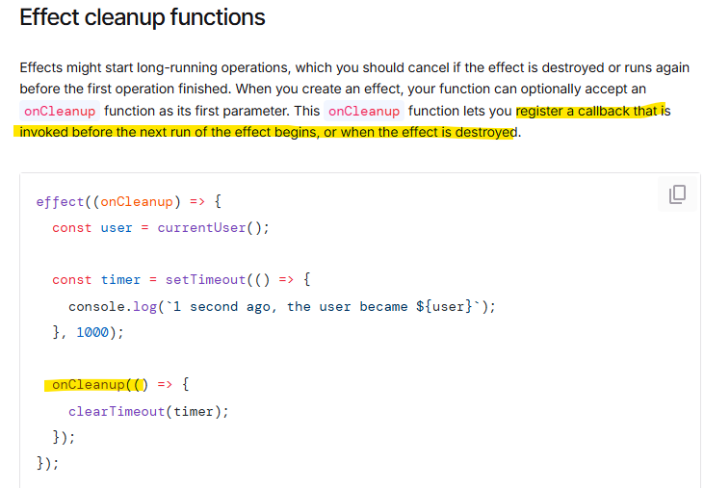

Linked signal

When the signal points to another signal which values might change

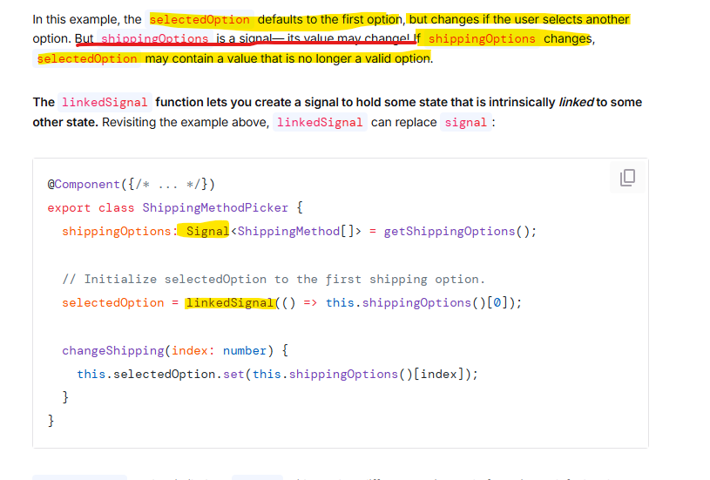

Accounting for previous state

In some cases, the computation for a linkedSignal needs to account for the previous value of the linkedSignal.

To accomplish this, you can create a linkedSignal with a separate source and computation:

Bind Dom properties and Html attributes

Angular supports binding dynamic values into DOM properties with square brackets:

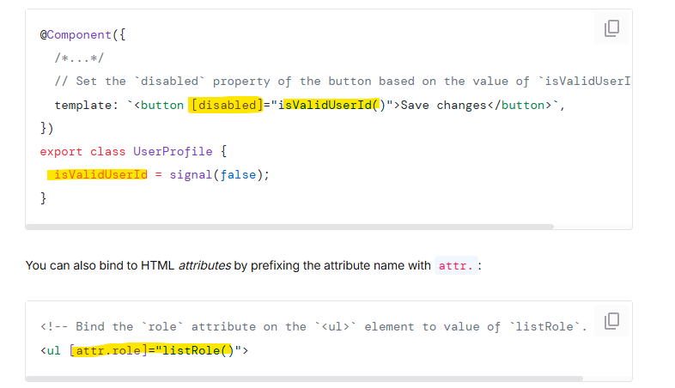

Event listeners

Angular lets you add event listeners to an element in your template with parentheses:

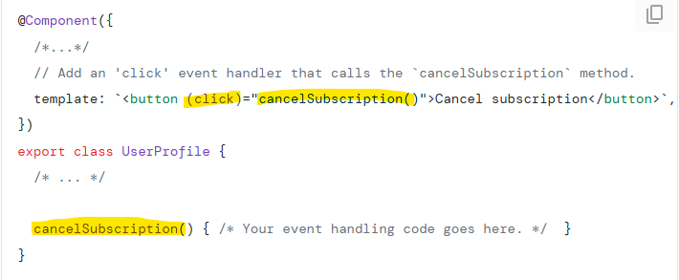

f you need to pass the event object to your listener, you can use Angular's built-in $event variable inside the function call

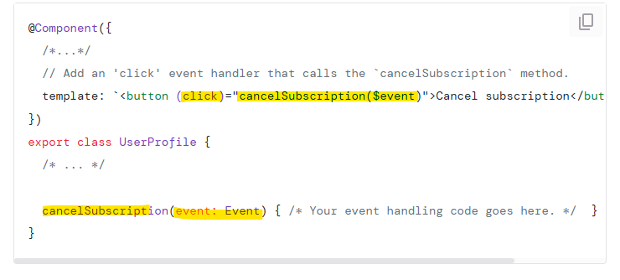

Control flow with @if and @for

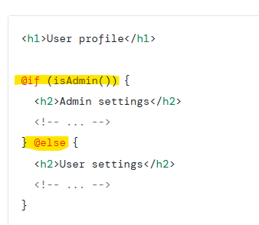

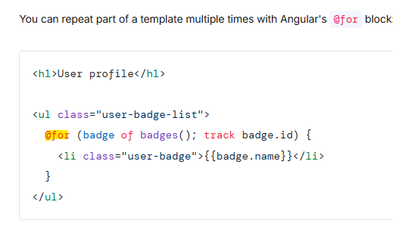

Using track in @for for optimize performance

Select a property that uniquely identifies each item in the track expression. If your data model includes a uniquely identifying property, commonly id or uuid, use this value.

For static collections that never change, you can use $index to tell Angular to track each item by its index in the collection.

If no other option is available, you can specify identity. This tells Angular to track the item by its reference identity using the triple-equals operator (===)

Dependency Injection

When you need to share logic between components, Angular leverages the design pattern of dependency injection that allows you to create a “service” which allows you to inject code into components while managing it from a single source of truth

Services

Services are reusable pieces of code that can be injected

You can specify what part of the application can access the service via the providedIn property

By using root as the property in providedIn it can be accesses anywhere in the application

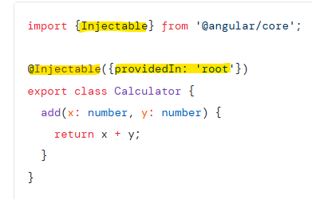

Add a service

When you want to use a service in a component, you need to:

Import the service

Declare a class field where the service is injected. Assign the class field to the result of the call of the built-in function inject which creates the service

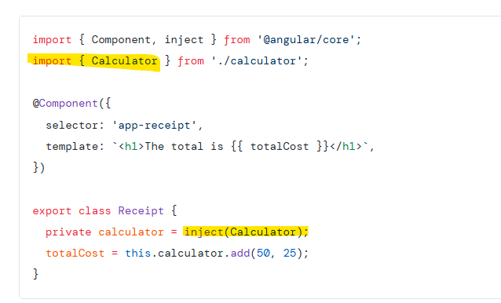

Accepting data with input properties into component

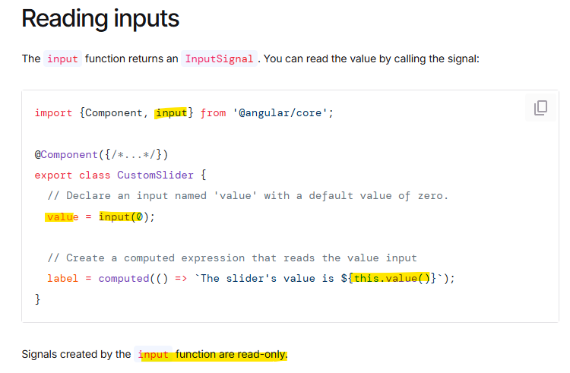

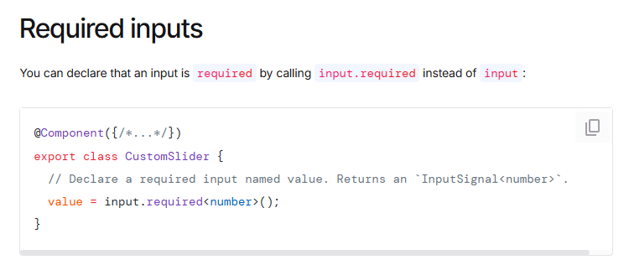

Component Selectors:

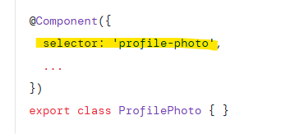

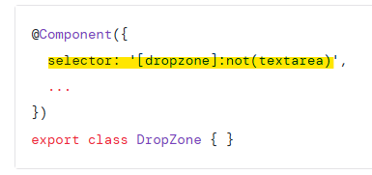

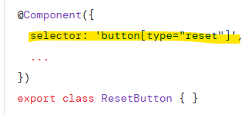

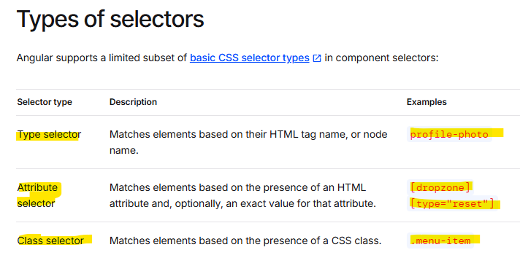

Component input data

When you use a component, you commonly want to pass some data to it. A component specifies the data that it accepts by declaring inputs

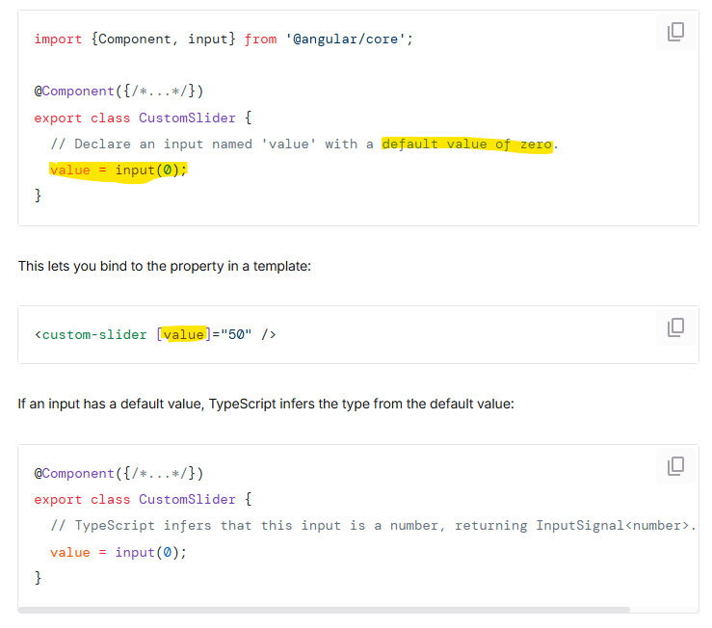

Ng-content

The <ng-content> element is neither a component nor DOM element. Instead, it is a special placeholder that tells Angular where to render content.

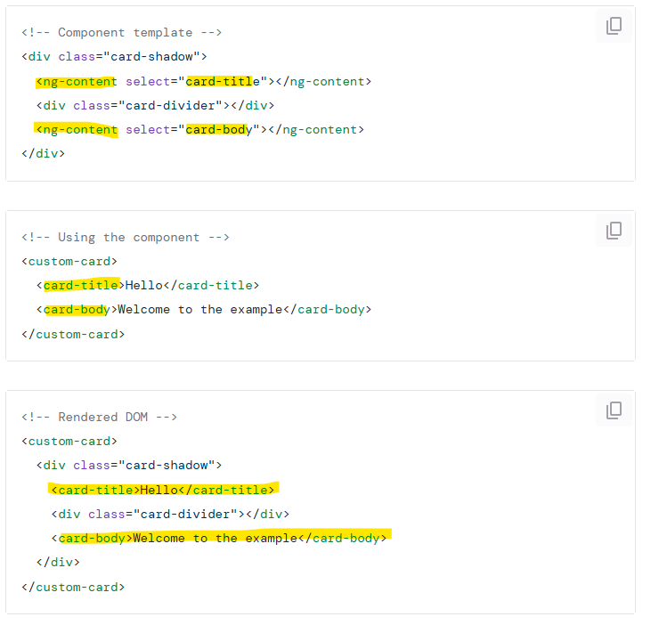

Component lifecycle

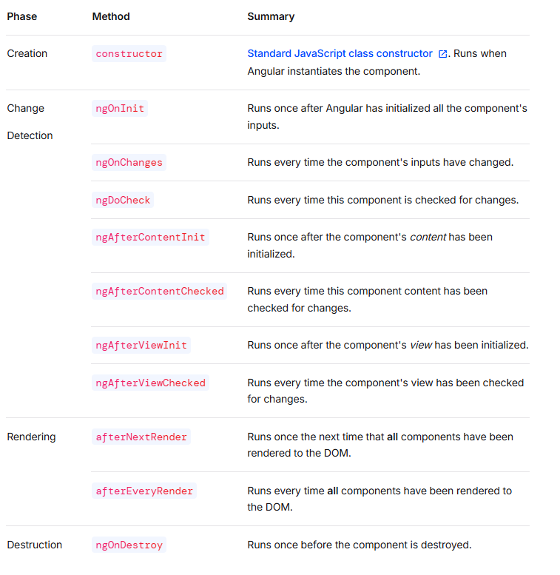

View queries

View queries retrieve results from the elements in the component's view — the elements d efined in the component's own template

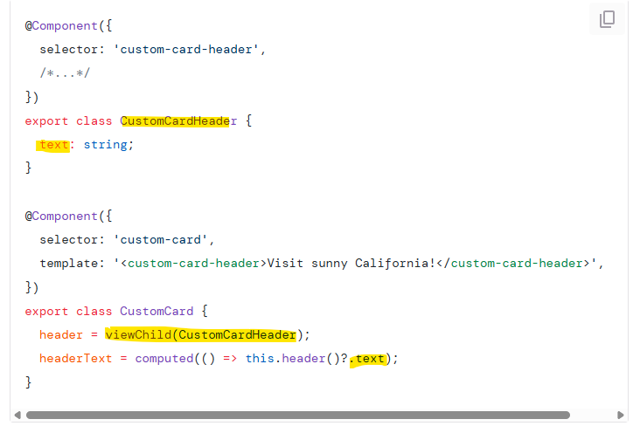

If the query does not find a result, its value is undefined. This may occur if the target element is hidden by @if. Angular keeps the result of viewChild up to date as your application state changes.

You can also query for multiple results with the viewChildren

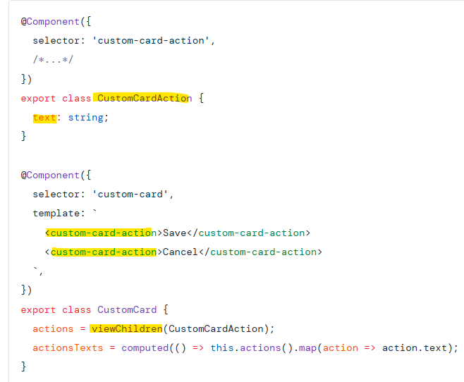

View queries can only retrieve results from the component's template.

Content Queries

retrieve results from the elements in the component's content. By default, content queries find only direct children of the component and do not traverse into descendants

Dom Apis

Angular handles most DOM creation, updates, and removals for you. However, you might rarely need to directly interact with a component's DOM. Components can inject ElementRef to get a reference to the component's host element:

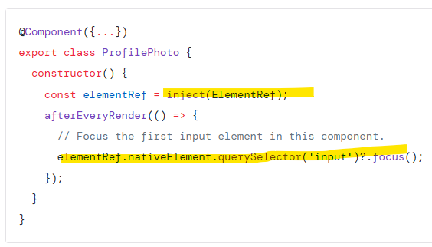

While Angular handles most rendering concerns, some behaviors may still require using DOM APIs. Some common use cases include:

Managing element focus

Measuring element geometry, such as with getBoundingClientRect

Reading an element's text content

Inheritance

Angular components are TypeScript classes and participate in standard JavaScript inheritance semantics

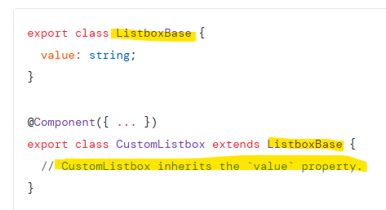

Memory management

Jps tool

Running processes

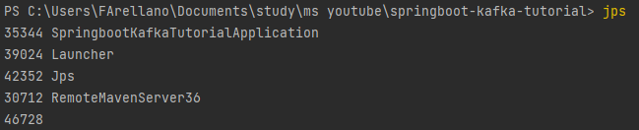

JvisualVM

Running processes as well, memory used, etc

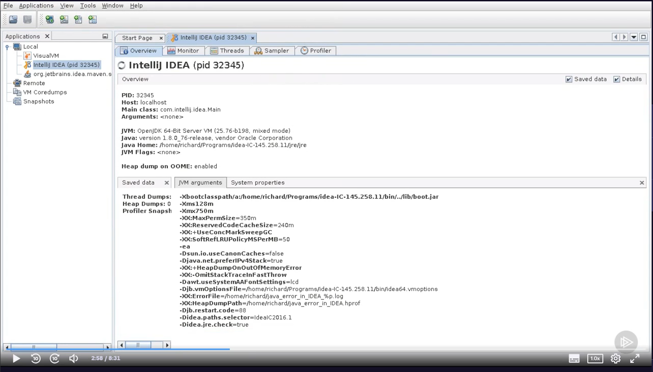

Object Histogram

Listing of how much memory is used by different objects

What is in the heap currently

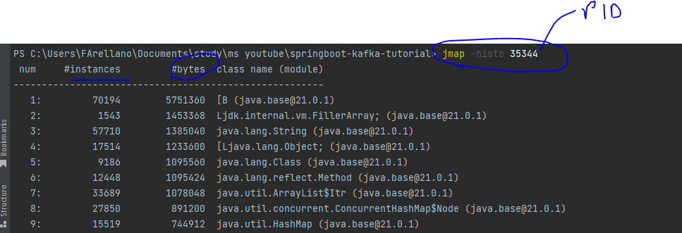

Heap Dump

Similar to histograms, slower but with more detail, you can trigger it when we have a out of memory error, it might take a lot of time

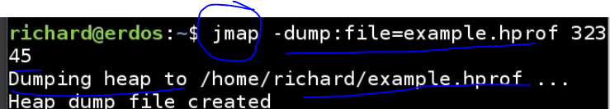

Jconsole

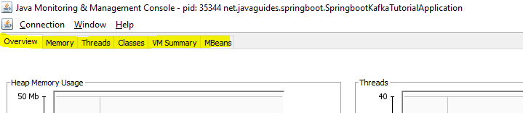

Memory Profiling

Records memory allocation in snapshots

Ex using JVisualVM

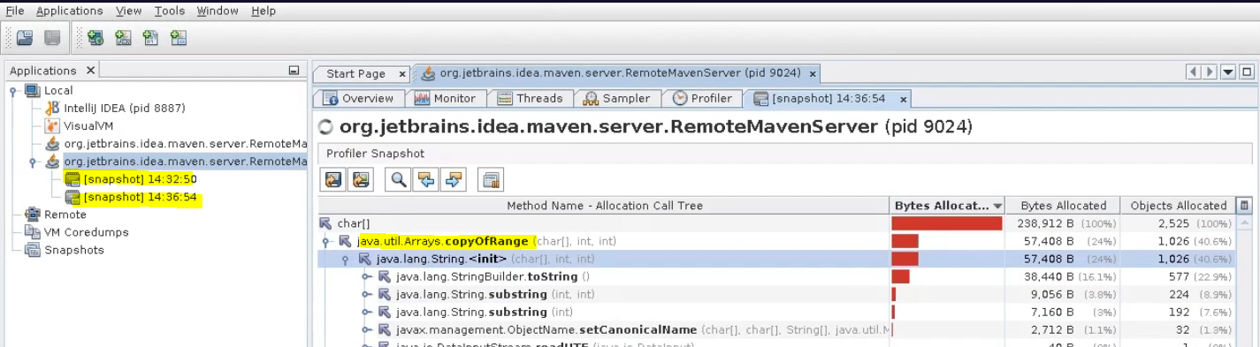

Memory Leak

A Memory has been allocated and is not longer needed but it is not get released

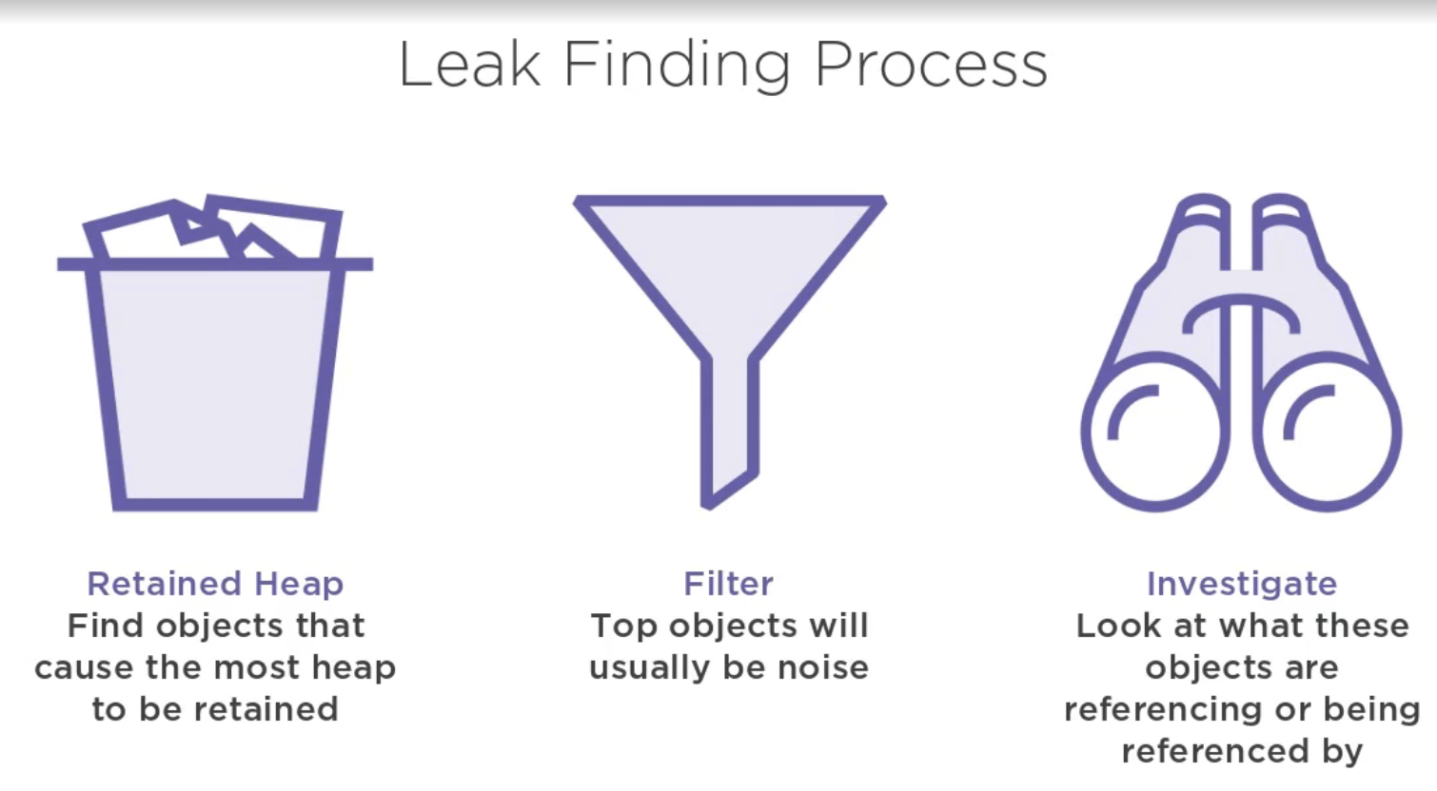

Heapdump

Check histogram

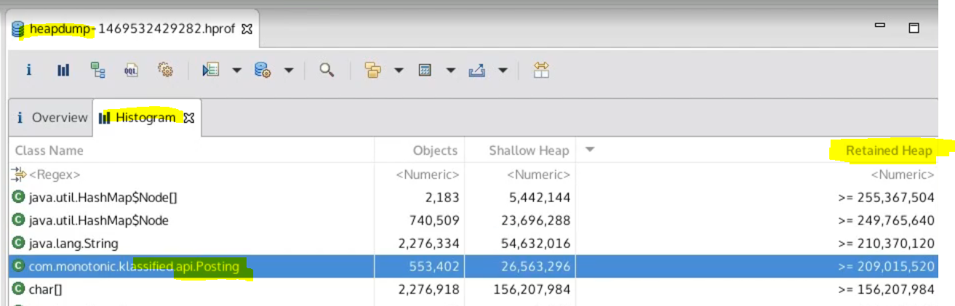

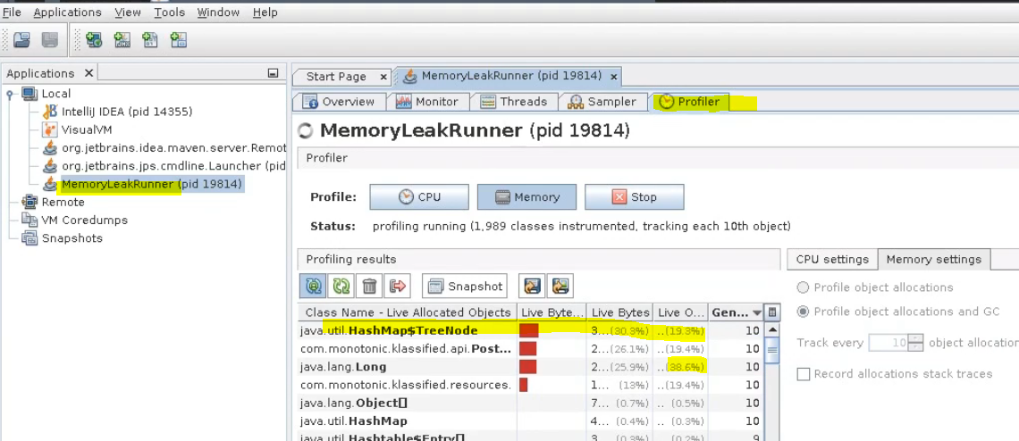

Issue was not equals from hashmap declared, every put and get was creating a different bucket

ThreadLocal not removing a value

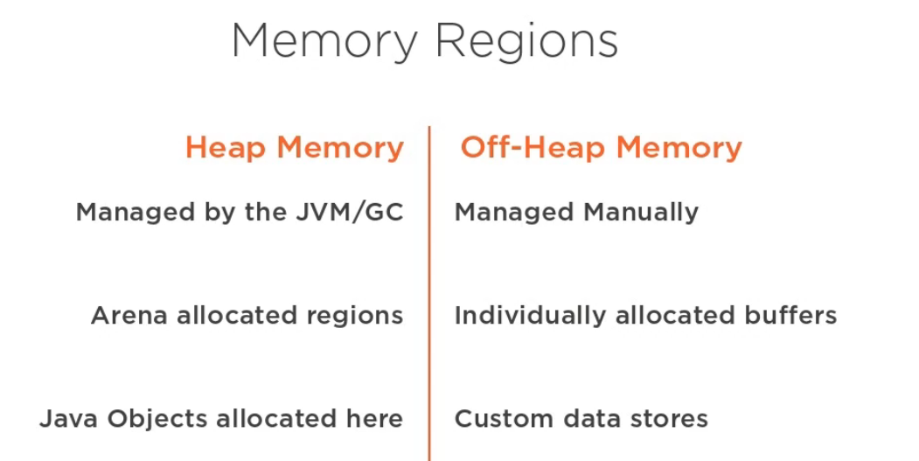

JIT

JVM comprise of

Classloader

Heap

Method area

Stack

Execution engine

Jni

How to create a demon thread

Calling setDaemon(true) before calling start()

Does java support global variables

No, to avoid namespace collitions and referencial transparency

How to create a RMI object

Differences between time slicing and preemptive

Methods using while serialization and deserialization

InputStream read, deserialize from byte stream into a usable object

OutputStream write, serialize an object into a byte stream

Stream collect to a specific type of collection, ex LinkHashSet

Using Collectors.toCollection

.collect(Collectors.toCollection(LinkedHashSet::new));

Stream sort entry set for key or for value:

.sorted(Map.Entry.*comparingByValue*(Comparator.*reverseOrder*()))

.sorted(Map.Entry.comparingByKey(Comparator.reverseOrder()))

.sorted(Map.Entry.<String, Long>comparingByValue(Comparator.reverseOrder()))

**1) Singleton**

**Problema:** Garantizar una única instancia de una clase y proporcionar un punto global de acceso. **Solución:** Se usa el *Initialization-on-demand holder idiom* (clase estática interna) que garantiza inicialización perezosa y es seguro en entornos multi-hilo sin coste de sincronización adicional. **Por qué funciona:** El cargador de clases de Java inicializa la clase holder la primera vez que se accede, asegurando inicialización segura en tiempo y visibilidad entre hilos. Alternativas: enum-based singleton (inherently serializable and simple).

**2) Factory Method**

**Problema:** Delegar la creación de objetos a subclases para evitar depender de clases concretas. **Solución:** Definir una interfaz Product y una fábrica abstracta con un createProduct(); crear fábricas concretas que devuelven implementaciones concretas. **Por qué funciona:** Permite variar la familia de productos sin cambiar el código cliente; facilita la extensión y pruebas.

**3) Abstract Factory**

**Problema:** Crear familias de objetos relacionados sin acoplarse a sus clases concretas. **Solución:** Definir interfaces para familias (ej. Button, Checkbox) y fábricas concretas por plataforma (Windows, Mac). **Por qué funciona:** Agrupa la creación y asegura compatibilidad entre productos; útil para configuraciones cross-product.

**4) Builder**

**Problema:** Construcción de objetos complejos paso a paso y con múltiples parámetros opcionales. **Solución:** Implementar un Builder anidado con métodos encadenados (withX(...)) y build(). **Por qué funciona:** Mejora legibilidad, evita constructores telescópicos y permite objetos inmutables.

**5) Prototype**

**Problema:** Crear nuevos objetos copiando un prototipo existente (clonación). **Solución:** Implementar clone() (o un método copyOf) que realice copia profunda cuando sea necesario. **Por qué funciona:** Útil cuando la creación por constructor es costosa; requiere cuidar referencias mutables.

**6) Adapter**

**Problema:** Hacer que dos interfaces incompatibles trabajen juntas. **Solución:** Crear un adaptador que implemente la interfaz esperada y delegue a la clase existente realizando las conversiones necesarias. **Por qué funciona:** Aísla la lógica de adaptación y evita cambiar las clases existentes.

**7) Facade**

**Problema:** Simplificar una API compleja ofreciendo una interfaz más simple. **Solución:** Implementar una clase Facade que coordina llamadas a subsistemas internos. **Por qué funciona:** Reduce el acoplamiento entre cliente y subsistemas y mejora la facilidad de uso.

**8) Decorator**

**Problema:** Añadir responsabilidades dinámicamente a objetos sin usar herencia estática. **Solución:** Usar componentes que implementan la misma interfaz y envuelven a otros componentes, agregando comportamiento. **Por qué funciona:** Permite combinación flexible y evita explosión de subclases.

**9) Proxy**

**Problema:** Controlar el acceso a un objeto (ej.: lazy, logging, seguridad). **Solución:** Crear un proxy que implemente la misma interfaz y delegue al objeto real aplicando la lógica (caching, lazy-loading). **Por qué funciona:** Encapsula responsabilidades transversales sin modificar la lógica del objeto real.

**10) Observer**

**Problema:** Notificar dependientes cuando el estado de un sujeto cambia. **Solución:** Implementar un sujeto que mantiene una lista de observadores y los notifica; observadores implementan una interfaz update. **Por qué funciona:** Desacopla sujeto y observadores; facilita añadir/eliminar listeners dinámicamente.

**11) Strategy**

**Problema:** Definir una familia de algoritmos intercambiables y encapsular cada uno. **Solución:** Crear una interfaz Strategy y clases concretas; el contexto mantiene una referencia y ejecuta la estrategia elegida. **Por qué funciona:** Facilita cambiar comportamiento en tiempo de ejecución sin condicionales complejos.

**12) Command**

**Problema:** Encapsular una solicitud como objeto para parametrizar clientes con operaciones, soportar colas, deshacer, etc. **Solución:** Implementar interfaz Command con execute(); el invocador ejecuta comandos y puede almacenar historial para deshacer. **Por qué funciona:** Desacopla quien invoca y quien ejecuta; permite operaciones refinadas como macro commands y undo.

Cada explicación en este archivo está ligada a la implementación de ejemplo en src/main/java y a los tests de src/test/java. Revisa los comentarios en cada clase para ver notas de diseño, variantes y ejercicios extra propuestos.